Scorecards
Procurement
Faith Warren
[Pick the date]

[Type the abstract of the document here. The abstract is typically a short summary of the contents of the document. Type the abstract of the document here. The abstract is typically a short summary of the contents of the document.]
Table of Contents
[To update the table of contents, right click the message below and select Update Field (F9 on PC, ⌥⌘U on Mac).]
1. Pages 3
1.1. Page Tree 3
1.2. Home 4
1.2.1. User Interface 4
1.3. DC Performance 5
1.3.1. User Interface 5
1.3.2. Activities Menu 5
1.3.2.1. Invisible 5
1.3.2.2. Visible 5
1.3.2.3. User Interface 5
1.4. Vendor Performance 6
1.4.1. User Interface 6
1.4.2. Activities Menu 6
1.4.2.1. Invisible 6
1.4.2.2. Visible 6
1.4.2.3. User Interface 6
1.5. Promo Low Stock 7
1.5.1. User Interface 7
1.5.2. Activities Menu 7
1.5.2.1. Invisible 7
1.5.2.2. Visible 7
1.5.2.3. User Interface 7
1.6. Late Purchase Orders 8
1.6.1. User Interface 18
1.6.2. Activities Menu 18
1.6.2.1. Invisible 18
1.6.2.2. Visible 18
1.6.2.3. User Interface 18

- Pages
  - Page Tree
Home
DC Performance
Vendor Performance
Promo Low Stock
Late Purchase Orders
  - Home
    - User Interface
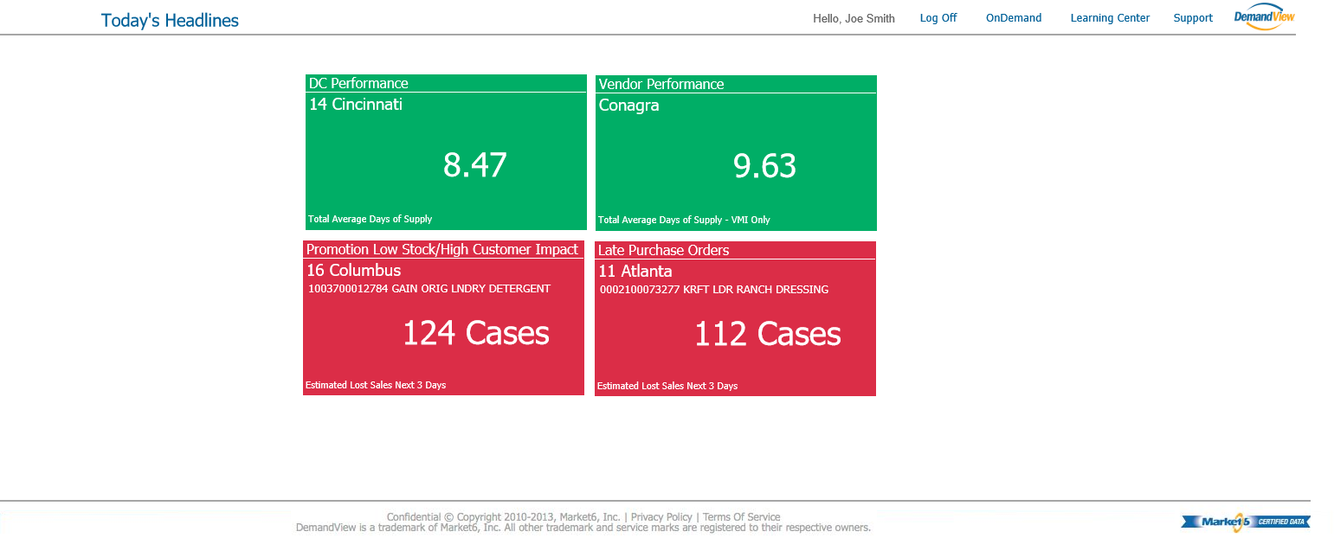
  - DC Performance
    - User Interface
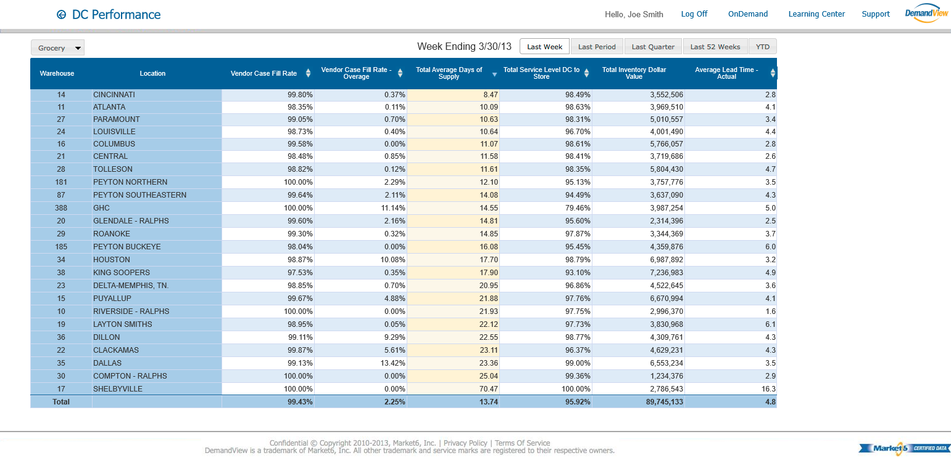
    - Activities Menu
      - Invisible
      - Visible
      - User Interface
  - Vendor Performance
    - User Interface
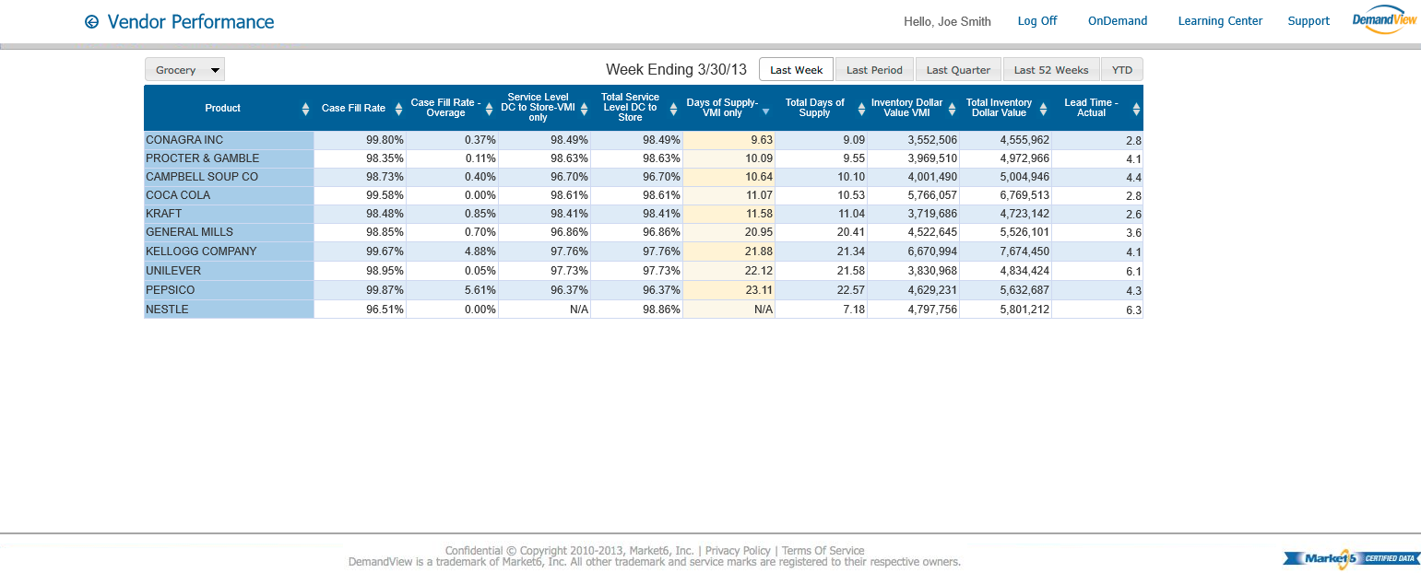
    - Activities Menu
      - Invisible
      - Visible
      - User Interface
  - Promo Low Stock
    - User Interface
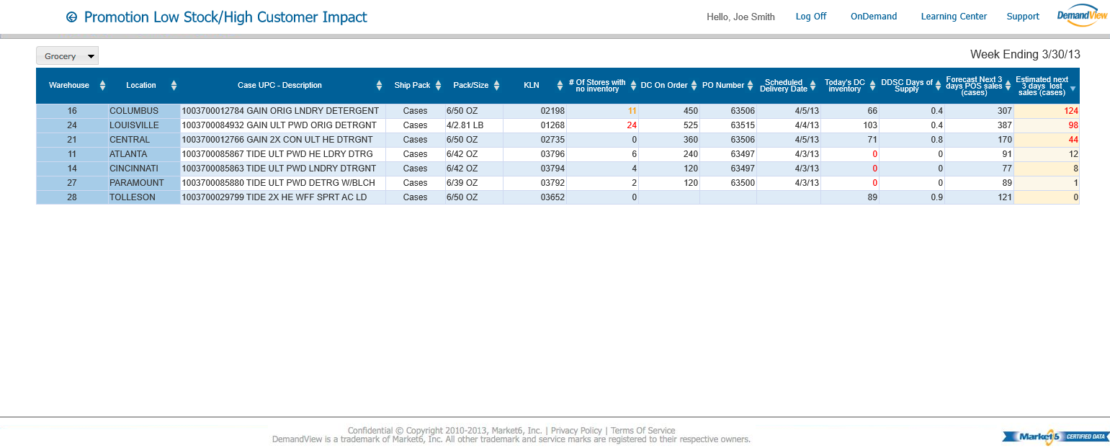
    - Activities Menu
      - Invisible
      - Visible
      - User Interface
  - Late Purchase Orders
    - User Interface
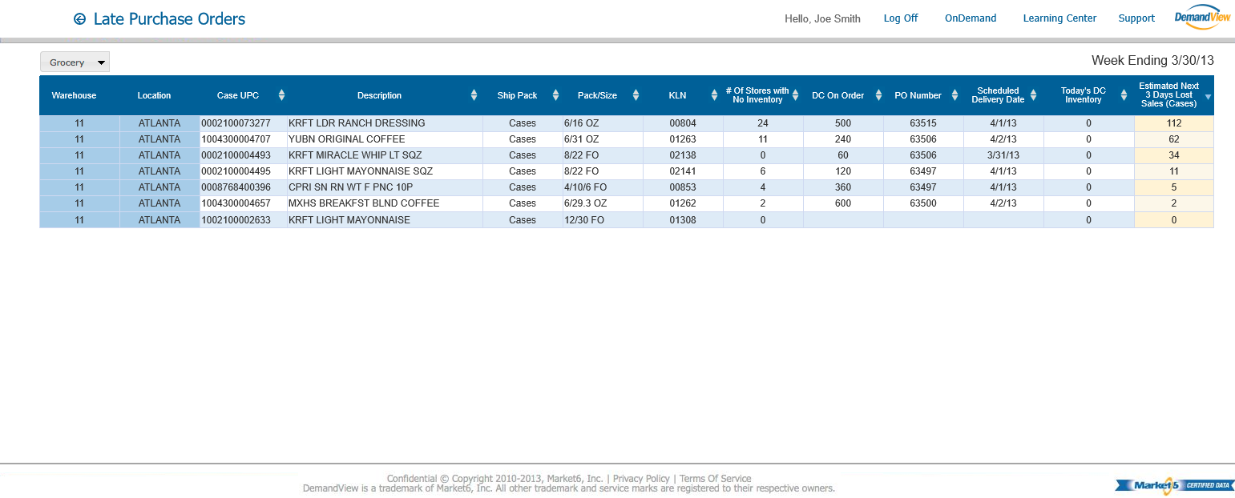
    - Activities Menu
      - Invisible
      - Visible
      - User Interface

