Pfizer Intranet
Wireframes
Faith Warren

Table of Contents
[To update the table of contents, right click the message below and select Update Field (F9 on PC, ⌥⌘U on Mac).]
1. Pages 5
1.1. Page Tree 5
1.2. iPhone 6 6
1.2.1. User Interface 6
1.2.2. home window 7
1.2.2.1. State1 7
1.2.2.2. User Interface 7
1.2.3. hme content 8
1.2.3.1. State1 8
1.2.3.2. User Interface 8
1.2.4. Header Panel 9
1.2.4.1. Header 9
1.2.4.2. User Interface 9
1.2.5. Menu Panel 9
1.2.5.1. Menu 9
1.2.5.2. User Interface 9
1.2.6. Unnamed 10
1.2.6.1. State1 10
1.2.6.2. User Interface 10
1.2.7. About Pfizer 10
1.2.7.1. State1 10
1.2.7.2. User Interface 10
1.2.7.3. State2 11
1.2.7.4. User Interface 11
1.2.8. Social Channels 11
1.2.8.1. State1 11
1.2.8.2. User Interface 11
1.2.8.3. State2 11
1.2.8.4. User Interface 11
1.2.9. Resources 11
1.2.9.1. State1 11
1.2.9.2. User Interface 11
1.2.9.3. State2 11
1.2.9.4. User Interface 11
1.3. my news 12
1.3.1. User Interface 12
1.4. industry news 13
1.4.1. User Interface 13
1.5. news article page 14
1.5.1. User Interface 14
1.5.2. new article page window 15
1.5.2.1. State1 15
1.5.2.2. User Interface 15
1.5.3. article content 16
1.5.3.1. State1 16
1.5.3.2. User Interface 16
2. Masters 17
2.1. Master List 17
2.2. iphone 18
2.2.1. User Interface 18
2.2.2. Header Panel 19
2.2.2.1. Header 19
2.2.2.2. User Interface 19
2.2.3. Menu Panel 19
2.2.3.1. Menu 19
2.2.3.2. User Interface 19
2.2.4. Unnamed 20
2.2.4.1. State1 20
2.2.4.2. User Interface 20
2.2.5. About Pfizer 20
2.2.5.1. State1 20
2.2.5.2. User Interface 20
2.2.5.3. State2 21
2.2.5.4. User Interface 21
2.2.6. Social Channels 21
2.2.6.1. State1 21
2.2.6.2. User Interface 21
2.2.6.3. State2 21
2.2.6.4. User Interface 21
2.2.7. Resources 21
2.2.7.1. State1 21
2.2.7.2. User Interface 21
2.2.7.3. State2 21
2.2.7.4. User Interface 21

- Pages
  - Page Tree
iPhone 6
my news
industry news
news article page
  - iPhone 6
    - User Interface
    - home window
      - State1
      - User Interface
    - hme content
      - State1
      - User Interface
    - Header Panel
      - Header
      - User Interface
    - Menu Panel
      - Menu
      - User Interface
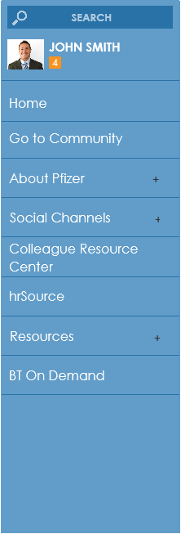
    - Unnamed
      - State1
      - User Interface
    - About Pfizer
      - State1
      - User Interface
      - State2
      - User Interface
    - Social Channels
      - State1
      - User Interface
      - State2
      - User Interface
    - Resources
      - State1
      - User Interface
      - State2
      - User Interface
  - my news
    - User Interface
  - industry news
    - User Interface
  - news article page
    - User Interface
    - new article page window
      - State1
      - User Interface
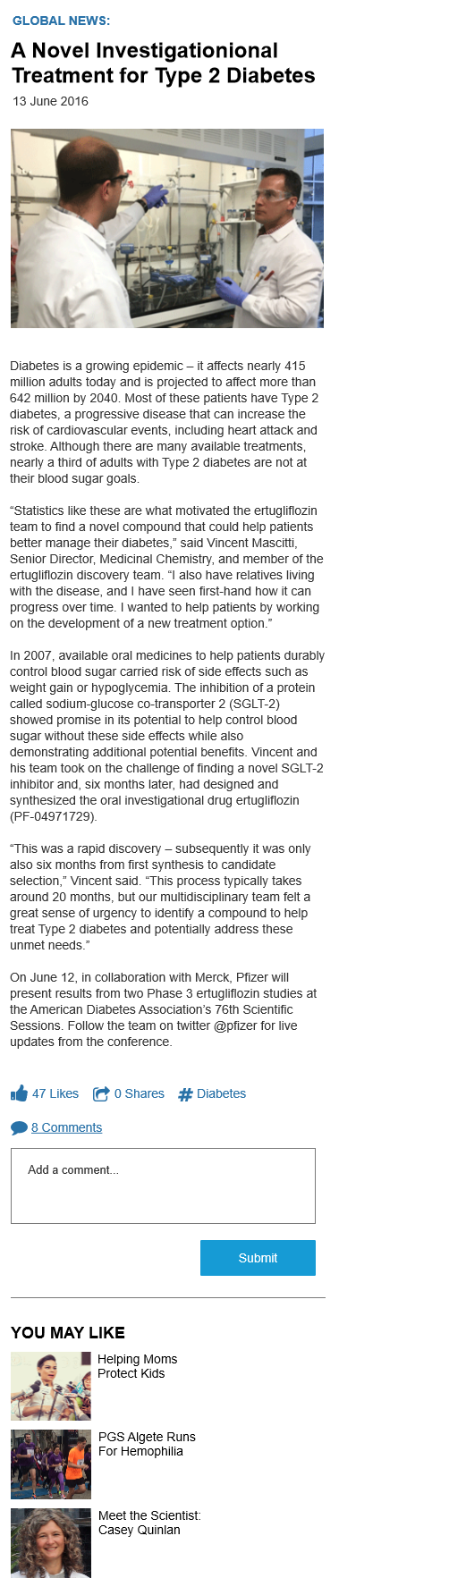
    - article content
      - State1
      - User Interface

- Masters
  - Master List
iphone
  - iphone
    - User Interface
    - Header Panel
      - Header
      - User Interface
    - Menu Panel
      - Menu
      - User Interface
    - Unnamed
      - State1
      - User Interface
    - About Pfizer
      - State1
      - User Interface
      - State2
      - User Interface
    - Social Channels
      - State1
      - User Interface
      - State2
      - User Interface
    - Resources
      - State1
      - User Interface
      - State2
      - User Interface

