PepsiCo
Wireframes
Faith Warren

[Type the abstract of the document here. The abstract is typically a short summary of the contents of the document. Type the abstract of the document here. The abstract is typically a short summary of the contents of the document.]
Table of Contents
[To update the table of contents, right click the message below and select Update Field (F9 on PC, ⌥⌘U on Mac).]
1. Pages 4
1.1. Page Tree 4
1.2. Home 5
1.3. Mobile eCommerce (2nd Level) 6
1.3.1. User Interface 6
1.4. Mobile eCommerce (1st Level) 7
1.4.1. User Interface 7
1.5. Mobile Self Service 8
1.5.1. User Interface 8
1.6. Route Guidance 9
1.6.1. User Interface 9
1.7. Timed Deals Pop Up 10
1.7.1. User Interface 10
1.8. Timed Deal 11
1.8.1. User Interface 11
1.9. Route Notifications 12
1.9.1. User Interface 12
1.10. Delivery Alert pop Up 13
1.10.1. User Interface 13
1.11. Dashboards 14
1.11.1. User Interface 14
1.12. Marketplace 15
1.12.1. User Interface 15
1.13. Auto Reorder / Quick Orders 16
1.13.1. User Interface 16
1.14. Mobile Training (2nd Level) 17
1.14.1. User Interface 17
1.15. Mobile Training (v2) 18
1.15.1. User Interface 18
1.16. Mobile Training (1st Level) 19
1.16.1. User Interface 19
1.17. Freezer Smart Screens 20
1.17.1. User Interface 20
2. Masters 21
2.1. Master List 21
2.2. Search box 22
2.3. Dynamic search box 23
2.4. Search paging 24

- Pages
  - Page Tree
Home
Mobile eCommerce (2nd Level)
Mobile eCommerce (1st Level)
Mobile Self Service
Route Guidance
Timed Deals Pop Up
Timed Deal
Route Notifications
Delivery Alert pop Up
Dashboards
Marketplace
Auto Reorder / Quick Orders
Mobile Training (2nd Level)
Mobile Training (v2)
Mobile Training (1st Level)
Freezer Smart Screens
  - Home
  - Mobile eCommerce (2nd Level)
    - User Interface
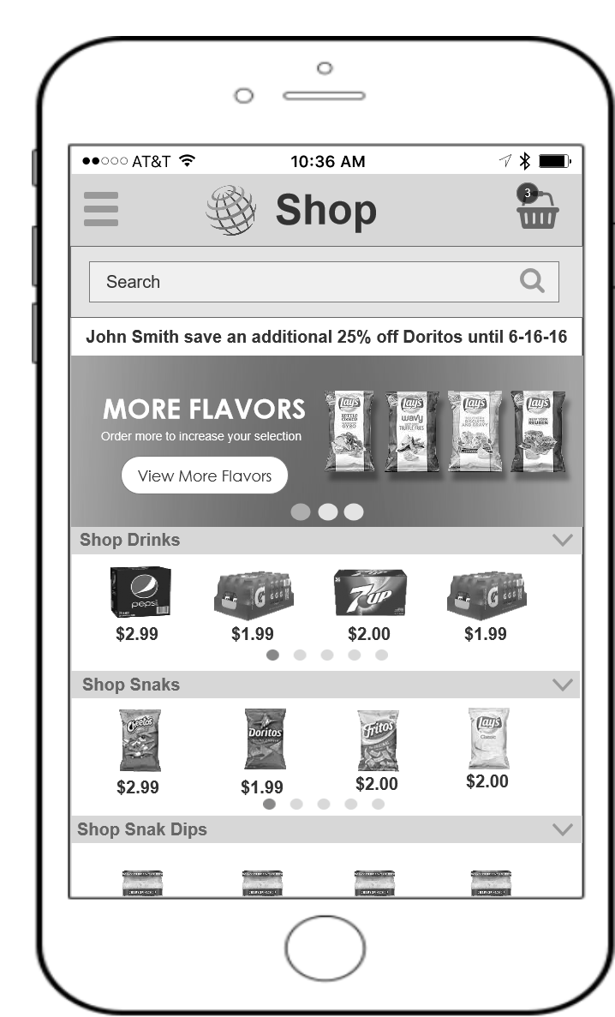
  - Mobile eCommerce (1st Level)
    - User Interface
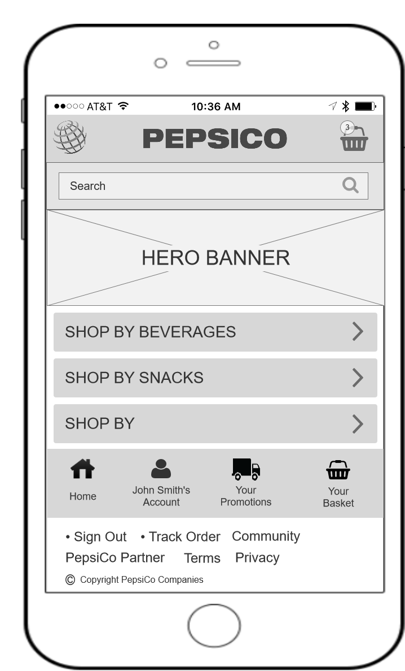
  - Mobile Self Service
    - User Interface
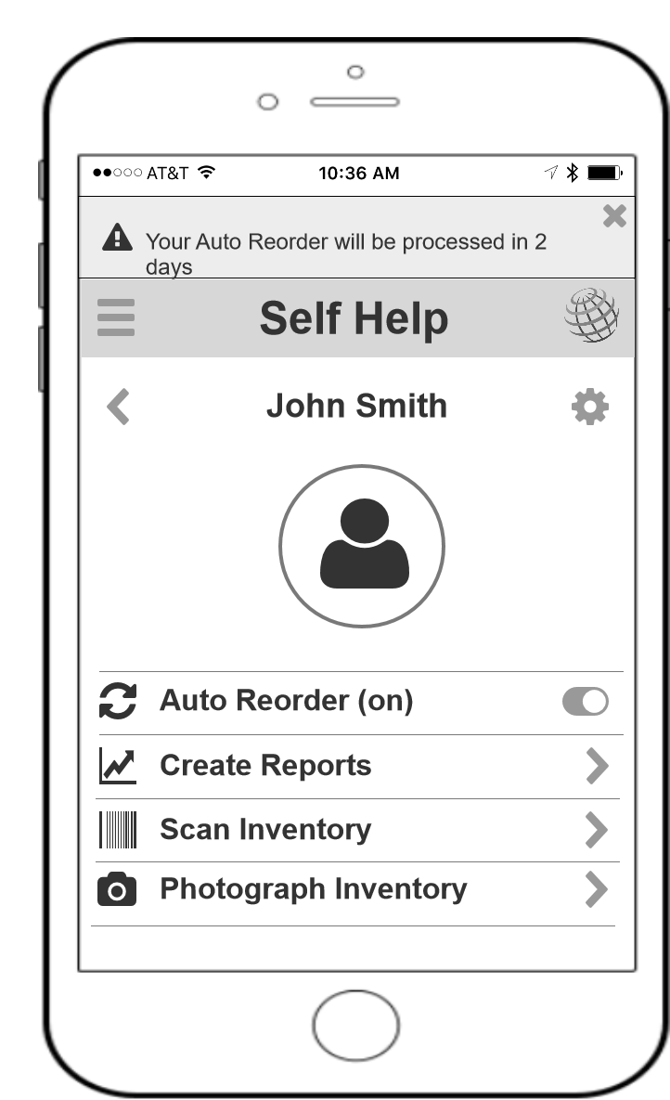
  - Route Guidance
    - User Interface
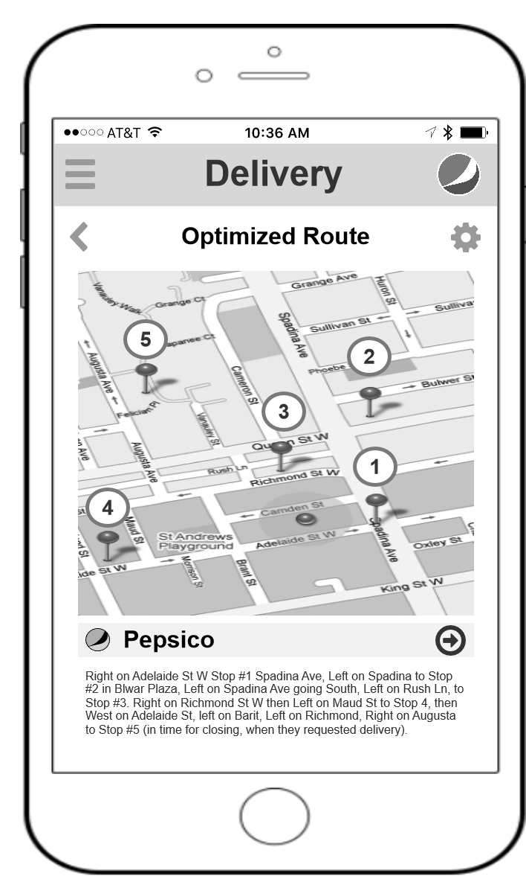
  - Timed Deals Pop Up
    - User Interface
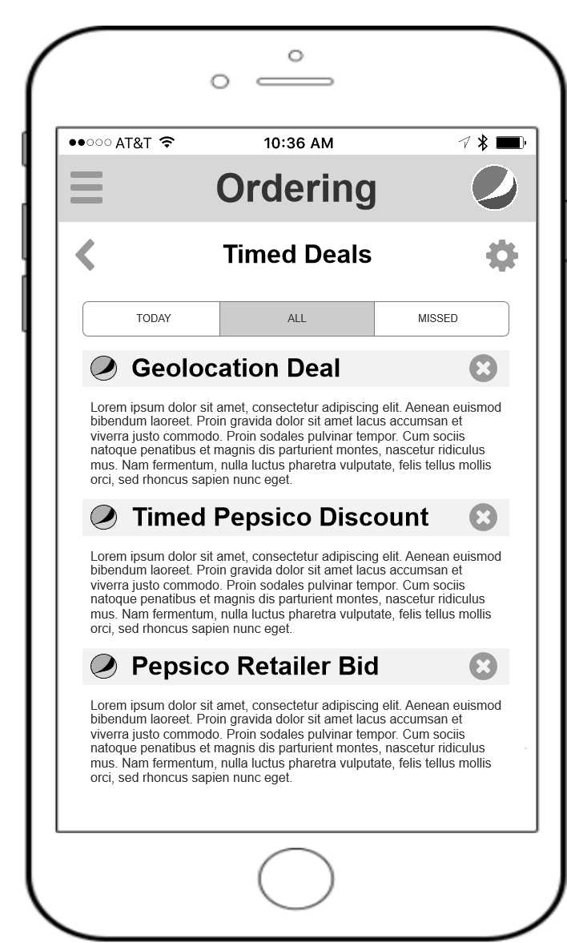
  - Timed Deal
    - User Interface
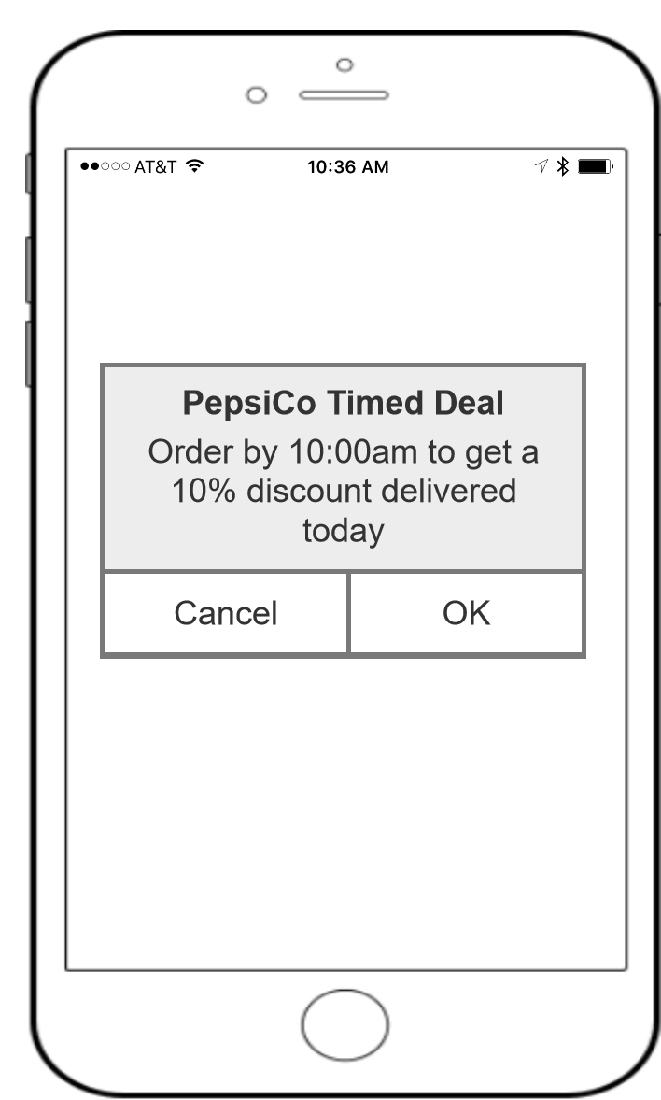
  - Route Notifications
    - User Interface
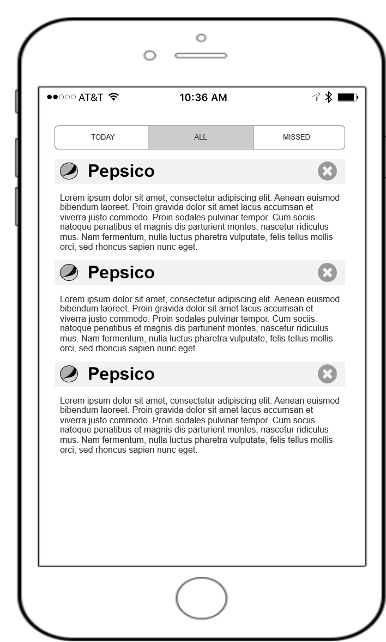
  - Delivery Alert pop Up
    - User Interface
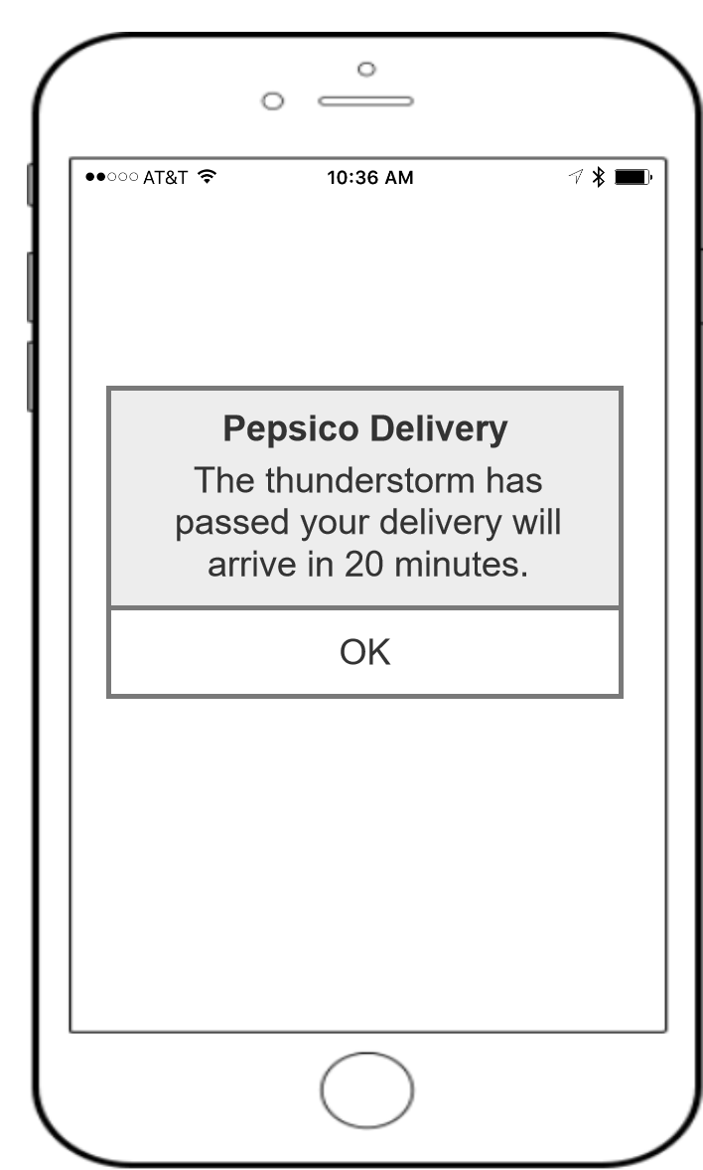
  - Dashboards
    - User Interface
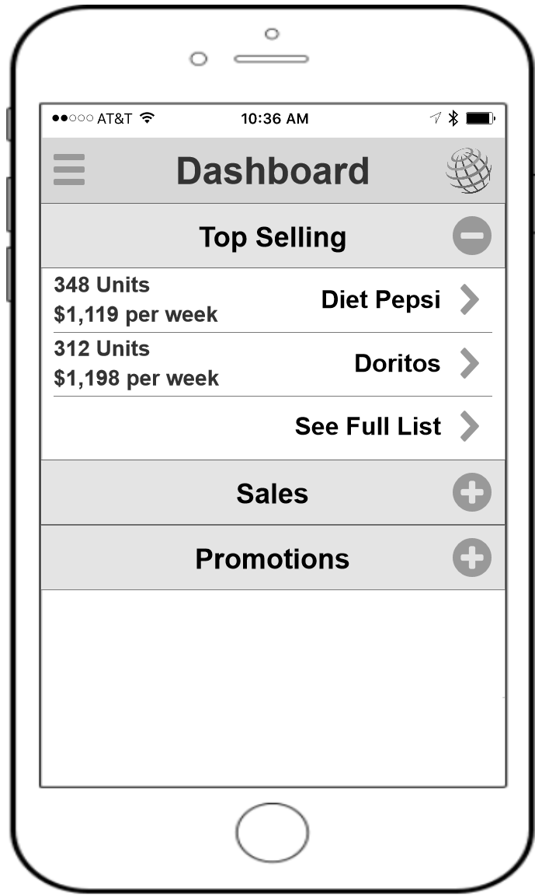
  - Marketplace
    - User Interface
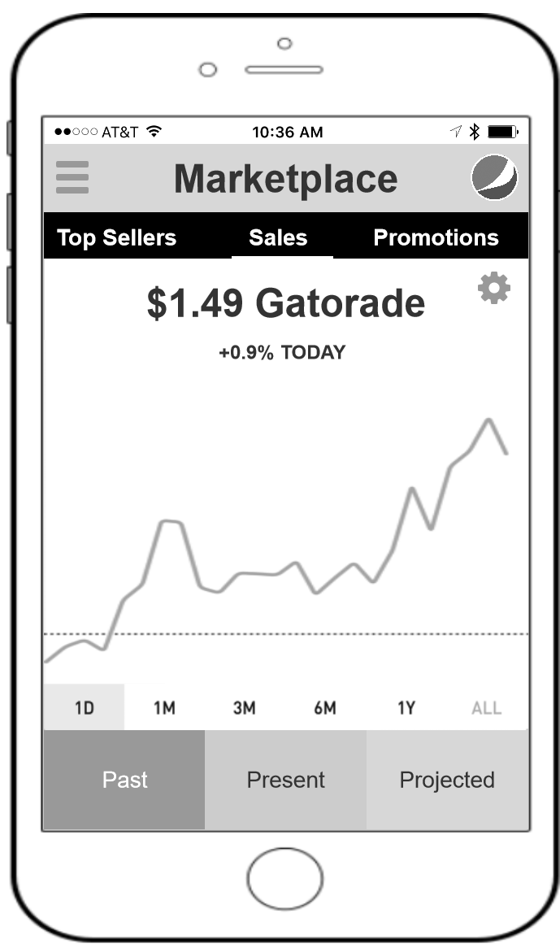
  - Auto Reorder / Quick Orders
    - User Interface
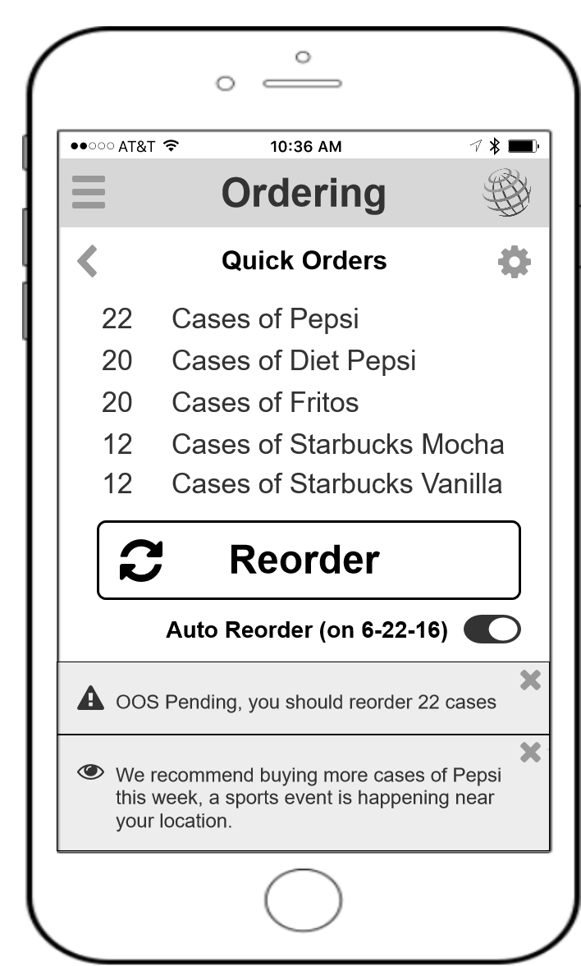
  - Mobile Training (2nd Level)
    - User Interface
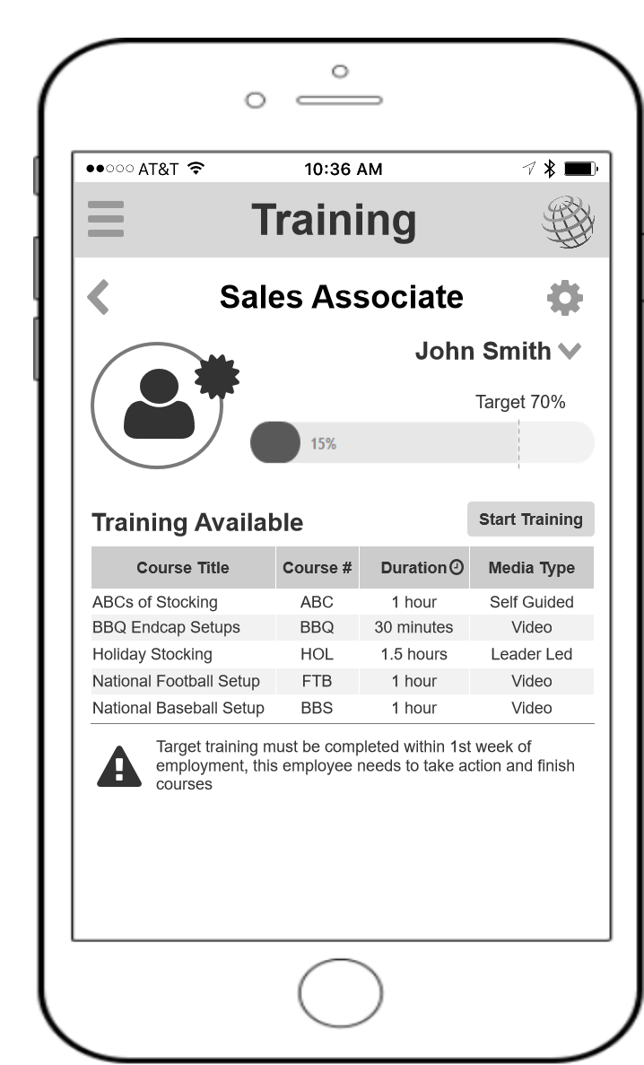
  - Mobile Training (v2)
    - User Interface
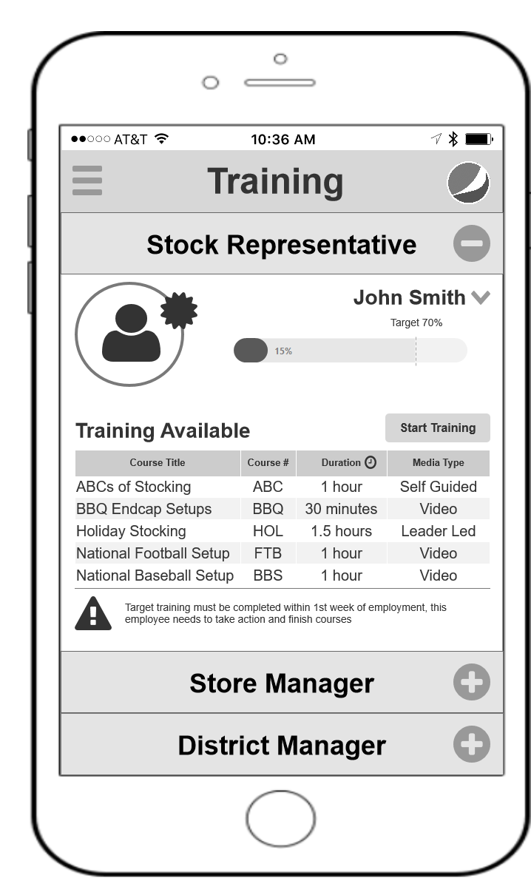
  - Mobile Training (1st Level)
    - User Interface
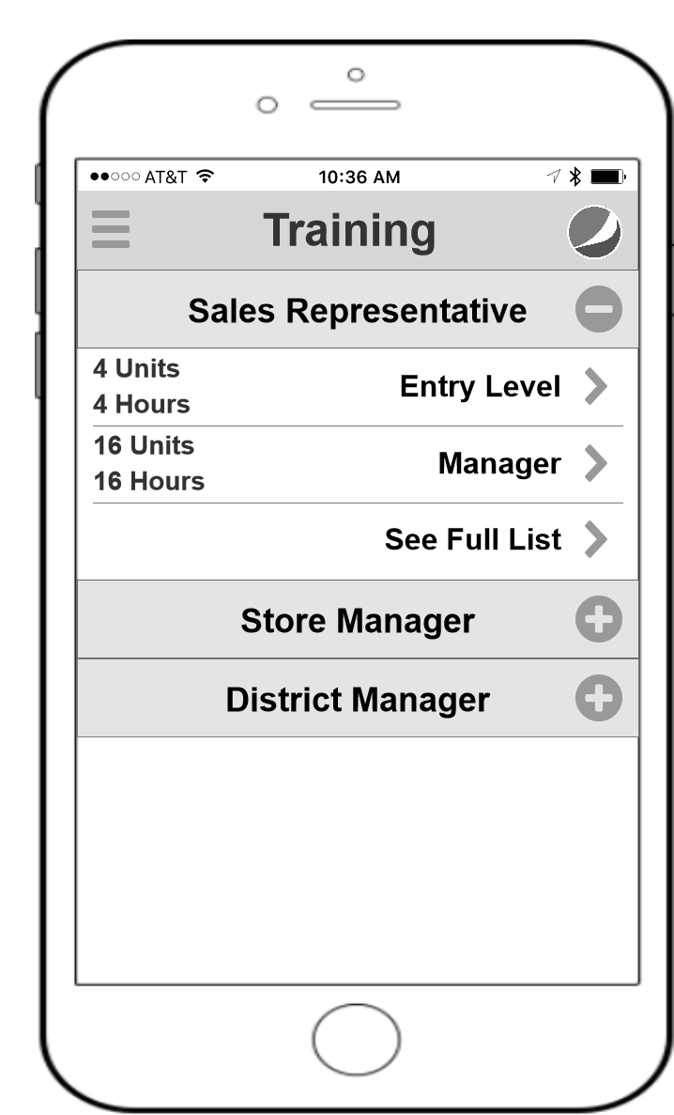
  - Freezer Smart Screens
    - User Interface
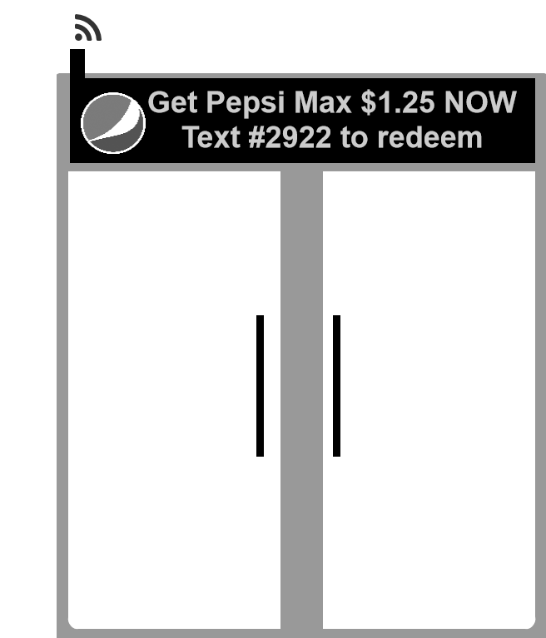

- Masters
  - Master List
Search box
Dynamic search box
Search paging
  - Search box
  - Dynamic search box
  - Search paging

