Market6
Design Specifications
Faith Warren

[Type the abstract of the document here. The abstract is typically a short summary of the contents of the document. Type the abstract of the document here. The abstract is typically a short summary of the contents of the document.]
Table of Contents
[To update the table of contents, right click the message below and select Update Field (F9 on PC, ⌥⌘U on Mac).]
1. Pages 6
1.1. Page Tree 6
1.2. Sitemap 7
1.2.1. User Interface 7
1.3. Log In 8
1.3.1. User Interface 8
1.4. Log In > Design 9
1.5. Log In > Copy 10
1.5.1. User Interface 10
1.6. Log In > Spacing 11
1.6.1. User Interface 11
1.7. Dashboard 12
1.7.1. User Interface 12
1.8. Dashboard > Selected 13
1.8.1. User Interface 13
1.9. Dashboard > Copy 14
1.9.1. User Interface 14
1.10. Dashboard > Unselected 15
1.10.1. User Interface 15
1.11. Dashboard > Spacing 16
1.11.1. User Interface 16
1.12. Library 17
1.12.1. User Interface 17
1.13. Library Report Closed 18
1.13.1. User Interface 18
1.14. Library > Spacing 19
1.14.1. User Interface 19
1.15. Library > Copy 20
1.15.1. User Interface 20
1.16. Library > Recent Reports 21
1.16.1. User Interface 21
1.17. Library > Report Library > Spacing 22
1.17.1. User Interface 22
1.18. Library > Report Library > Copy 23
1.18.1. User Interface 23
1.19. Library > Saved Reports 24
1.19.1. User Interface 24
1.20. Library > Saved Reports > Copy 25
1.20.1. User Interface 25
1.21. Library > Saved Reports > Spacing 26
1.21.1. User Interface 26
1.22. Library > Report Library 27
1.22.1. User Interface 27
1.23. Library > Report Library > Copy 28
1.23.1. User Interface 28
1.24. Library > Recent Reports > Copy 29
1.24.1. User Interface 29
1.25. Scorecard 30
1.25.1. User Interface 30
1.26. Scorecard > Spacing 31
1.26.1. User Interface 31
1.27. Scorecard > Copy 32
1.27.1. User Interface 32
1.28. Scorecard > Geography Popup 33
1.28.1. User Interface 33
1.29. Scorecard > Geography Popup > Copy 34
1.29.1. User Interface 34
1.30. Scorecard > Geography Popup > Selected 35
1.30.1. User Interface 35
1.31. Scorecard > Geography Popup > Unselected 36
1.31.1. User Interface 36
1.32. Scorecard > Open Caalendar Popup 37
1.32.1. User Interface 37
1.33. Scorecard > Open Calendar Pop Up > Selected > Copy 38
1.33.1. User Interface 38
1.34. Scorecard > Open Calendar Pop Up > Selected > Spacing 39
1.34.1. User Interface 39
1.35. Scorecard > Product Popup > Spacing 40
1.35.1. User Interface 40
1.36. Scorecard > Product Popup > Selected > Spacing 41
1.36.1. User Interface 41
1.37. Scorecard > Vendor > Popup > Inactive 42
1.37.1. User Interface 42
1.38. Scorecard > Vendor > Popup > Selected 43
1.38.1. User Interface 43
1.39. Scorecard > Vendor > Popup > Selected > Copy 44
1.39.1. User Interface 44
1.40. Scorecard > Vendor > Popup > Selected > Spacing 45
1.40.1. User Interface 45
1.41. Input & Selectors 46
1.41.1. User Interface 46
1.42. Spacing for Input & Selectors 47
1.42.1. User Interface 47
1.43. Icons & Button PNG Files 48
1.43.1. User Interface 48
1.44. Design Notes 49
1.44.1. User Interface 49
1.45. Errors, Alerts & Grids 50
1.45.1. User Interface 50
1.45.2. All Vendors 51
1.45.2.1. Collapsed 51
1.45.2.2. User Interface 51
1.45.2.3. P&G Quarters Expanded 51
1.45.2.4. User Interface 51
1.45.2.5. P&G Periods Expanded 52
1.45.2.6. User Interface 52
1.45.2.7. P&G Weeks Expanded 53
1.45.2.8. User Interface 53
1.45.3. Unnamed 54
1.45.3.1. State1 54
1.45.3.2. User Interface 54
2. Masters 55
2.1. Master List 55
2.2. Footer 56
2.2.1. User Interface 56

- Pages
  - Page Tree
Sitemap
Log In
Log In > Design
Log In > Copy
Log In > Spacing
Dashboard
Dashboard > Selected
Dashboard > Copy
Dashboard > Unselected
Dashboard > Spacing
Library
Library Report Closed
Library > Spacing
Library > Copy
Library > Recent Reports
Library > Report Library > Spacing
Library > Report Library > Copy
Library > Saved Reports
Library > Saved Reports > Copy
Library > Saved Reports > Spacing
Library > Report Library
Library > Report Library > Copy
Library > Recent Reports > Copy
Scorecard
Scorecard > Spacing
Scorecard > Copy
Scorecard > Geography Popup
Scorecard > Geography Popup > Copy
Scorecard > Geography Popup > Selected
Scorecard > Geography Popup > Unselected
Scorecard > Open Caalendar Popup
Scorecard > Open Calendar Pop Up > Selected > Copy
Scorecard > Open Calendar Pop Up > Selected > Spacing
Scorecard > Product Popup > Spacing
Scorecard > Product Popup > Selected > Spacing
Scorecard > Vendor > Popup > Inactive
Scorecard > Vendor > Popup > Selected
Scorecard > Vendor > Popup > Selected > Copy
Scorecard > Vendor > Popup > Selected > Spacing
Input & Selectors
Spacing for Input & Selectors
Icons & Button PNG Files
Design Notes
Errors, Alerts & Grids
  - Sitemap
    - User Interface
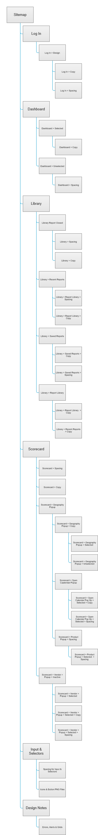
  - Log In
    - User Interface
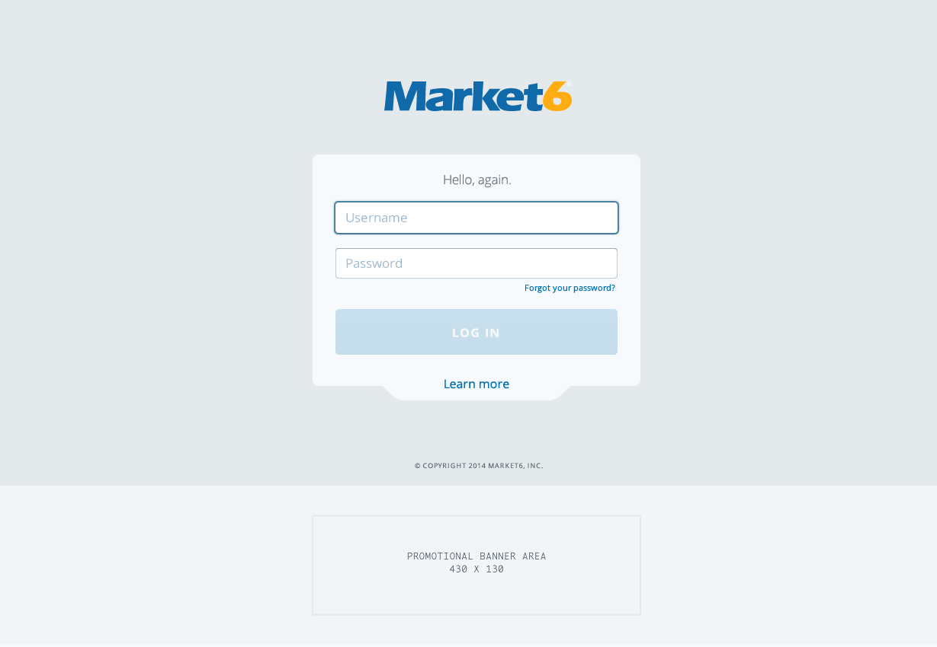
  - Log In > Design
  - Log In > Copy
    - User Interface
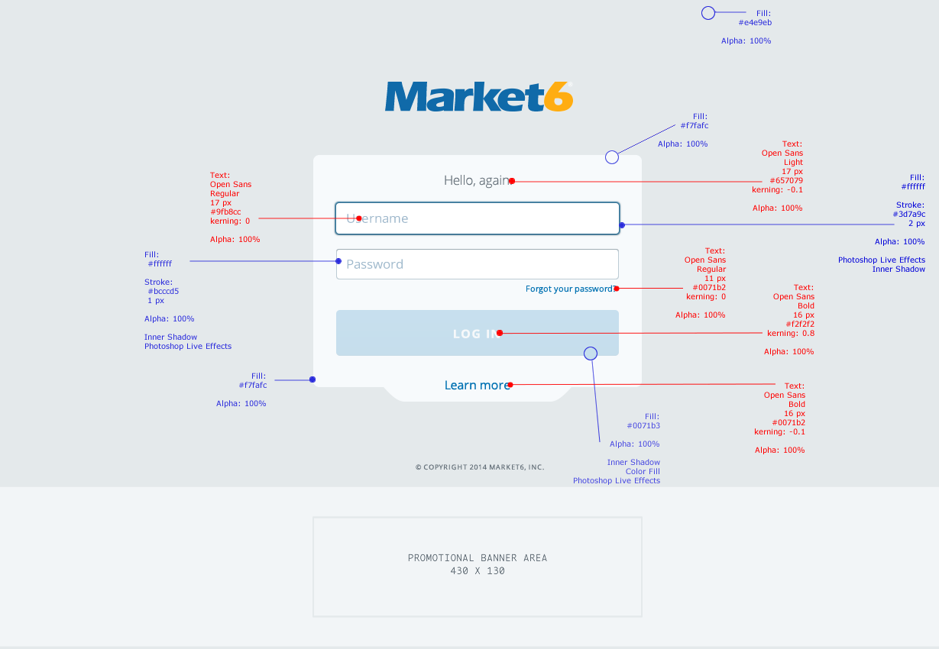
  - Log In > Spacing
    - User Interface
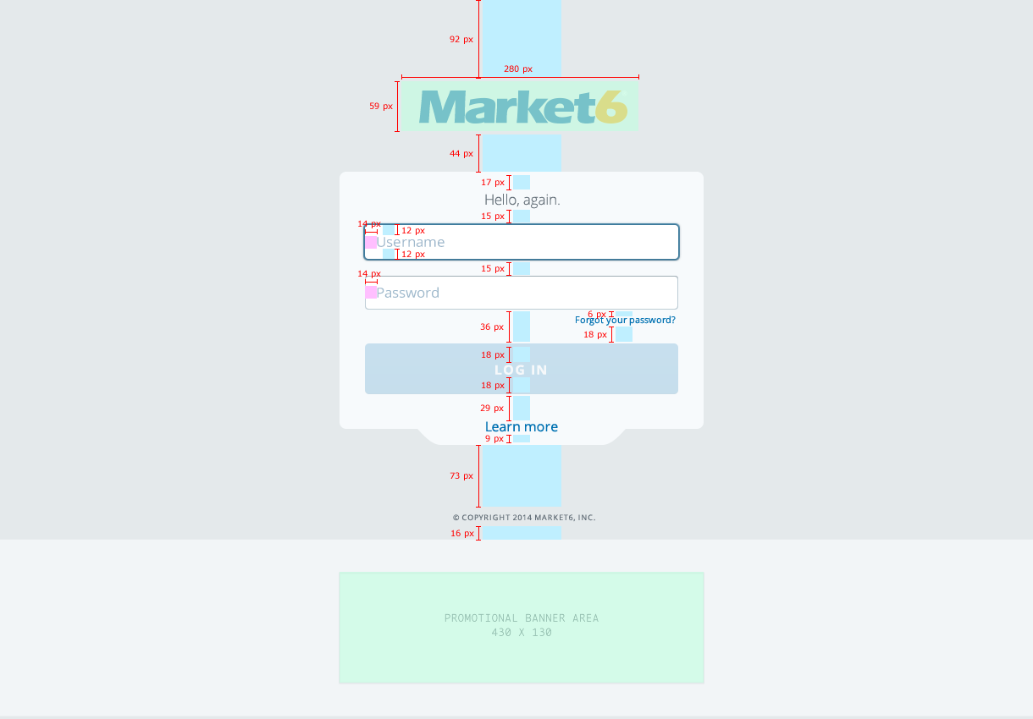
  - Dashboard
    - User Interface
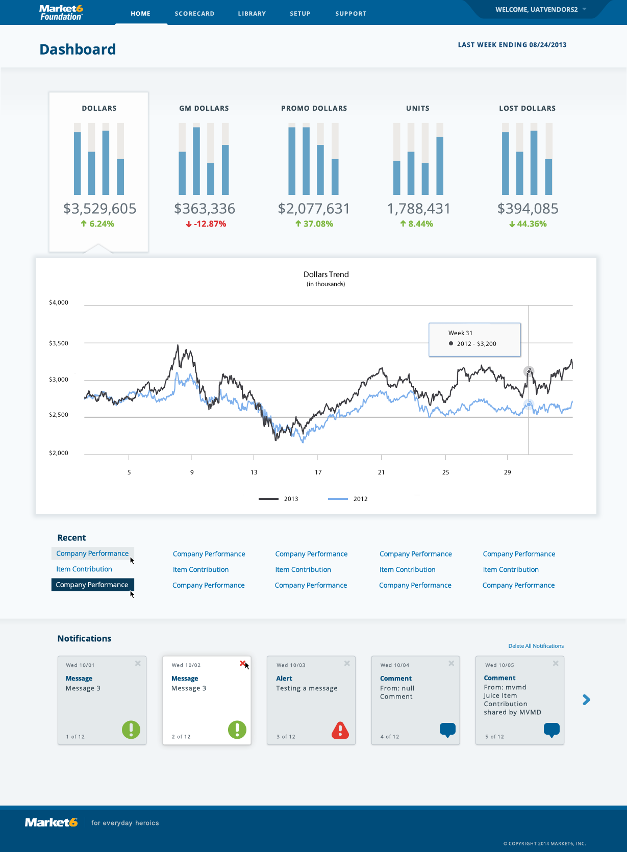
  - Dashboard > Selected
    - User Interface
  - Dashboard > Copy
    - User Interface
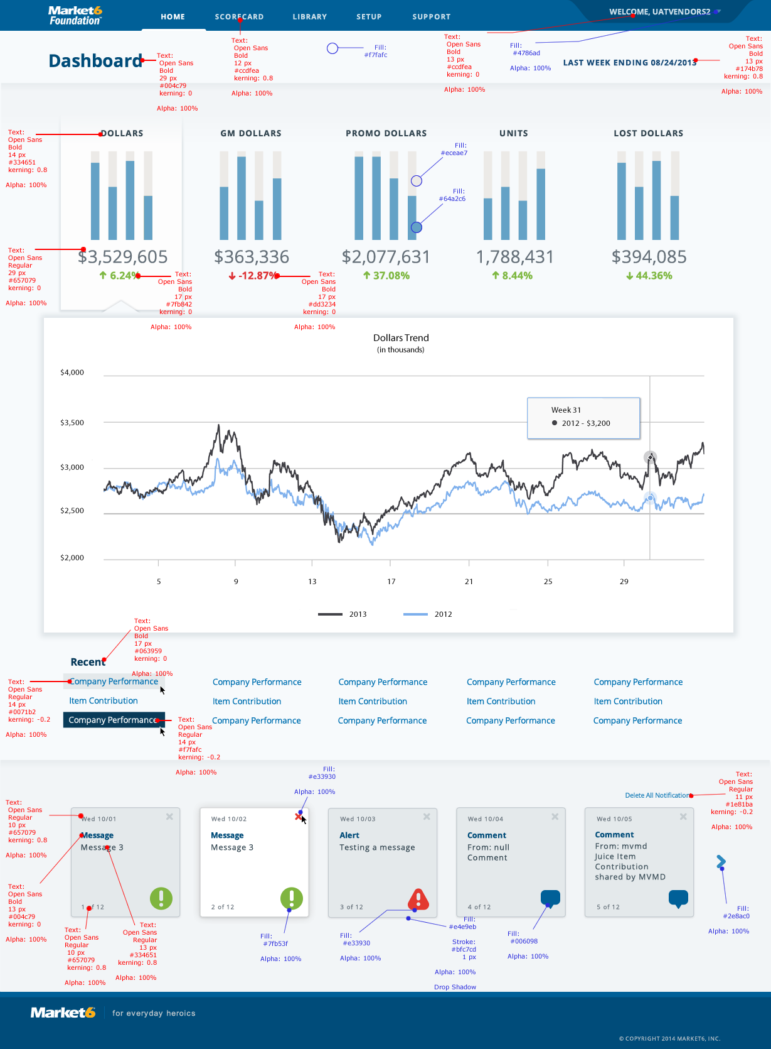
  - Dashboard > Unselected
    - User Interface
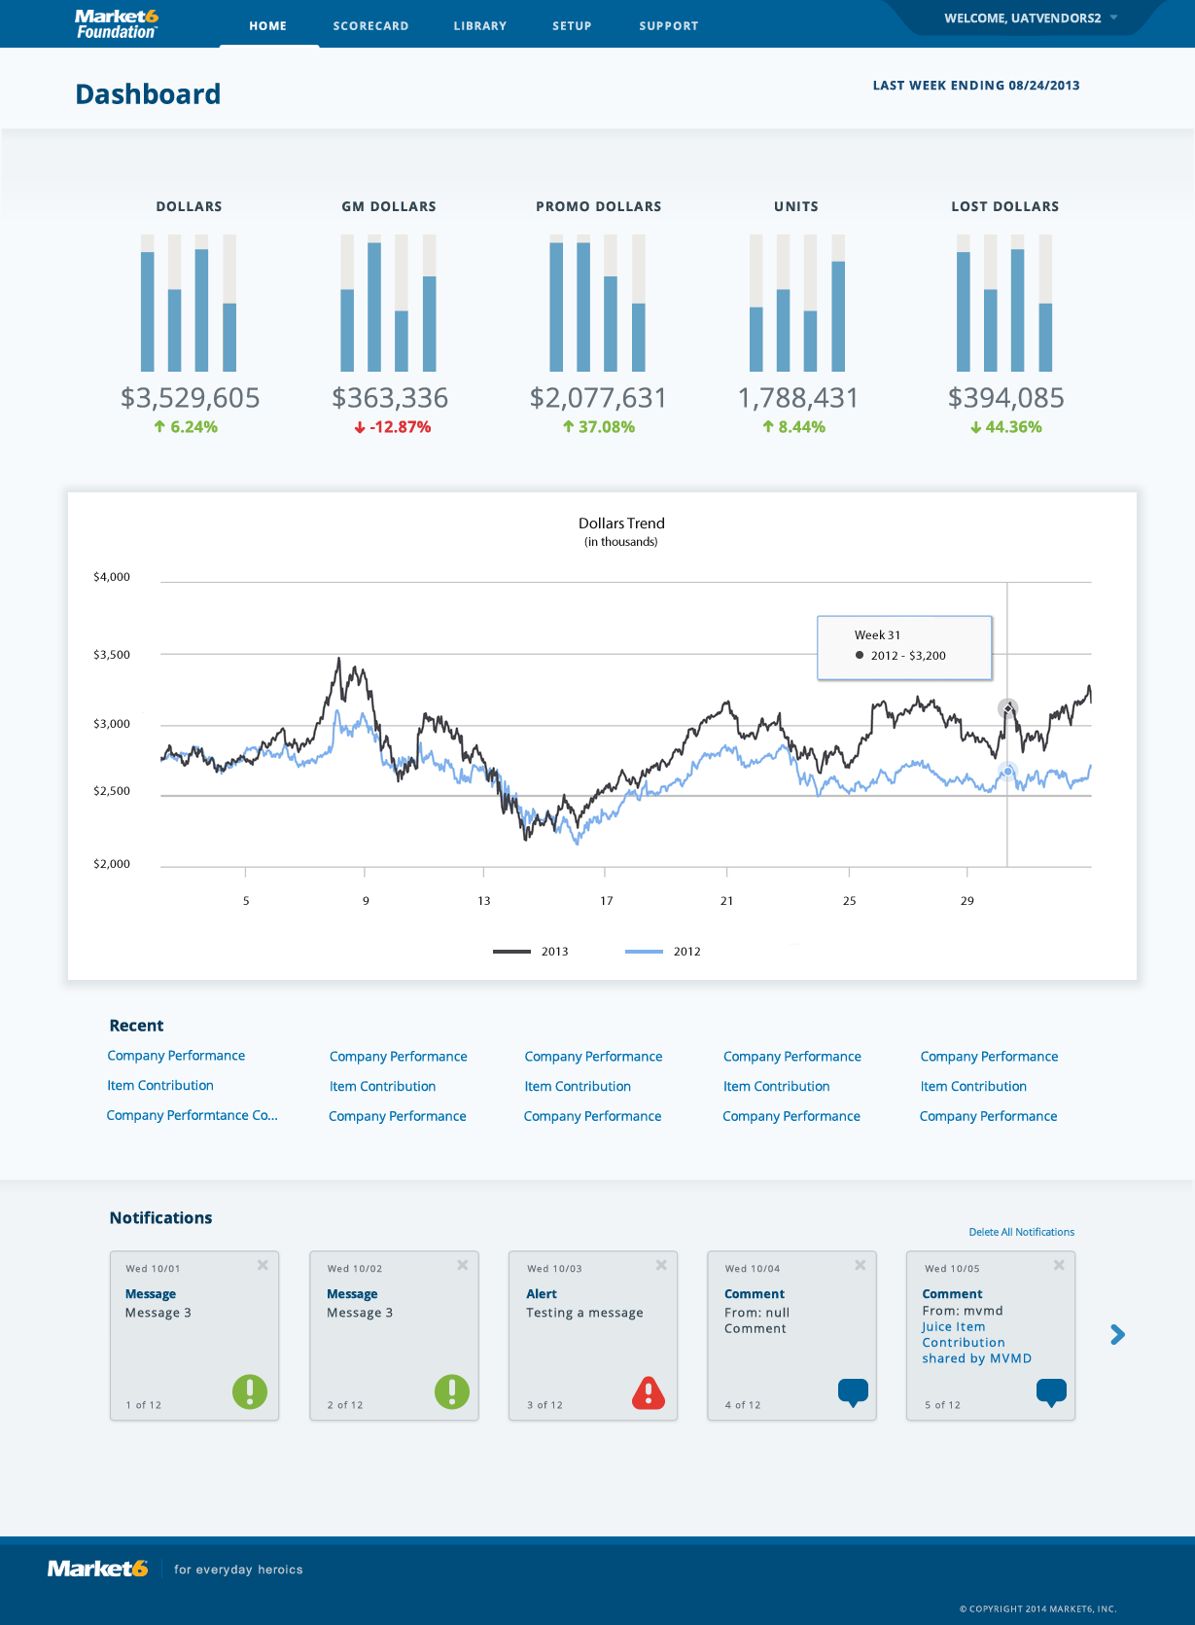
  - Dashboard > Spacing
    - User Interface
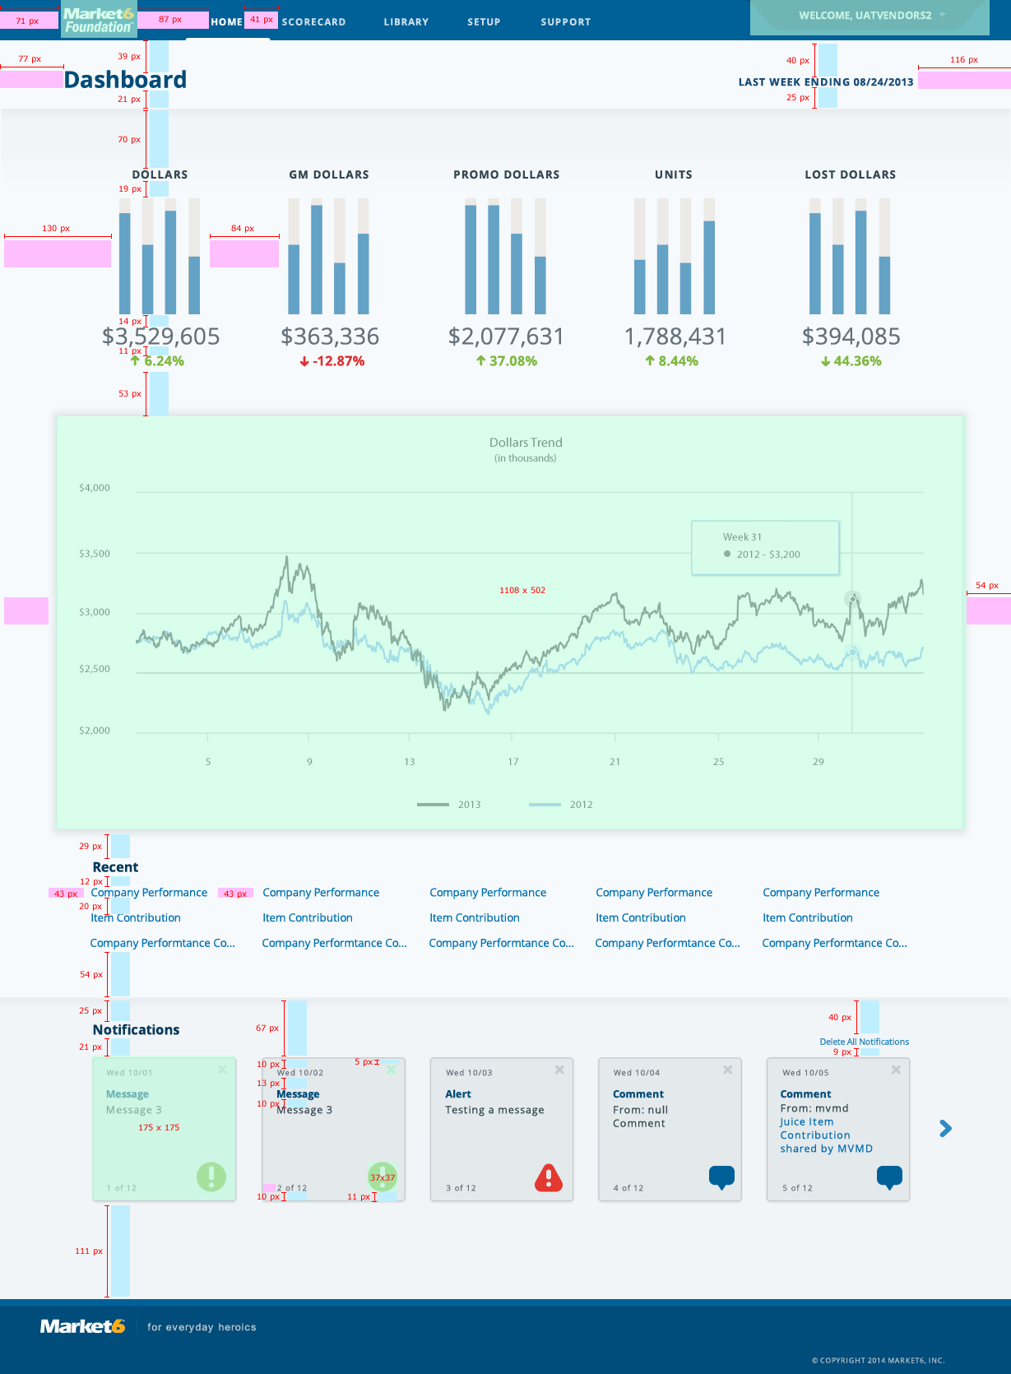
  - Library
    - User Interface
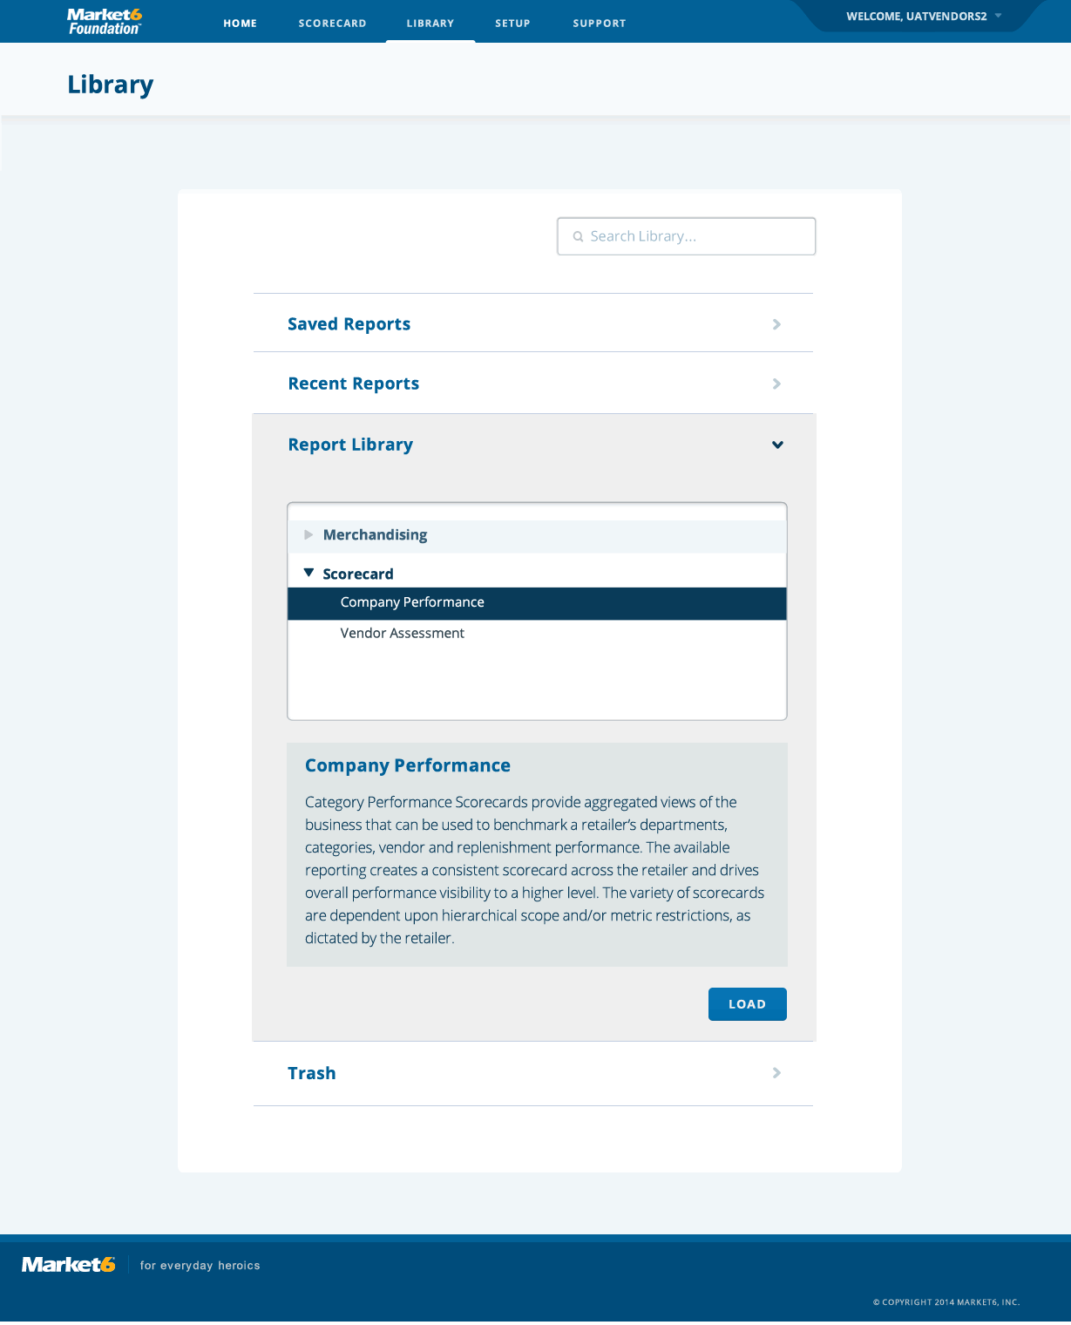
  - Library Report Closed
    - User Interface
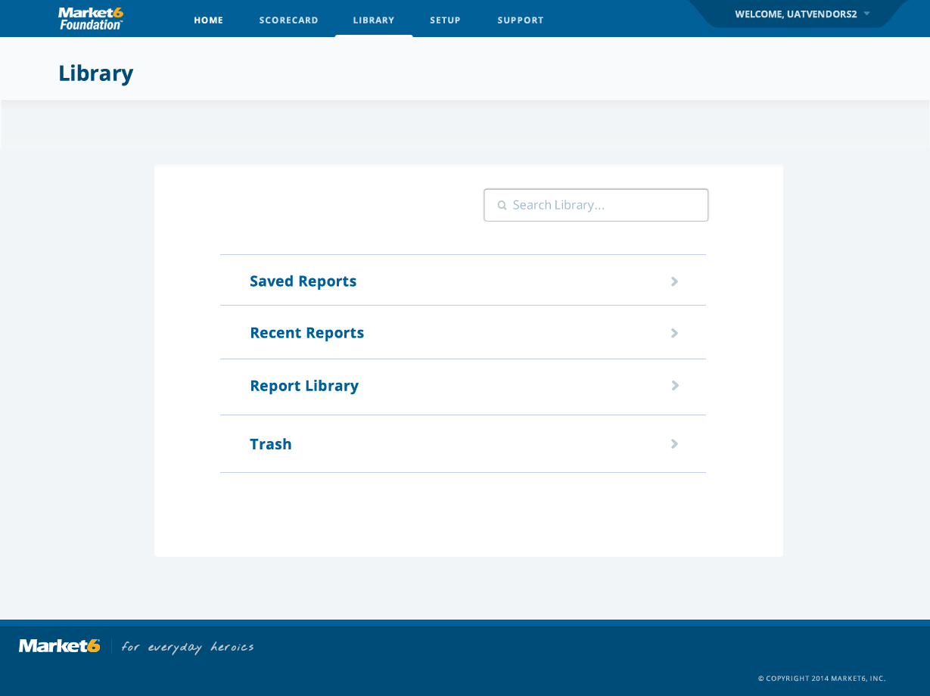
  - Library > Spacing
    - User Interface
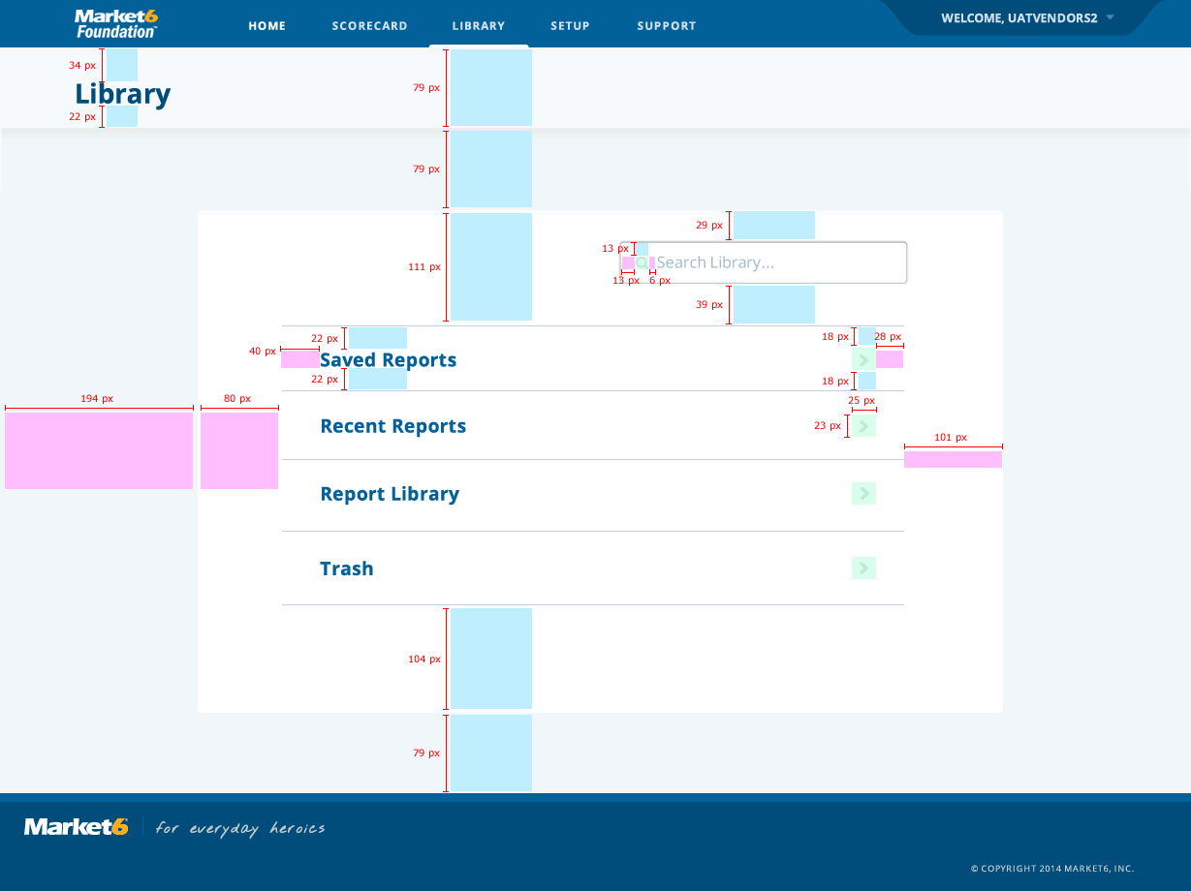
  - Library > Copy
    - User Interface
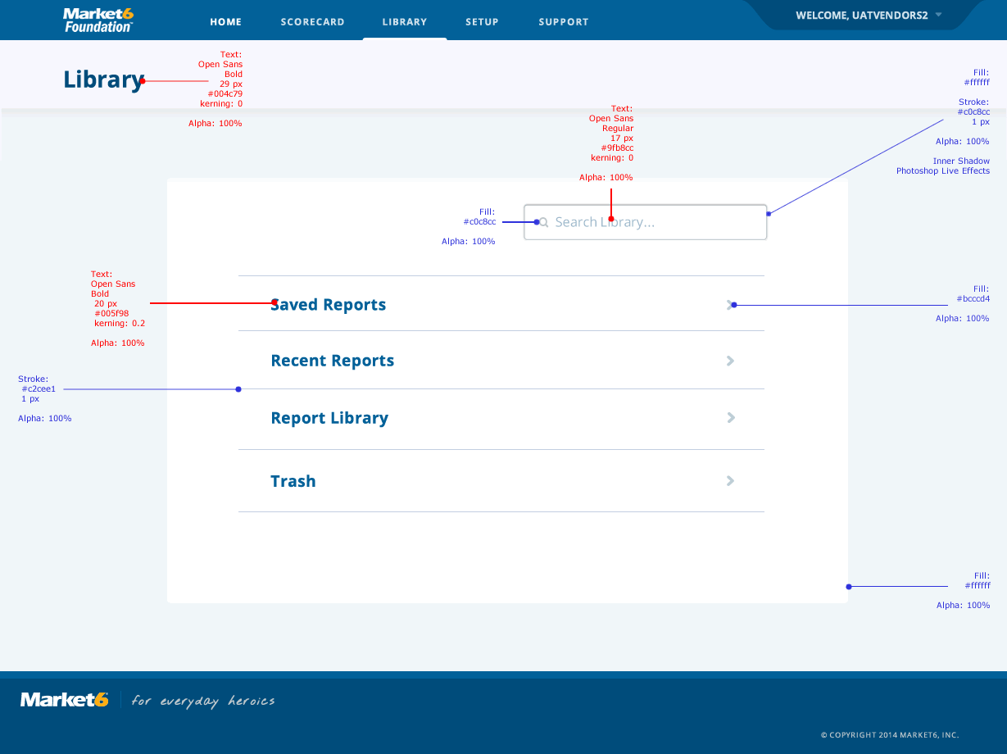
  - Library > Recent Reports
    - User Interface
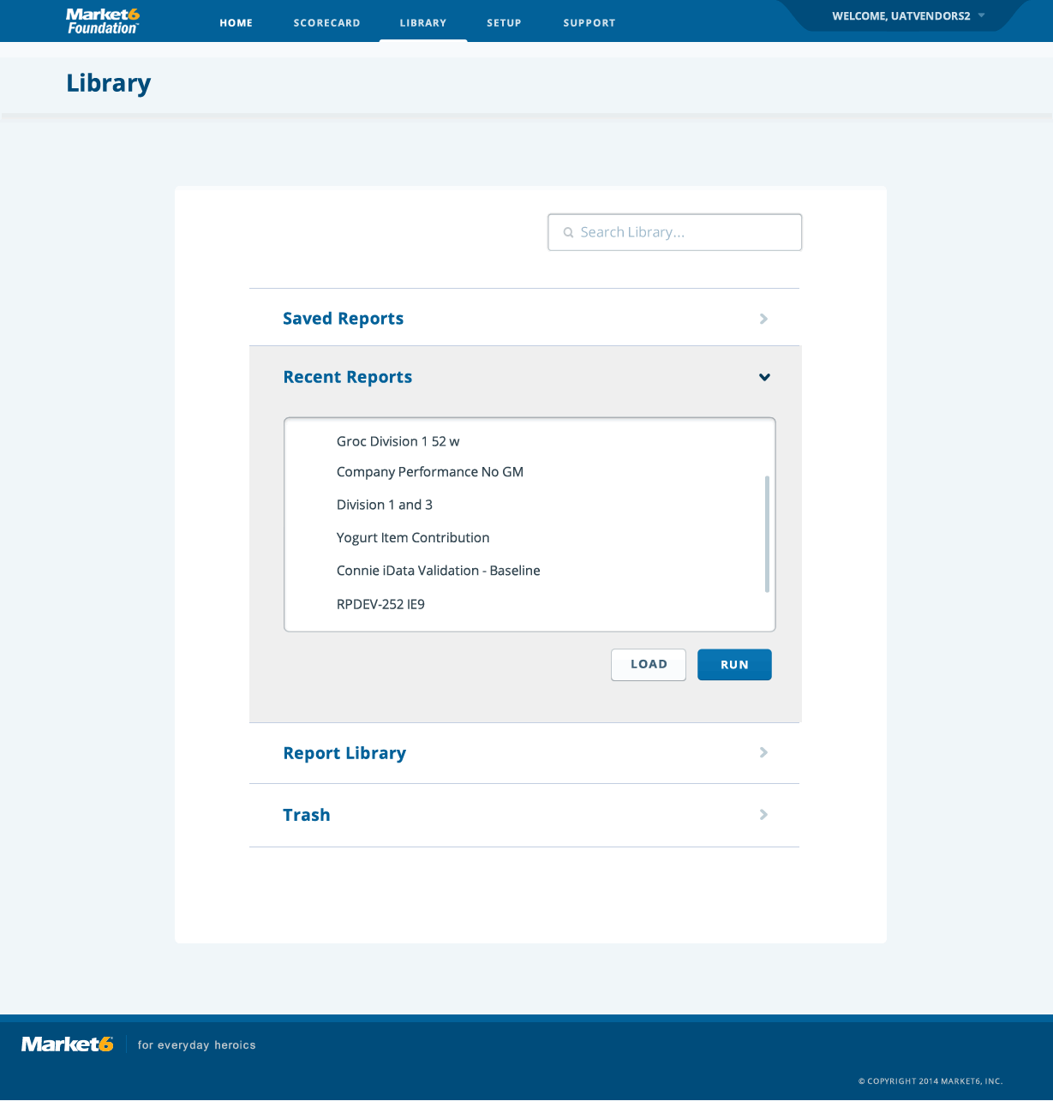
  - Library > Report Library > Spacing
    - User Interface
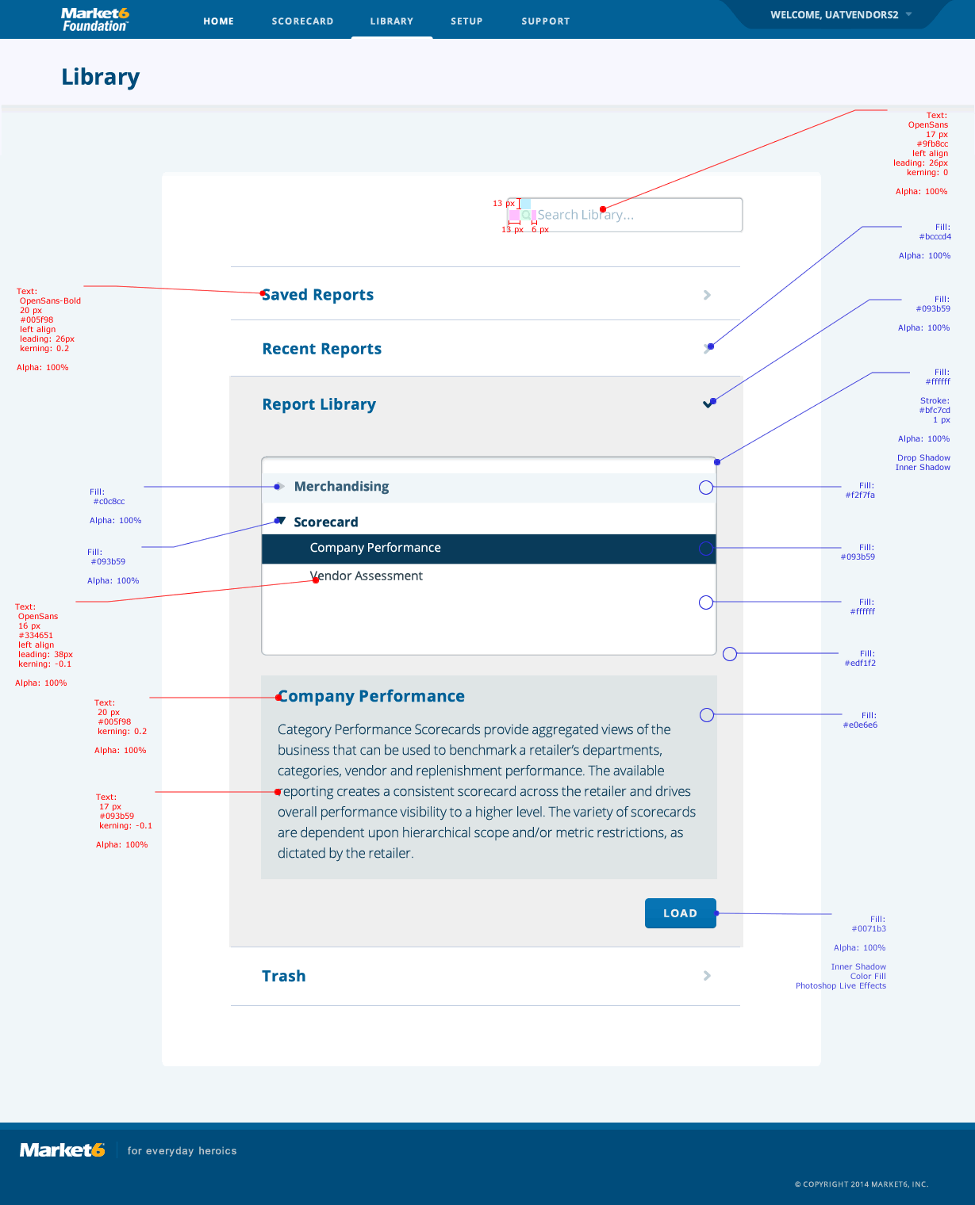
  - Library > Report Library > Copy
    - User Interface
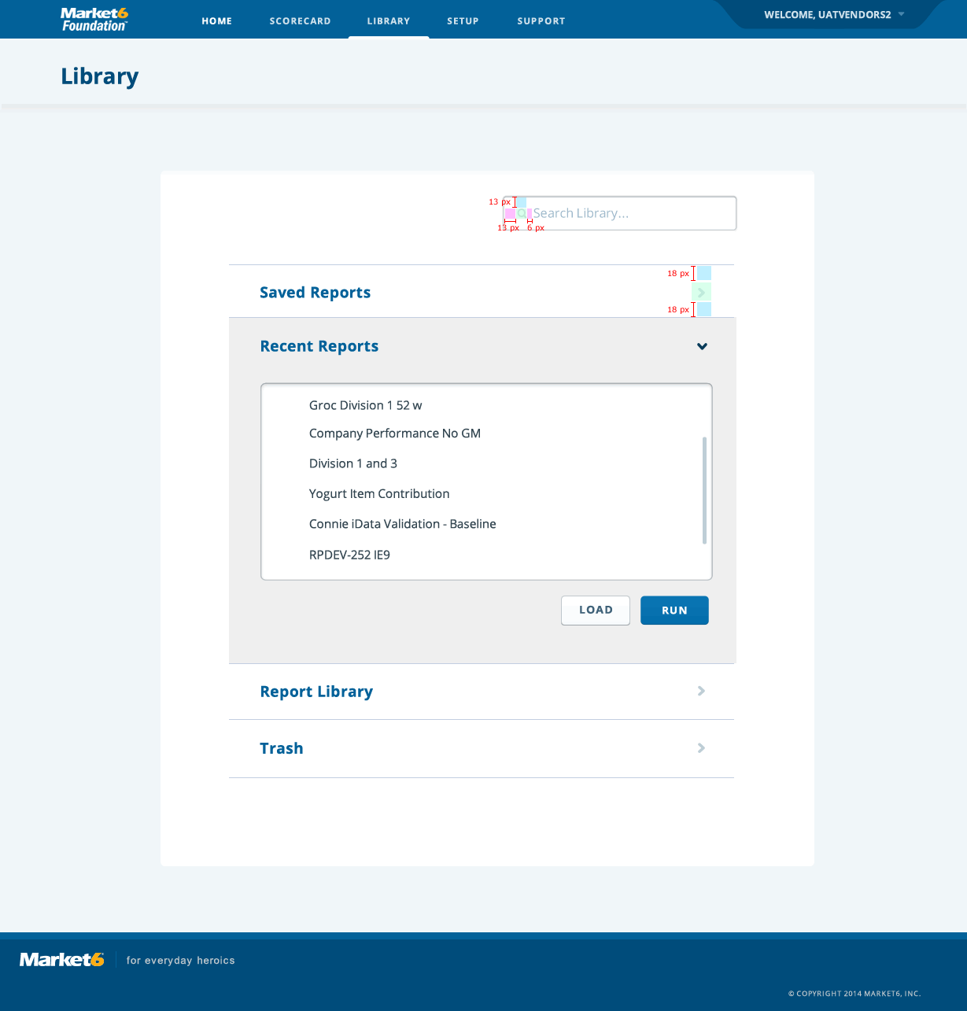
  - Library > Saved Reports
    - User Interface
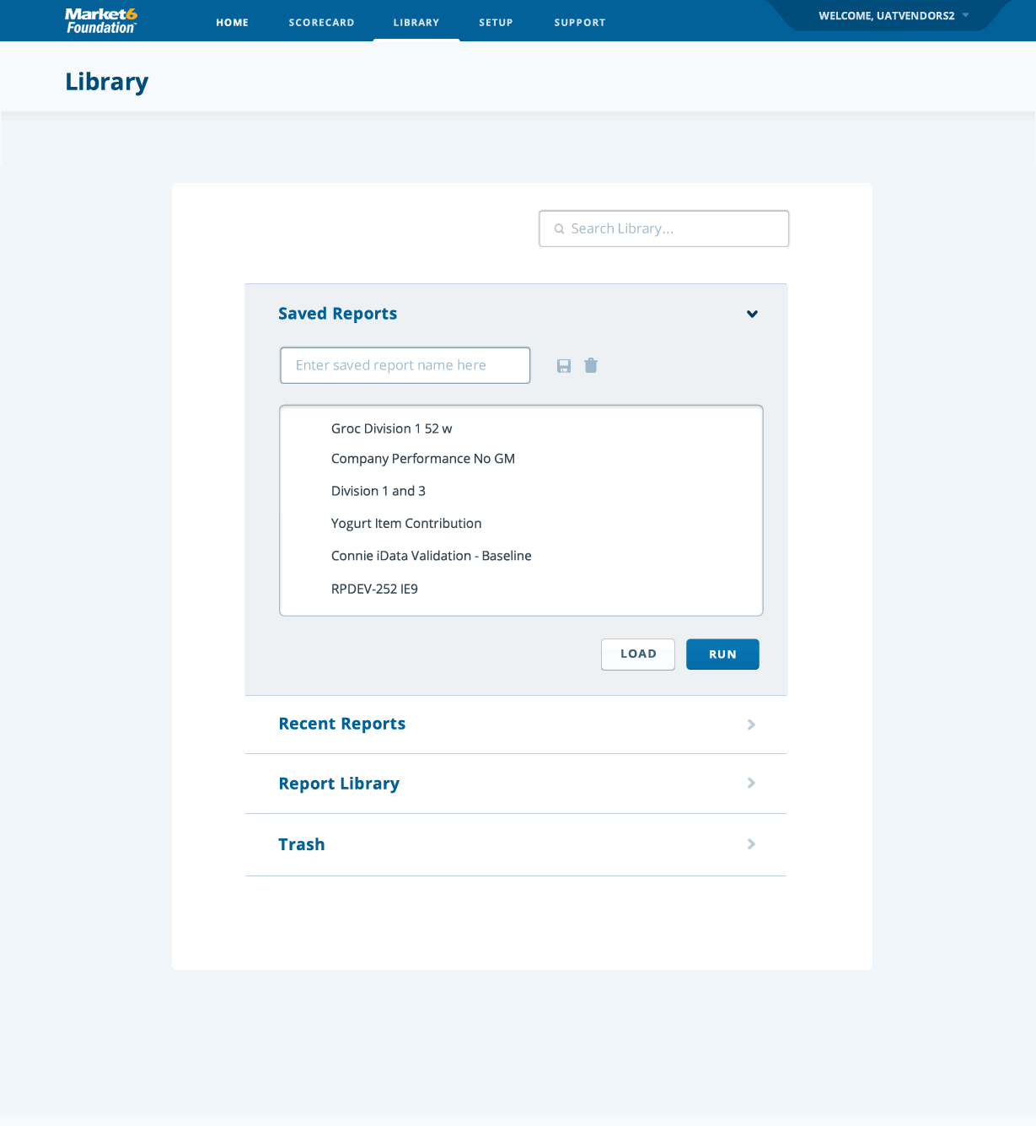
  - Library > Saved Reports > Copy
    - User Interface
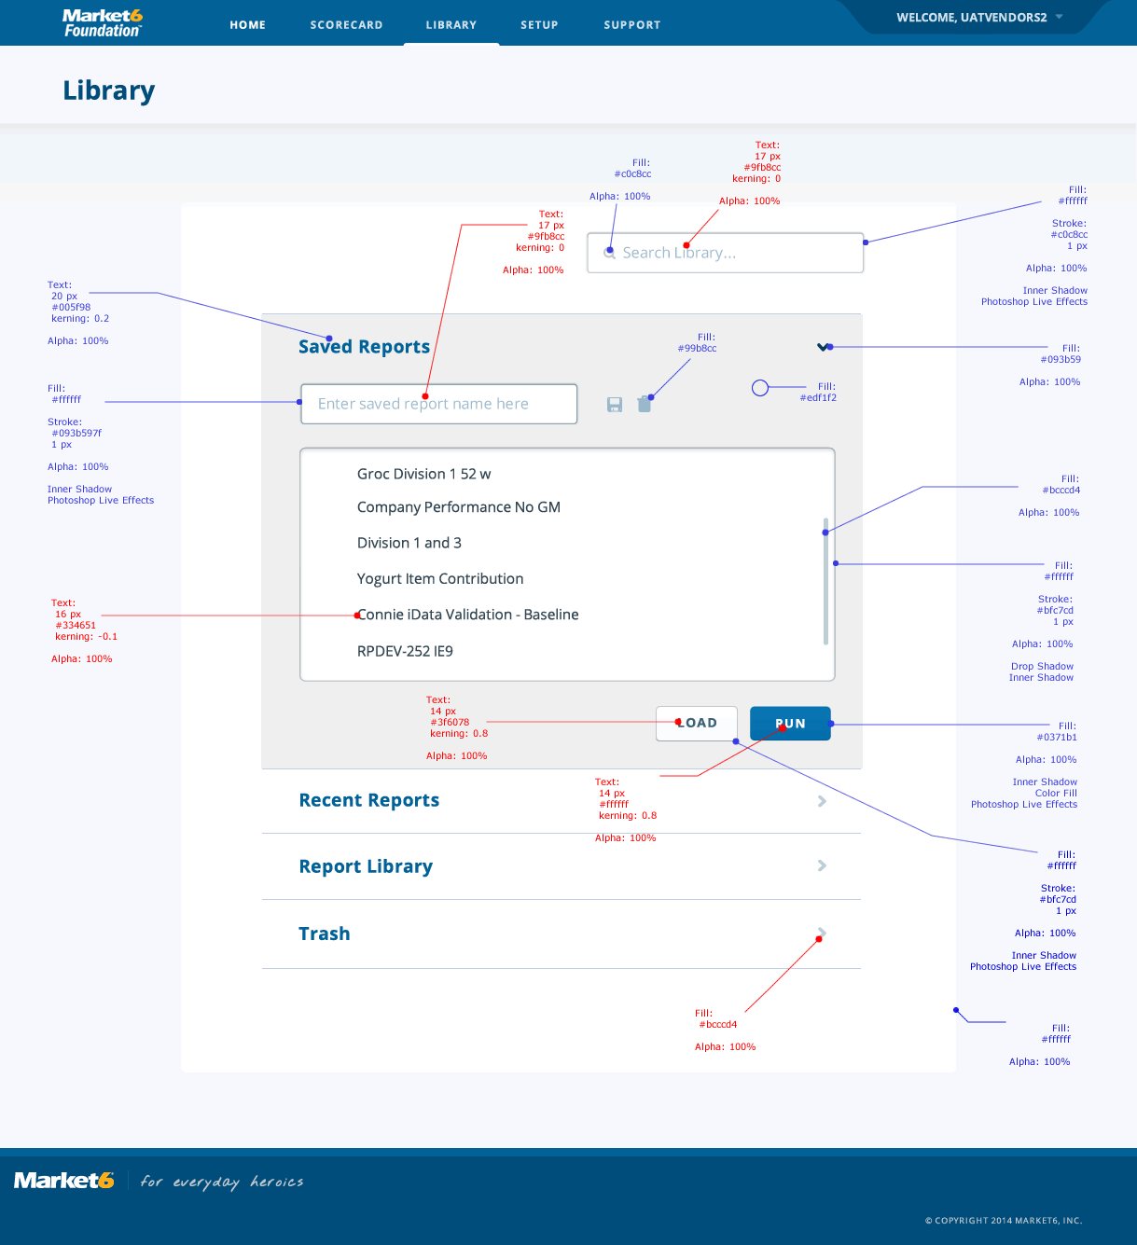
  - Library > Saved Reports > Spacing
    - User Interface
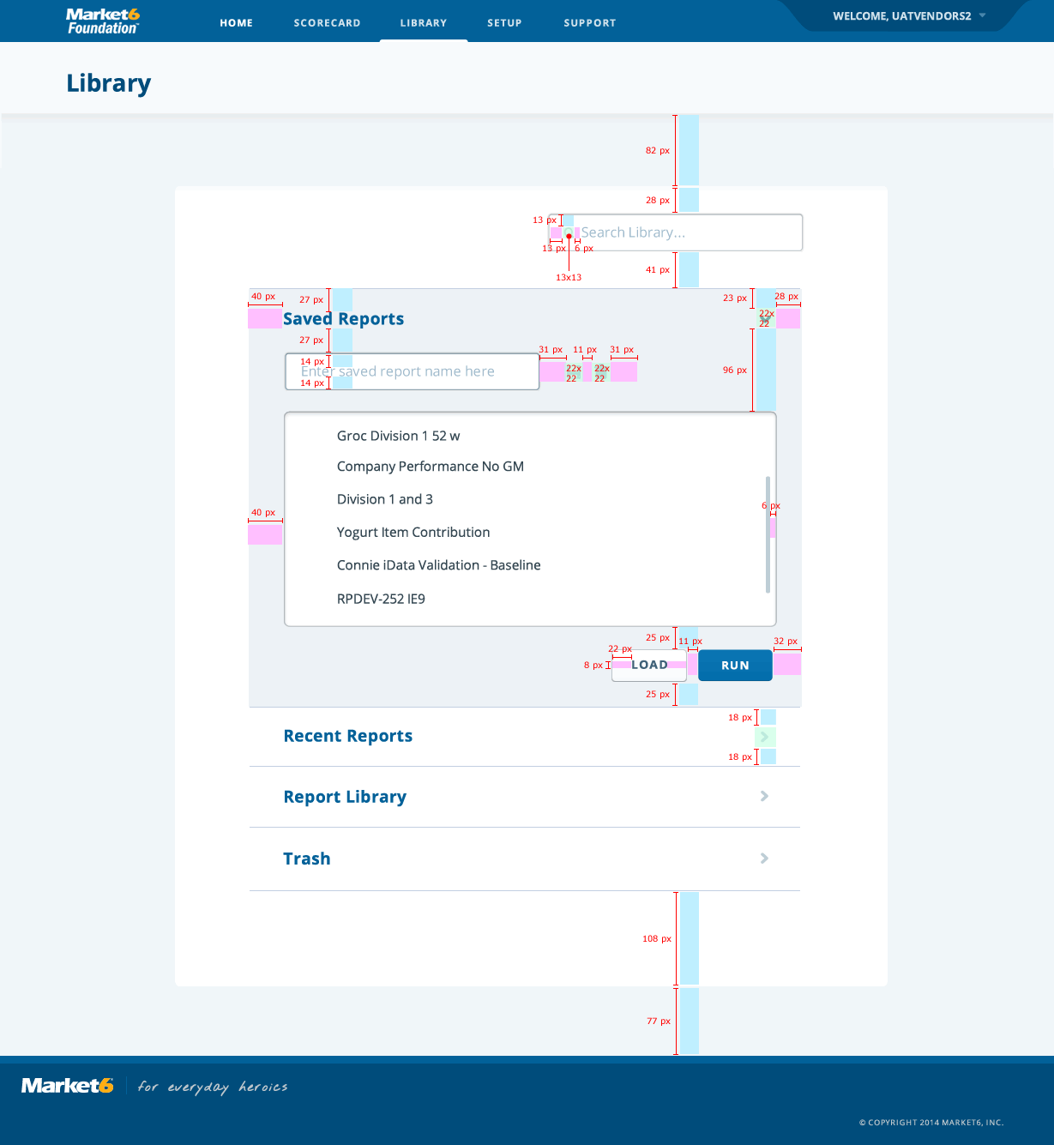
  - Library > Report Library
    - User Interface
  - Library > Report Library > Copy
    - User Interface
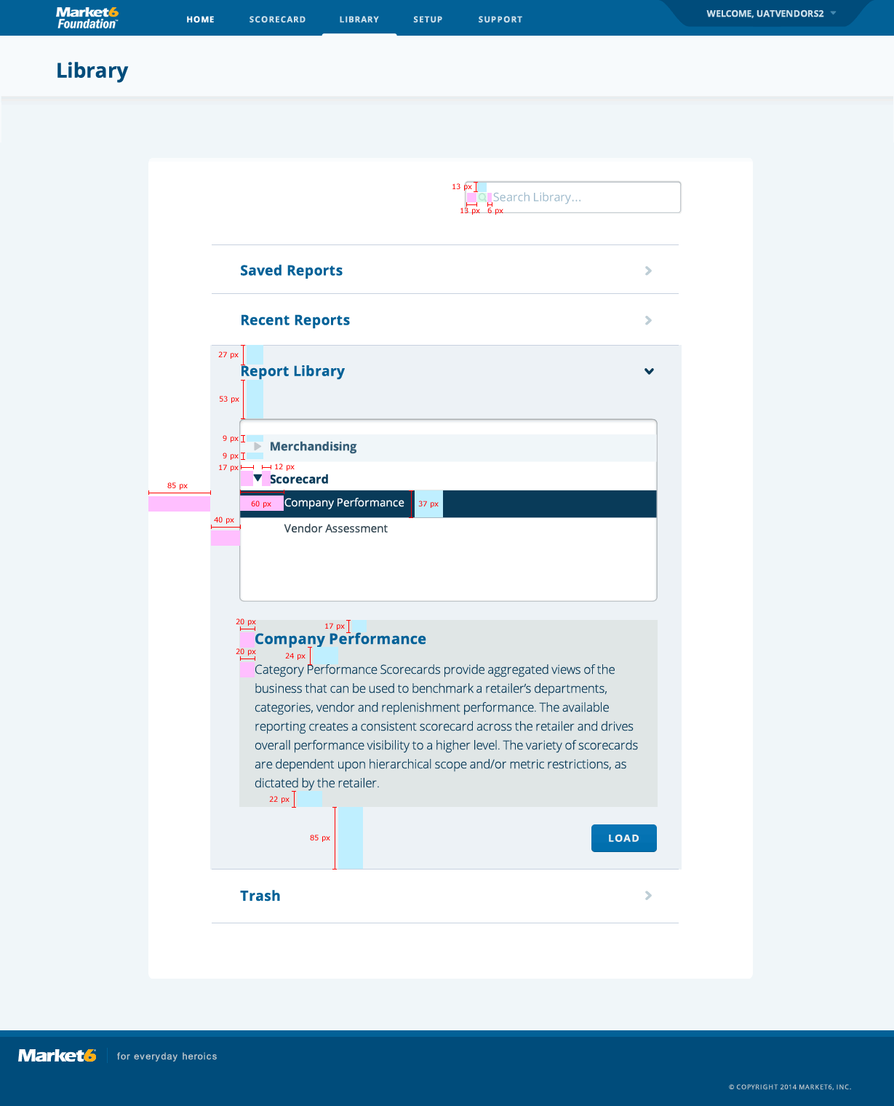
  - Library > Recent Reports > Copy
    - User Interface
  - Scorecard
    - User Interface
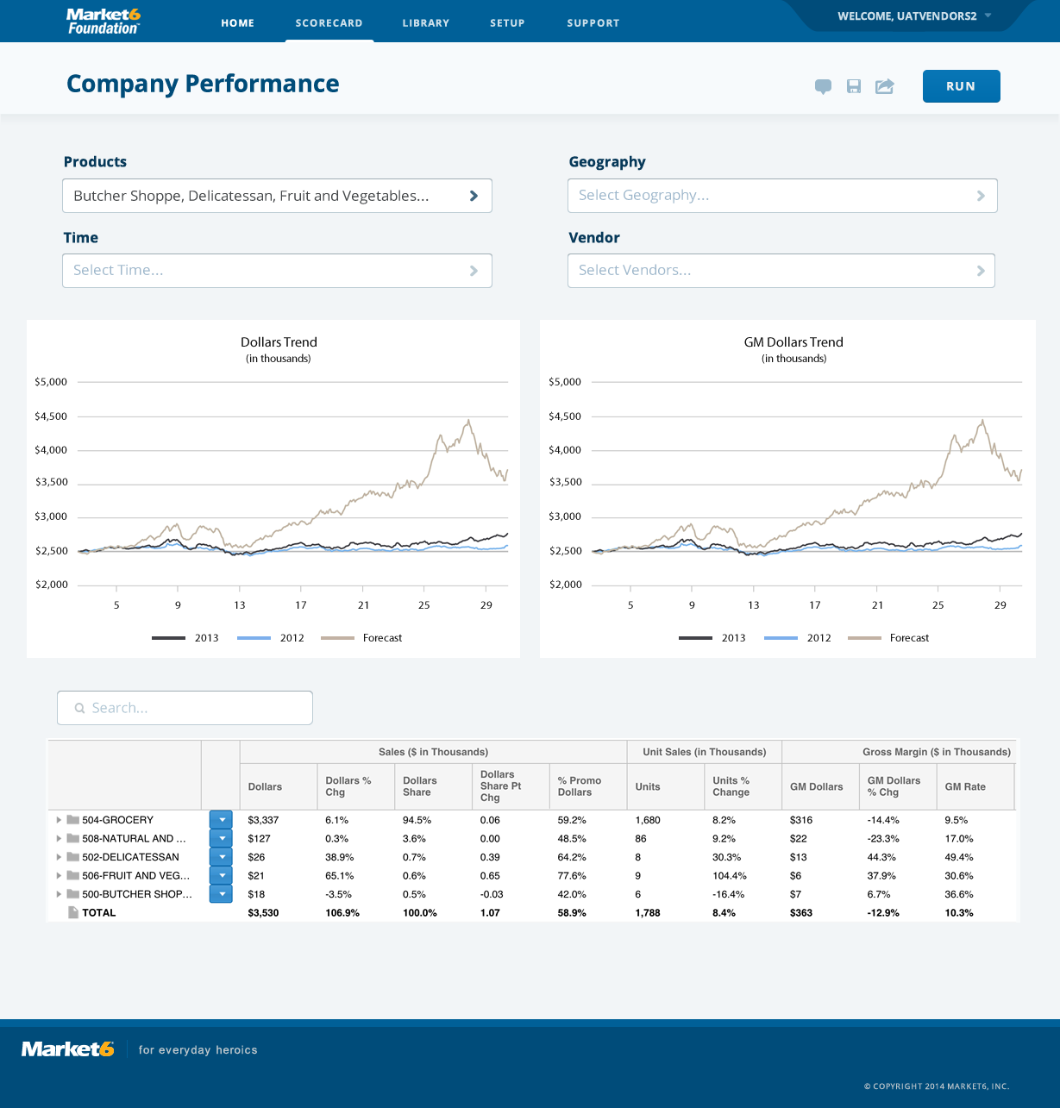
  - Scorecard > Spacing
    - User Interface
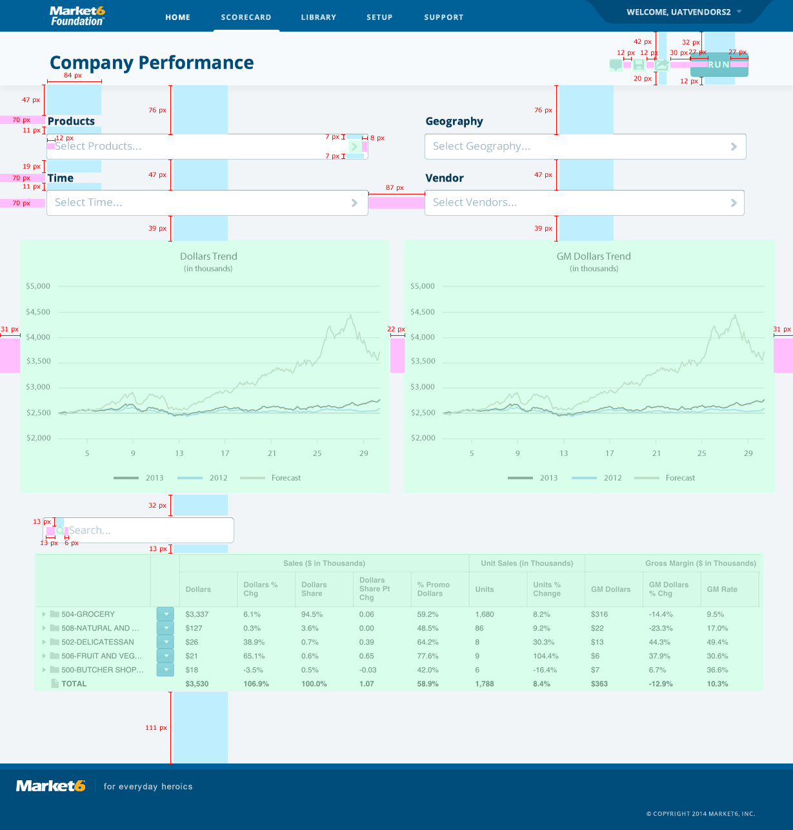
  - Scorecard > Copy
    - User Interface
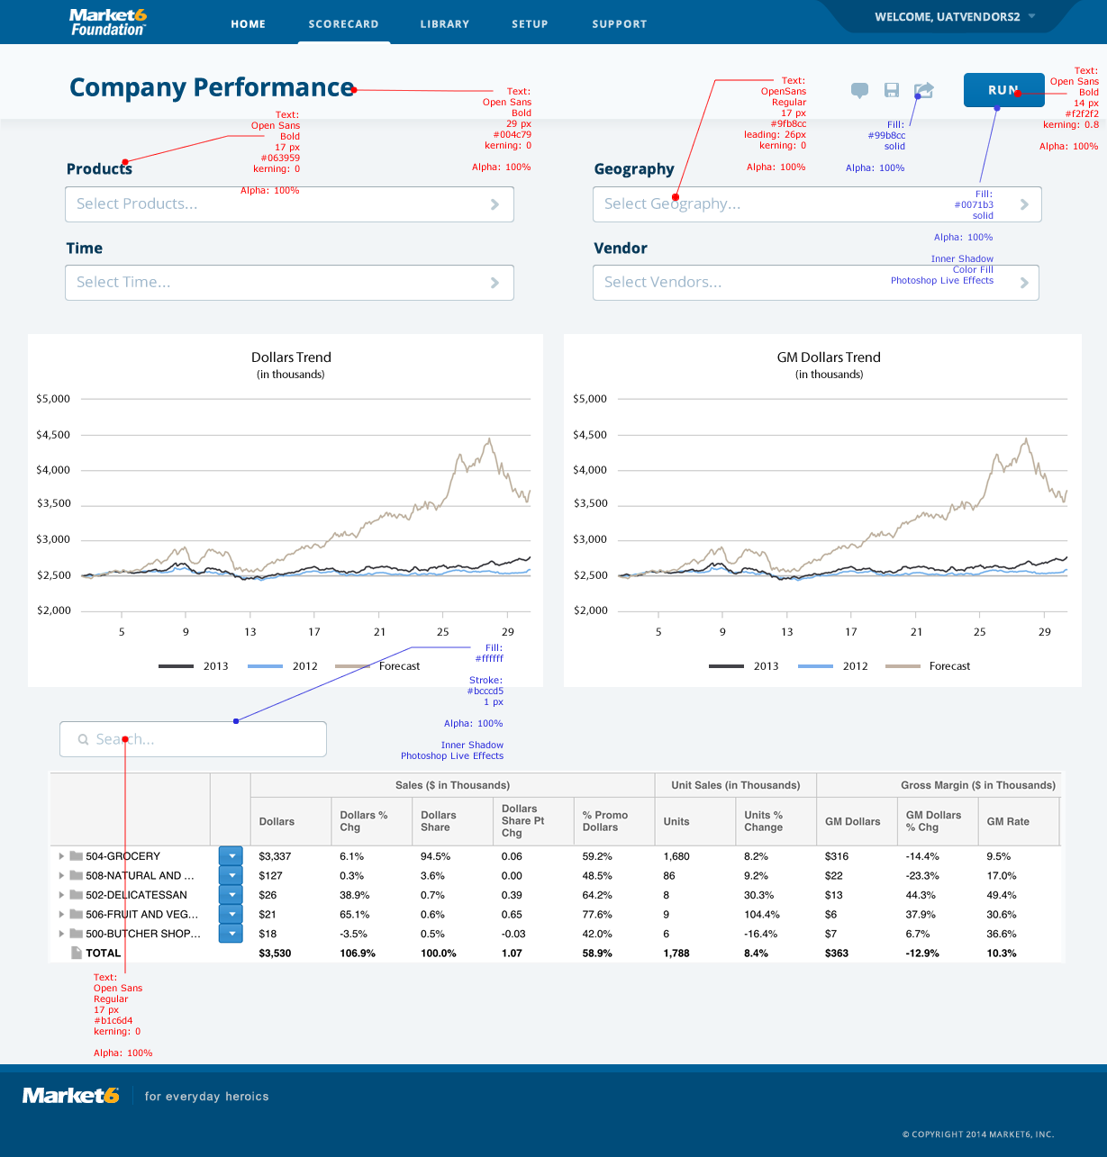
  - Scorecard > Geography Popup
    - User Interface
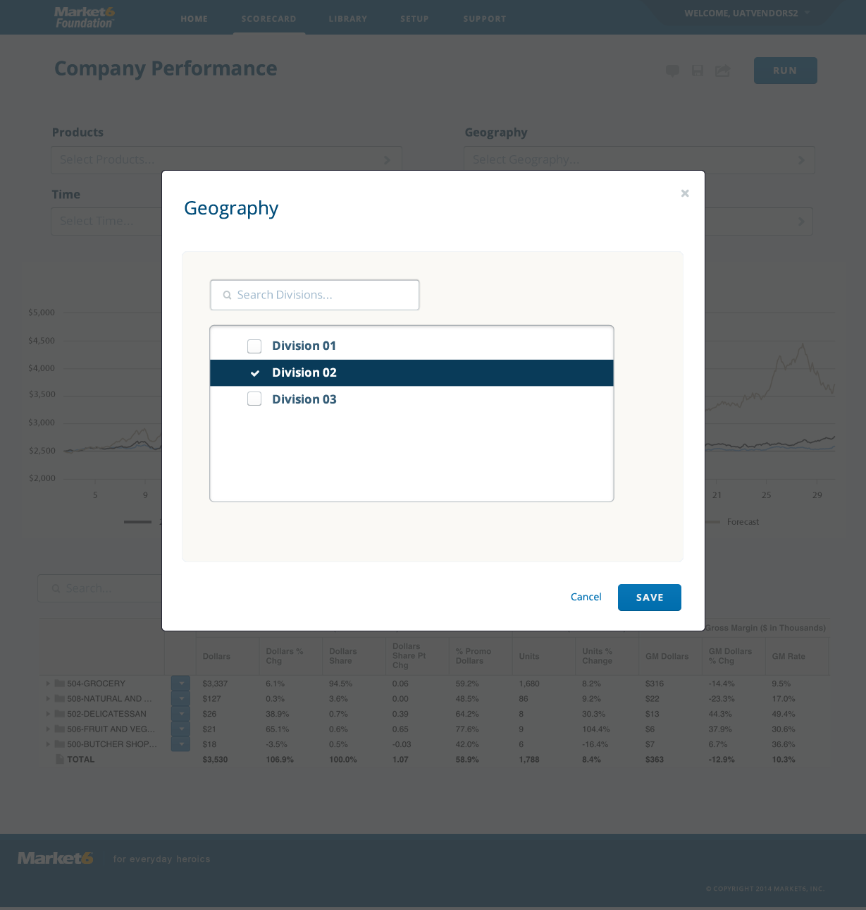
  - Scorecard > Geography Popup > Copy
    - User Interface
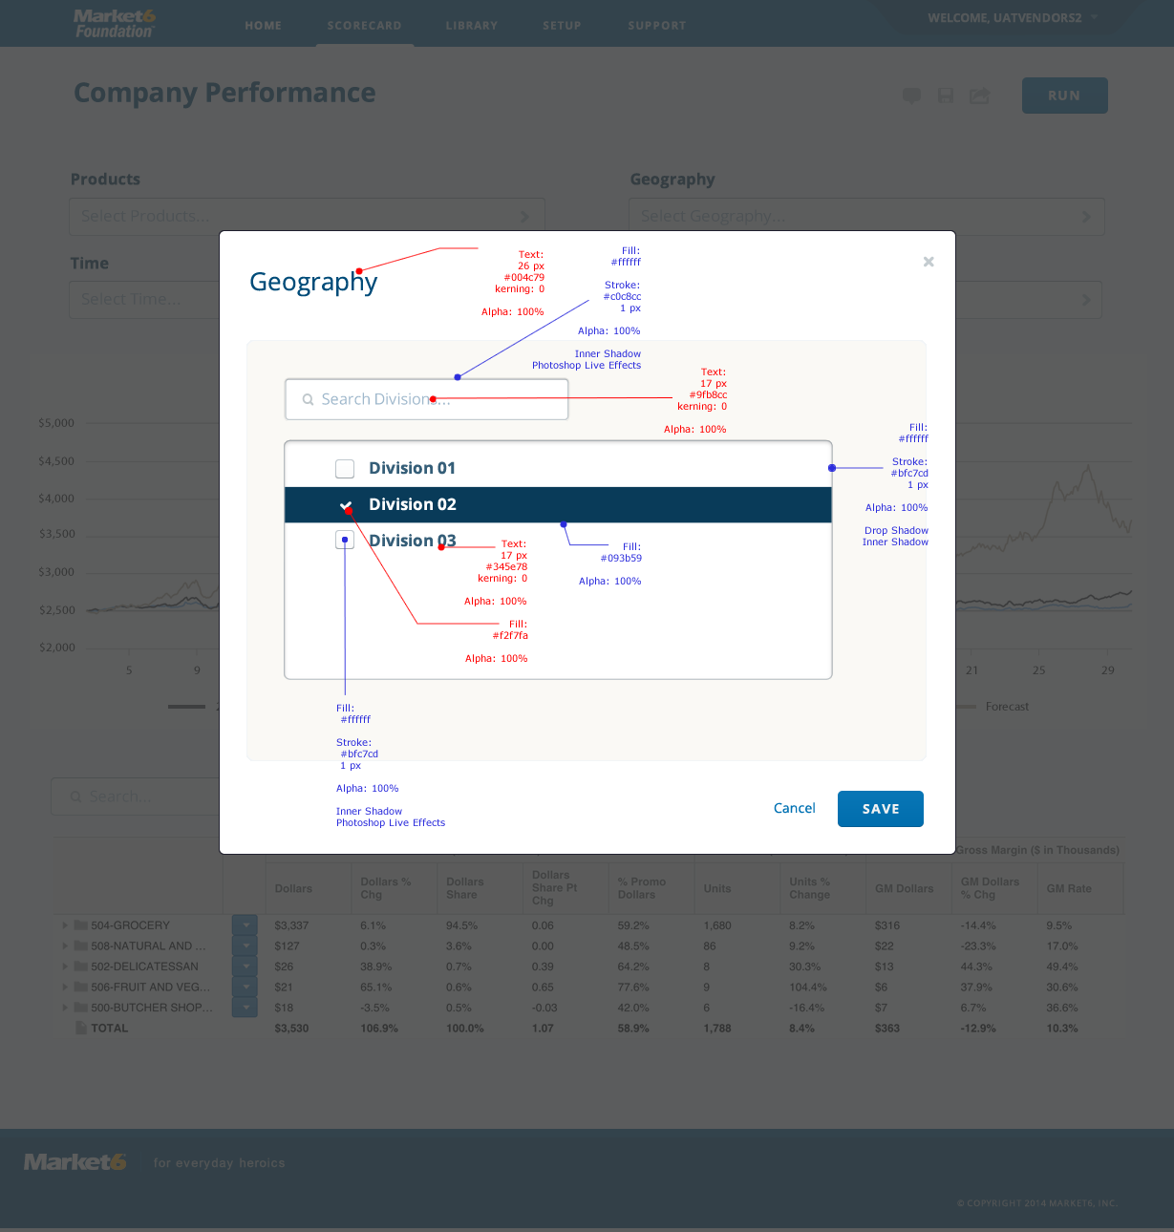
  - Scorecard > Geography Popup > Selected
    - User Interface
  - Scorecard > Geography Popup > Unselected
    - User Interface
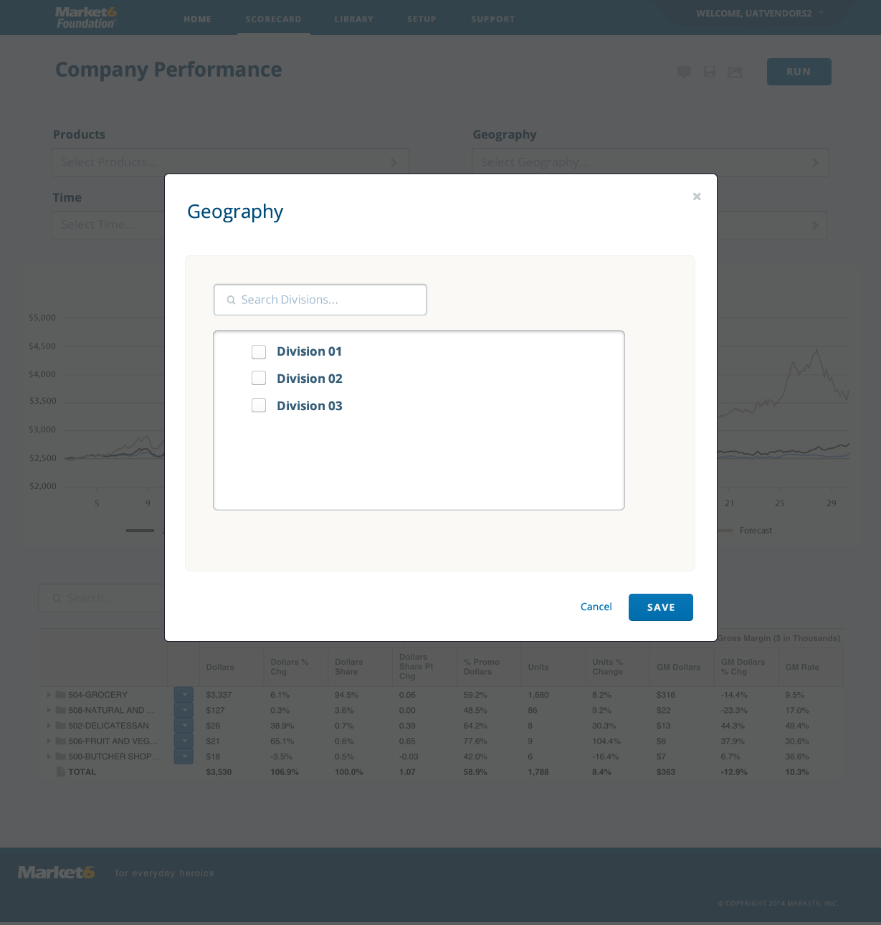
  - Scorecard > Open Caalendar Popup
    - User Interface
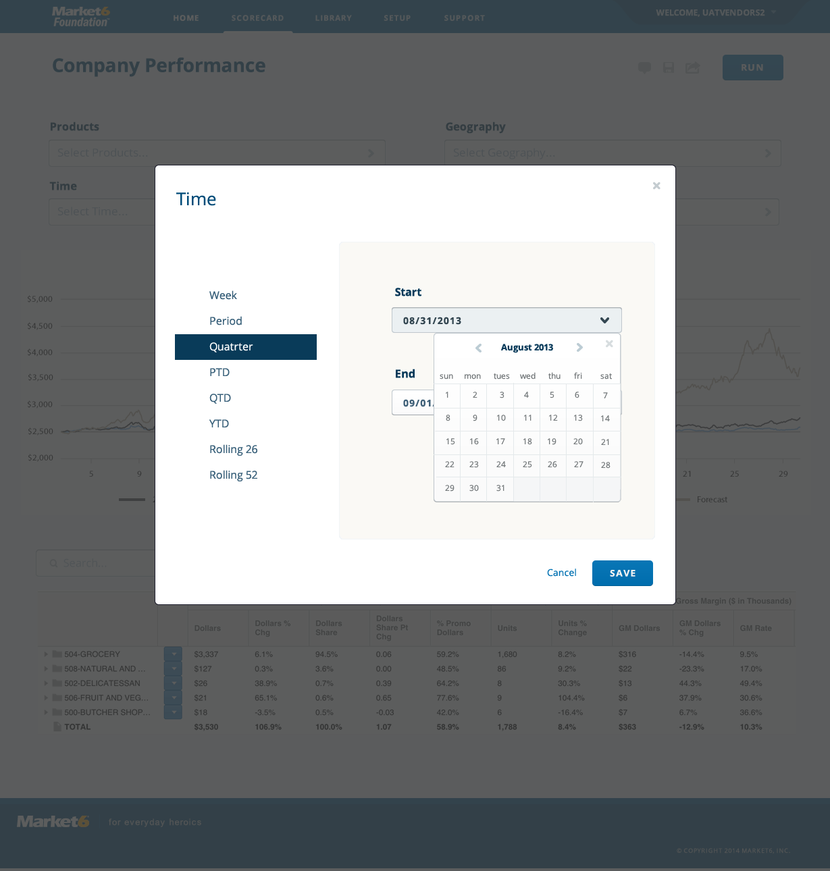
  - Scorecard > Open Calendar Pop Up > Selected > Copy
    - User Interface
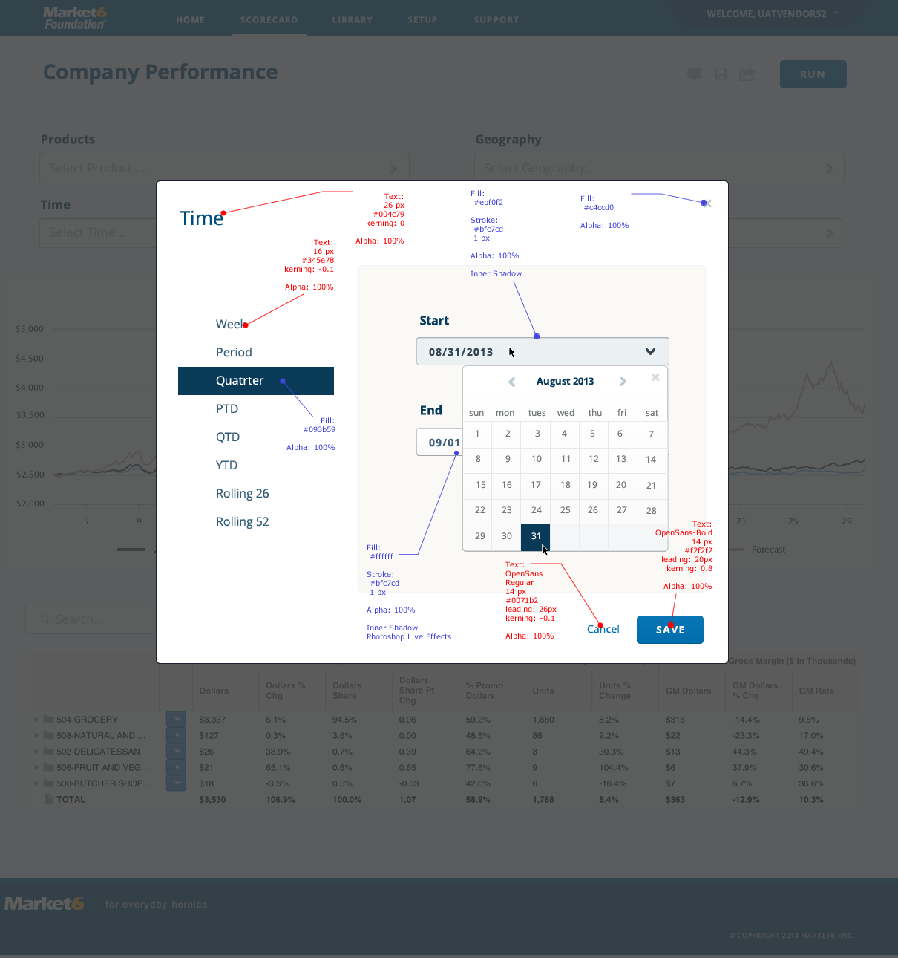
  - Scorecard > Open Calendar Pop Up > Selected > Spacing
    - User Interface
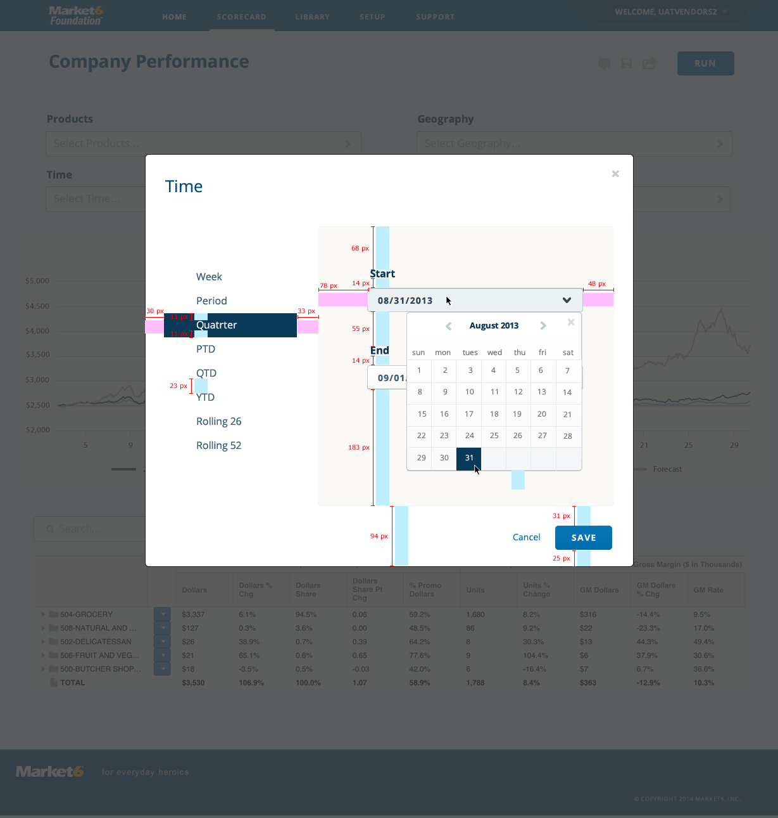
  - Scorecard > Product Popup > Spacing
    - User Interface
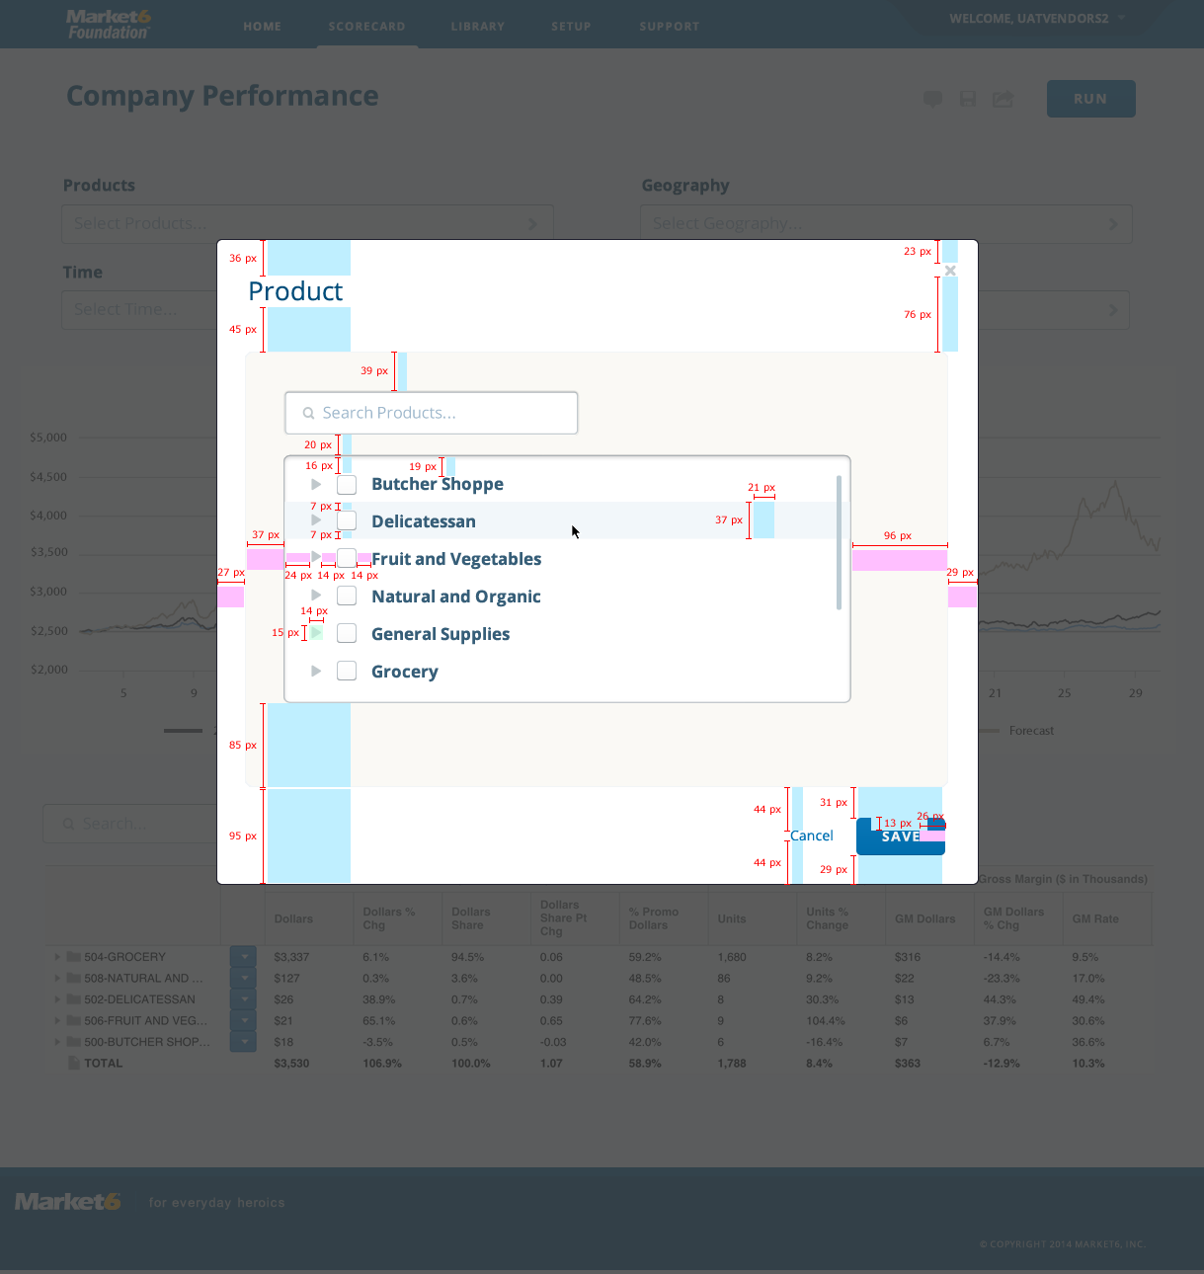
  - Scorecard > Product Popup > Selected > Spacing
    - User Interface
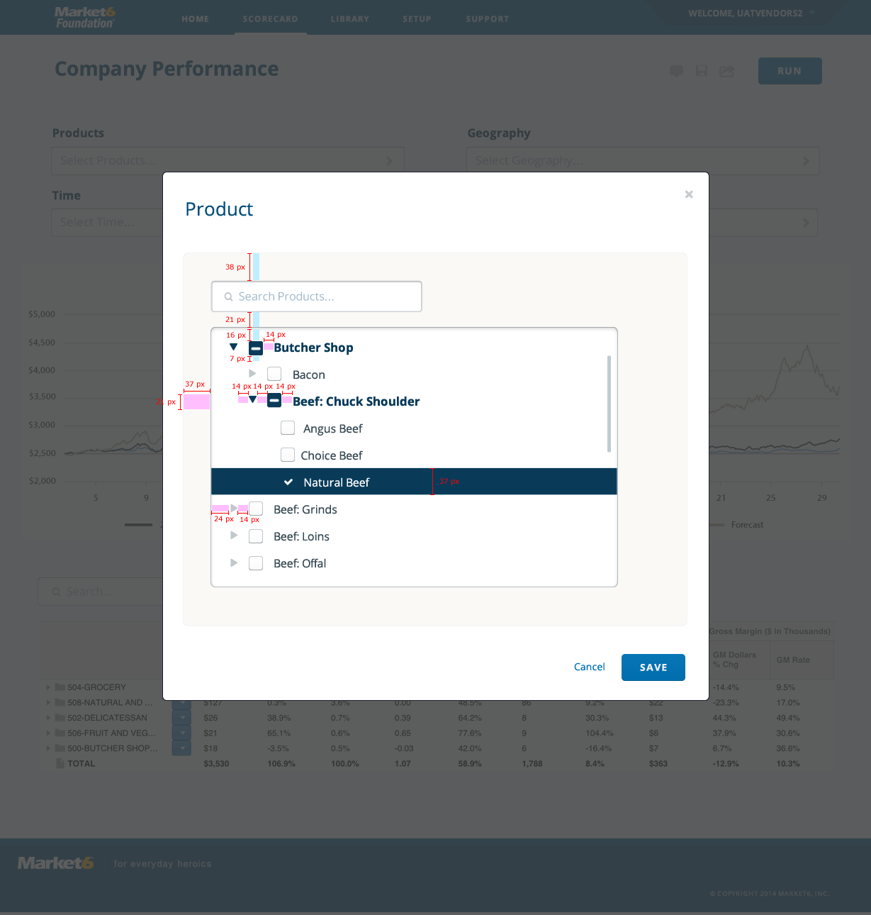
  - Scorecard > Vendor > Popup > Inactive
    - User Interface
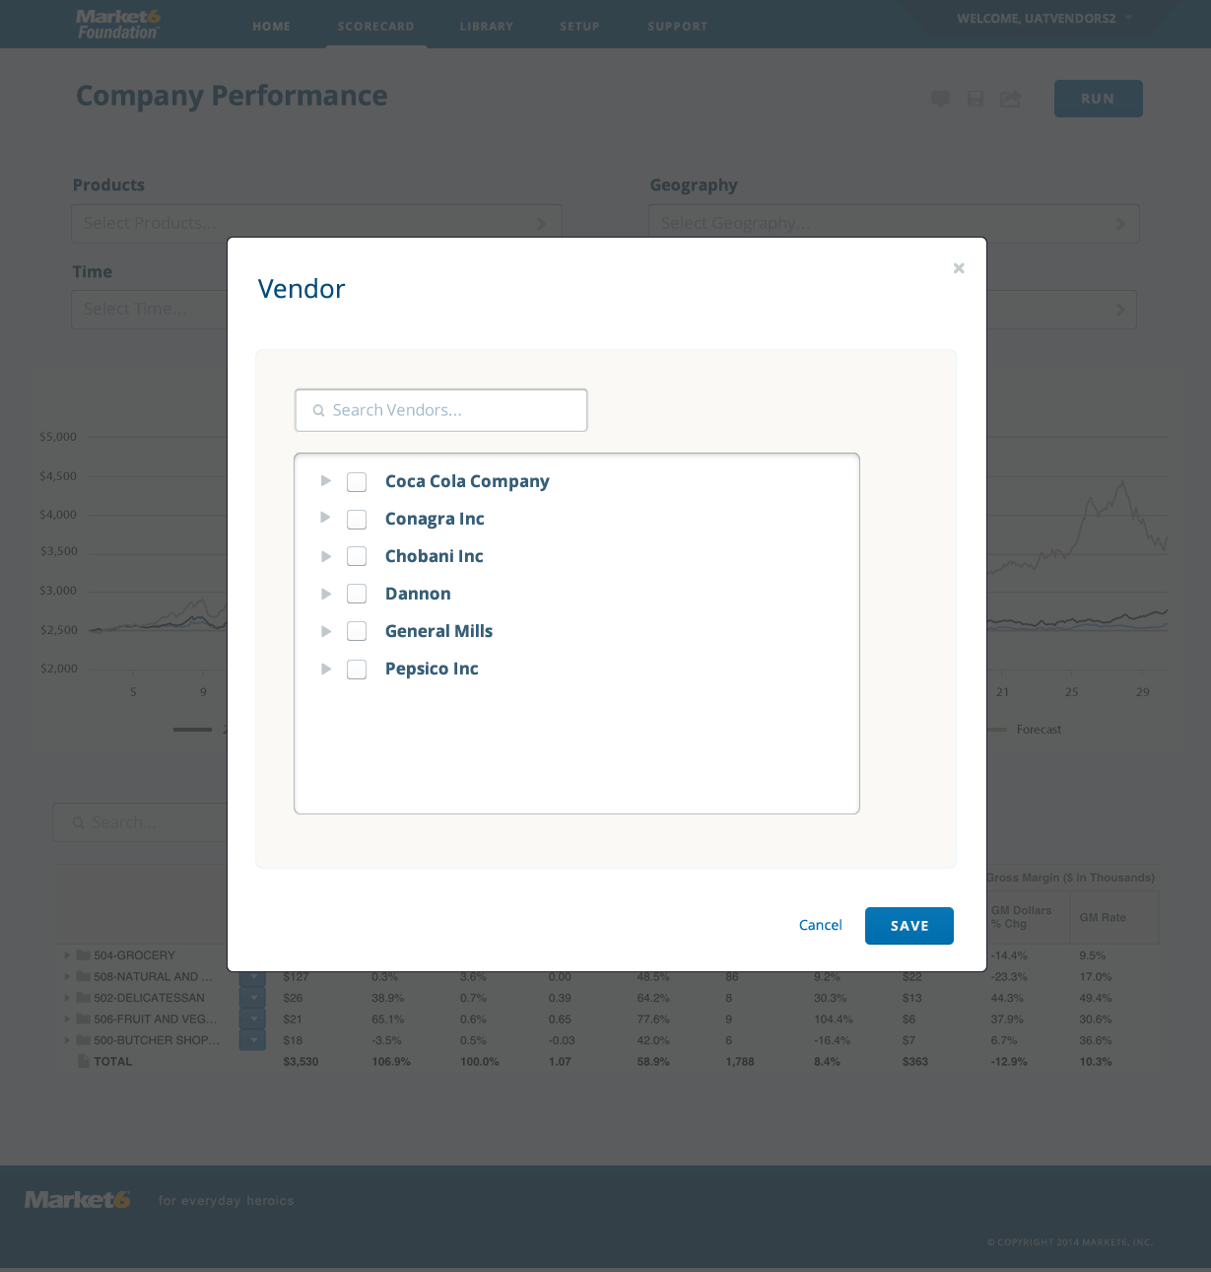
  - Scorecard > Vendor > Popup > Selected
    - User Interface
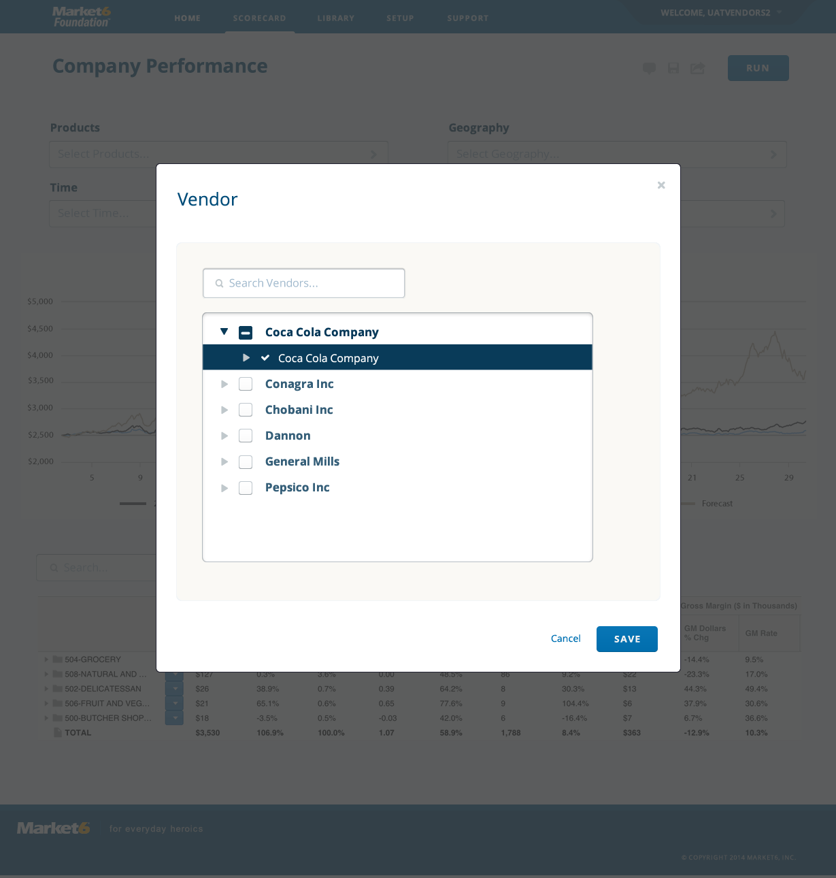
  - Scorecard > Vendor > Popup > Selected > Copy
    - User Interface
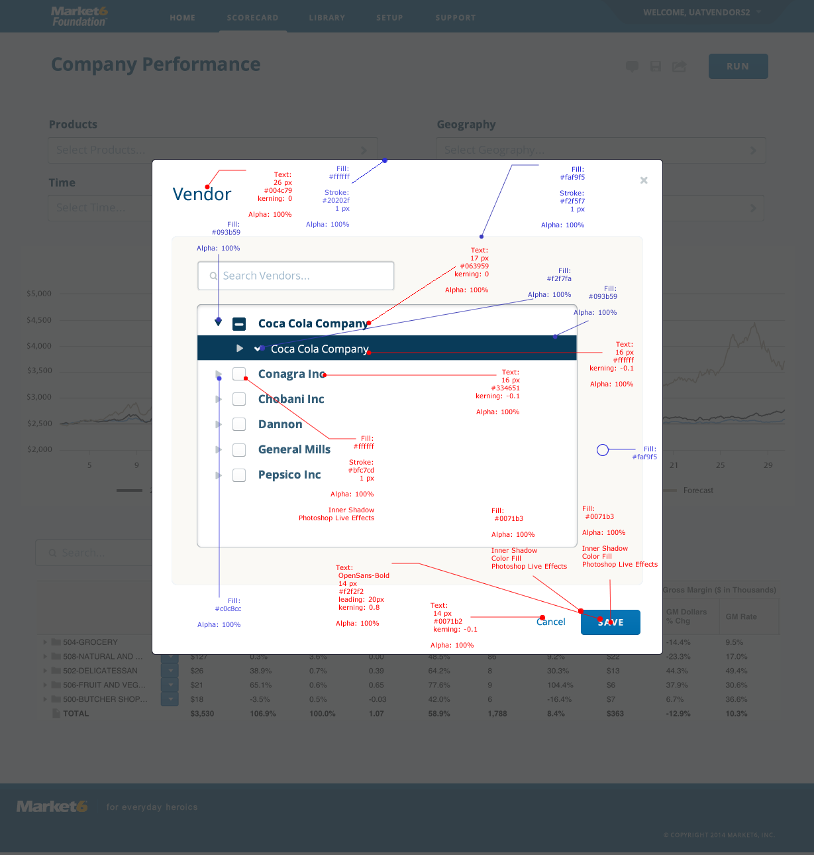
  - Scorecard > Vendor > Popup > Selected > Spacing
    - User Interface
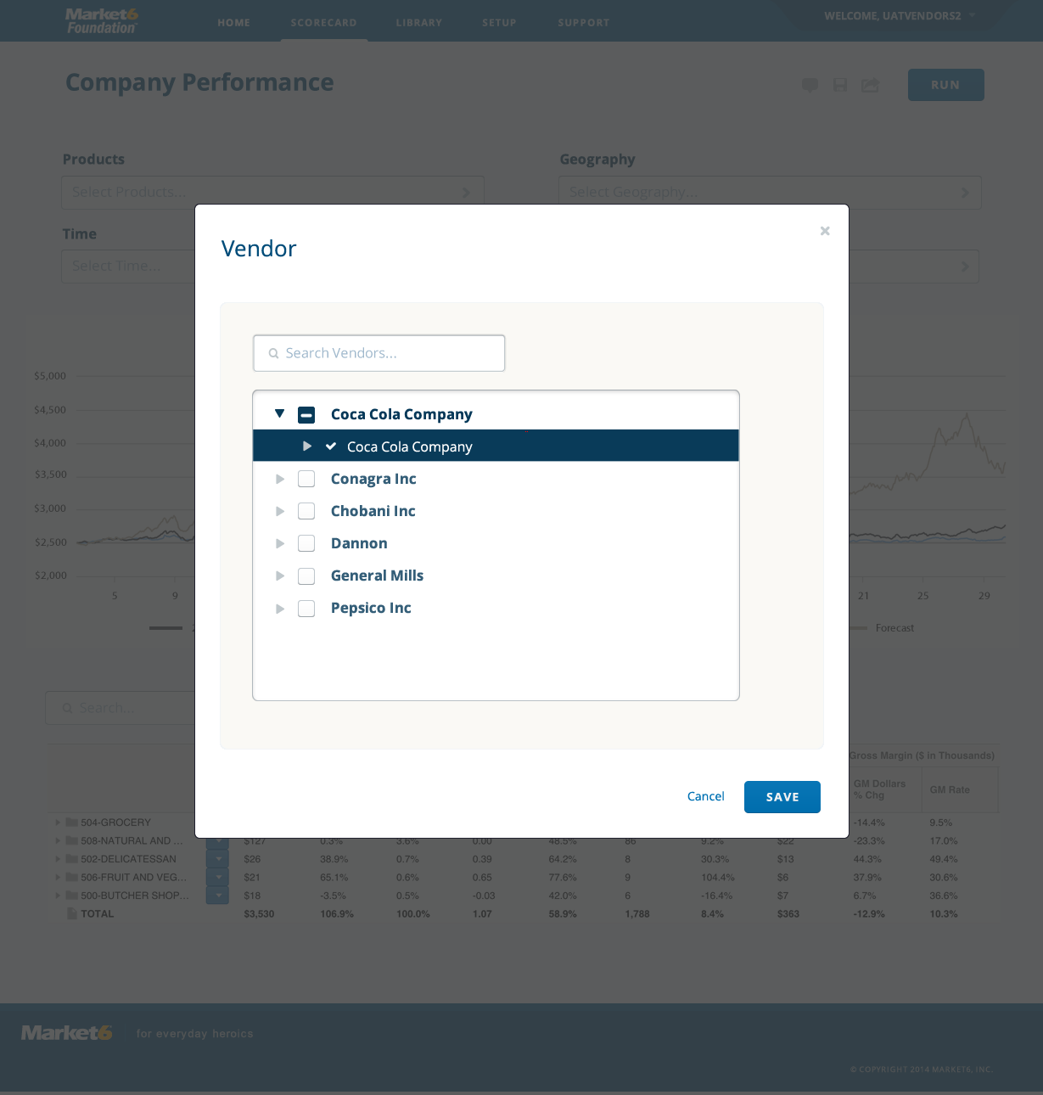
  - Input & Selectors
    - User Interface
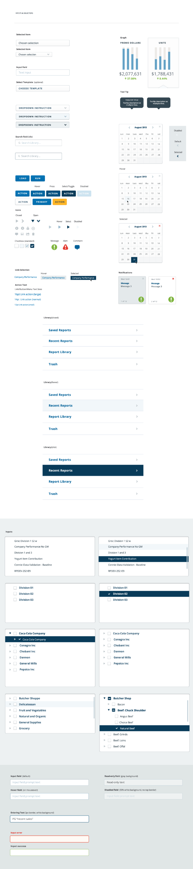
  - Spacing for Input & Selectors
    - User Interface
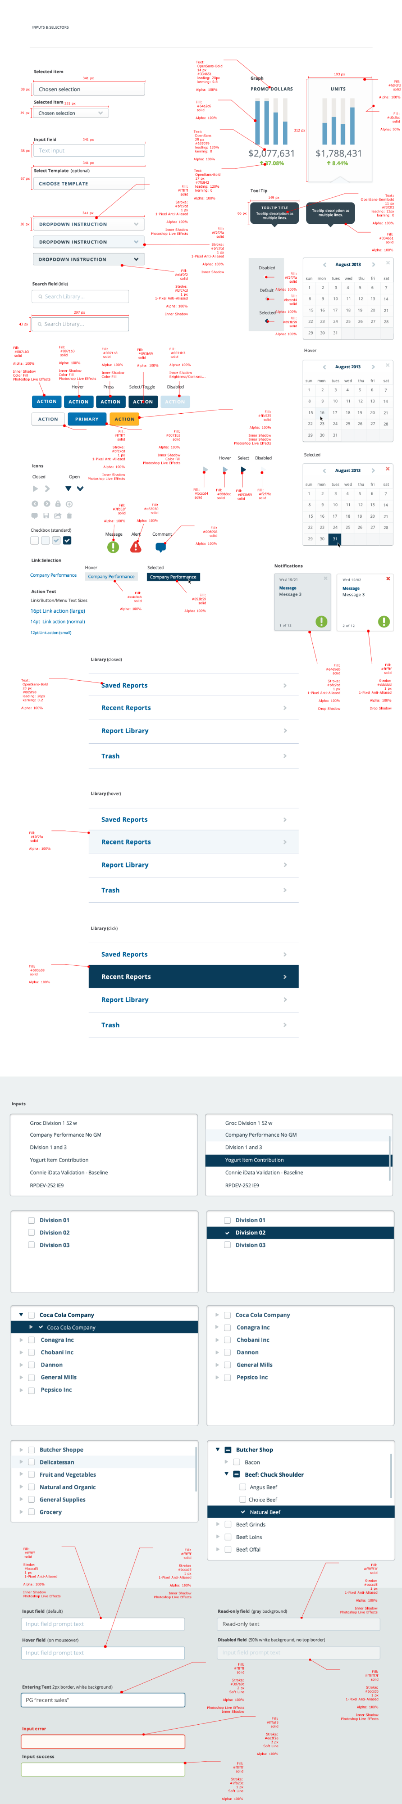
  - Icons & Button PNG Files
    - User Interface
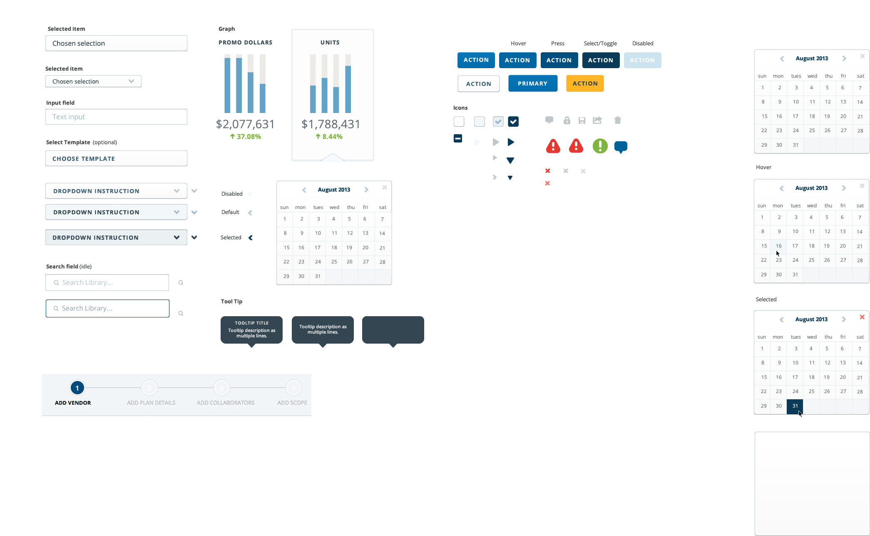
  - Design Notes
    - User Interface
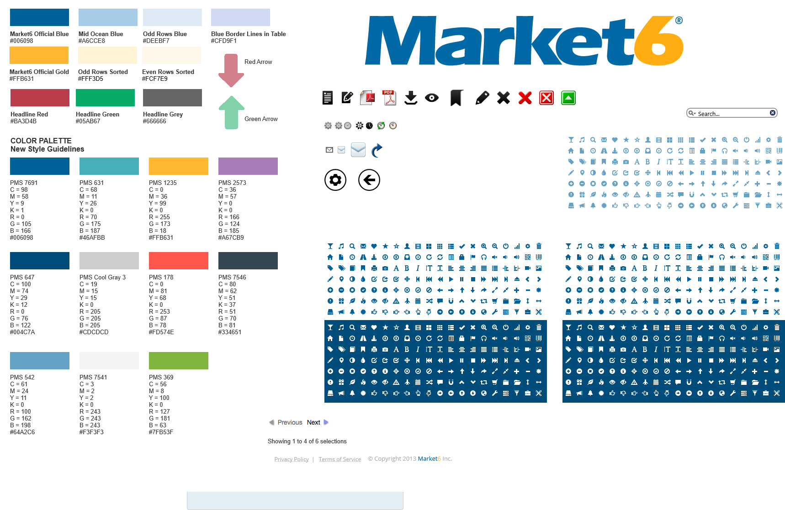
  - Errors, Alerts & Grids
    - User Interface
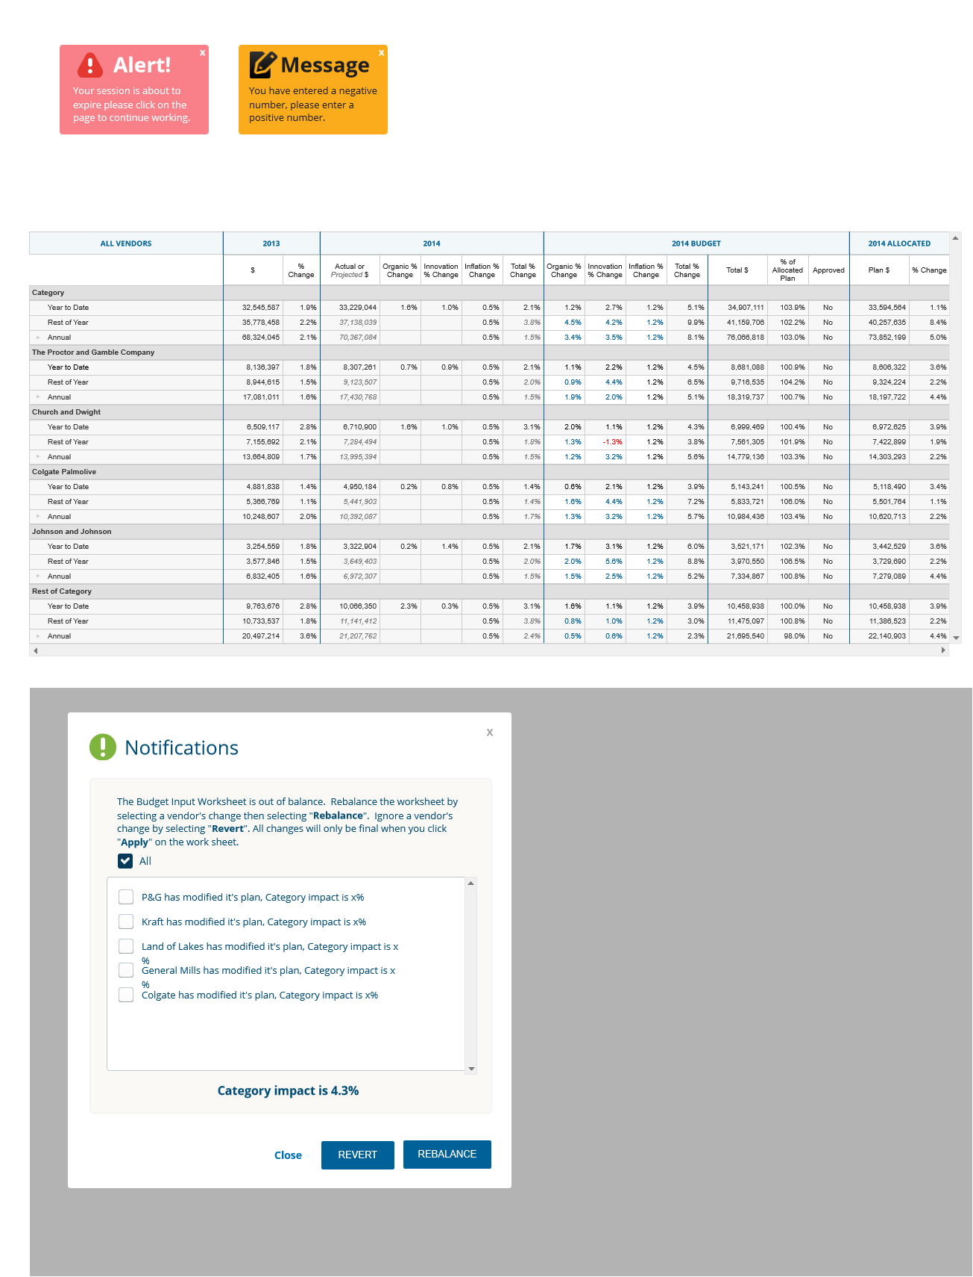
    - All Vendors
      - Collapsed
      - User Interface
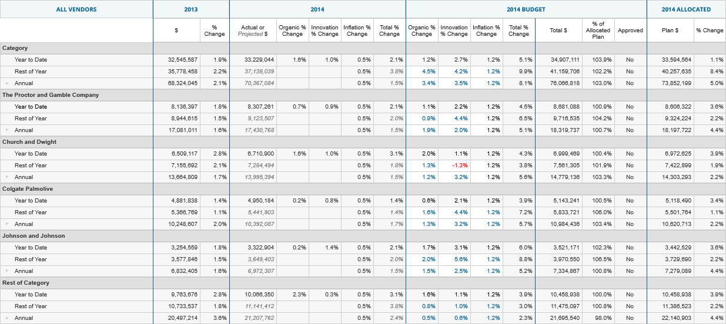
      - P&G Quarters Expanded
      - User Interface
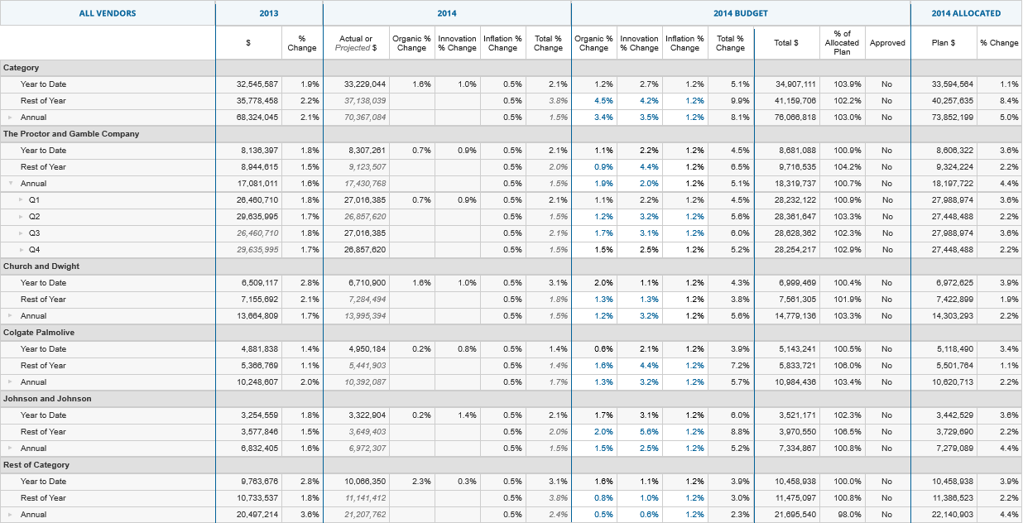
      - P&G Periods Expanded
      - User Interface
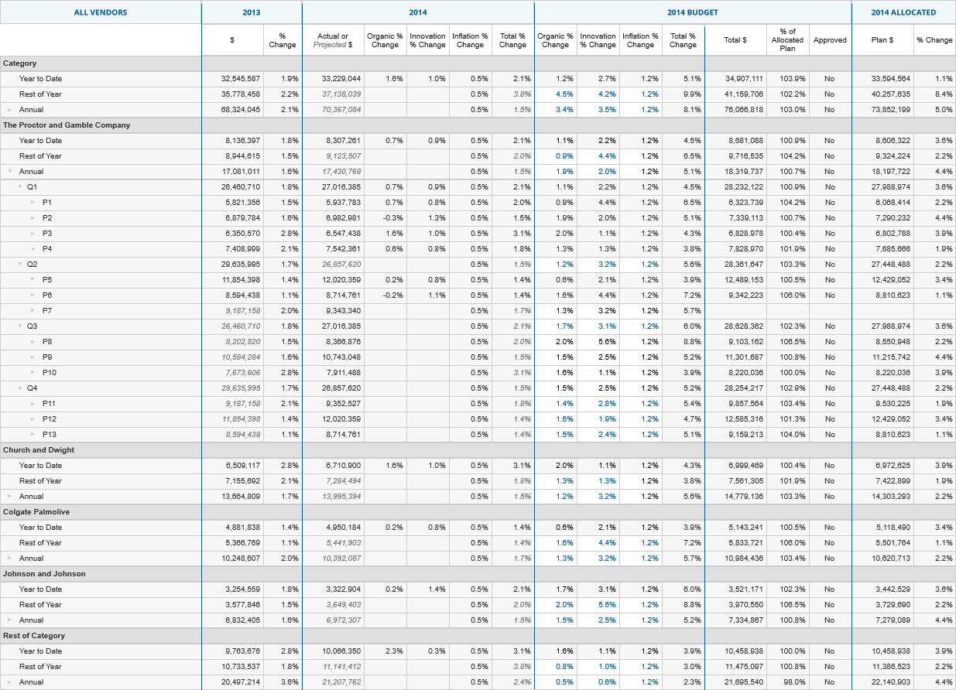
      - P&G Weeks Expanded
      - User Interface
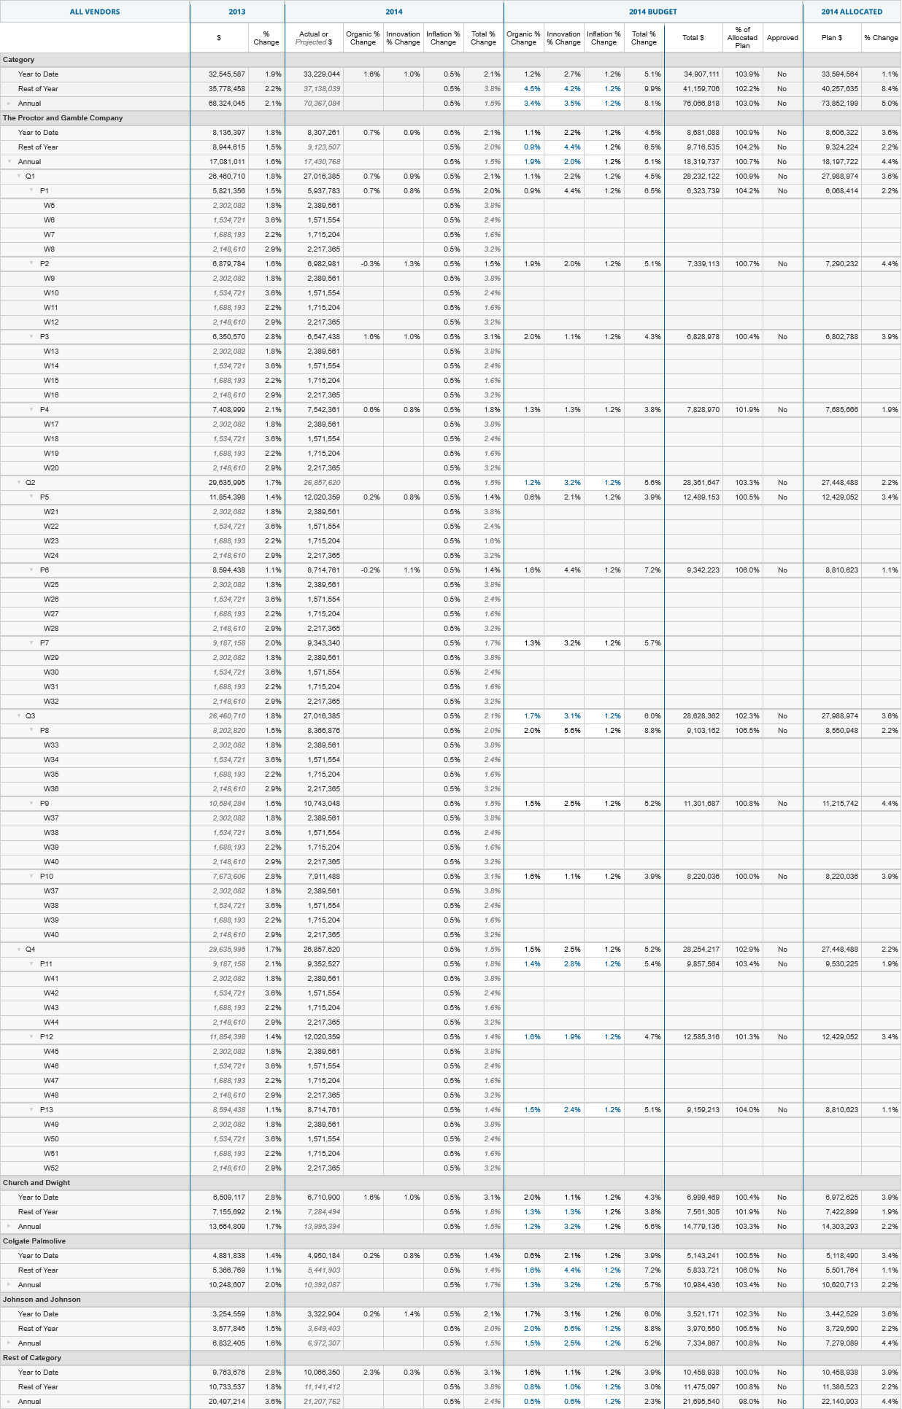
    - Unnamed
      - State1
      - User Interface

- Masters
  - Master List
Footer
  - Footer
    - User Interface

