Faith Warren

Project

Wireframes

Wireframes
Version 1.0
March 24, 2020

Client Signature

Date

Table of Contents

Introduction to Wireframes 3

Introduction to Wireframes
A wireframe, known as page architecture or a blueprint, is a highly simplified sketch to inventory page content and relationships to show the organization and priority of information as well as essential links and functionality. It is not a visual design.
Changes to the wireframe are necessary if doing so will make a substantive impact on the design and user experience. These reasons include:
- Content areas are missing.
- The relationship between two or more elements is incorrect.
- Unnecessary or useless content is present.
- Priority given to the elements is not sufficient to meet the strategic needs of the website.
- Functionality will not support typical user behavior.
- Content or functionality is out of scope for this project or otherwise cannot be implemented.

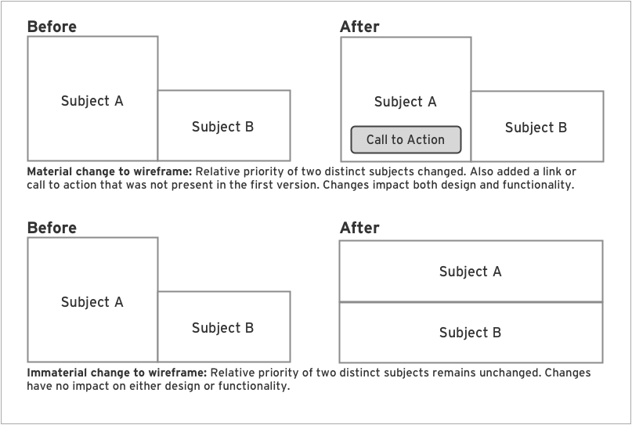

Category Forecast
User Interface
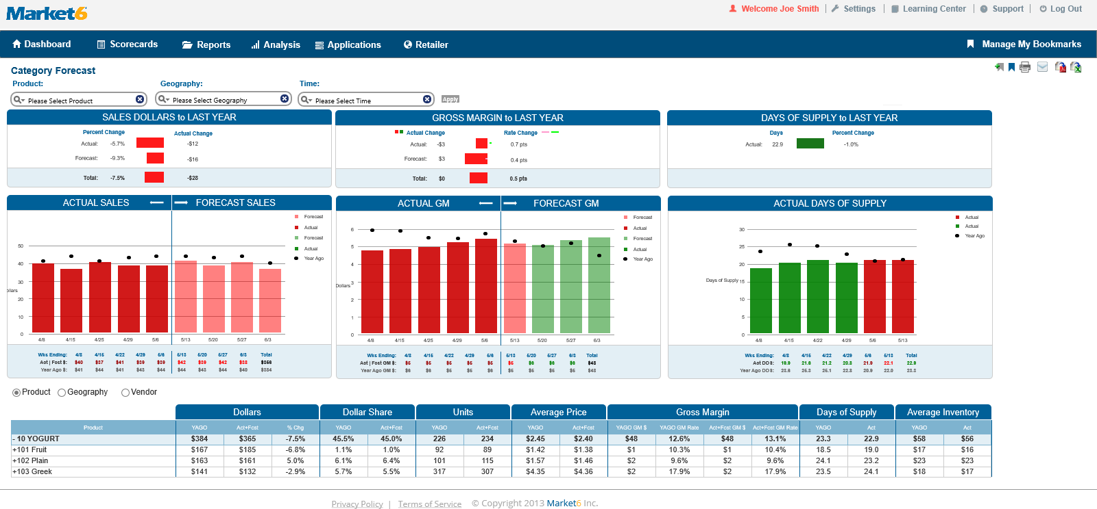
SALES DOLLARS to LAST YEAR
Active
User Interface
Time Data Tree Bubble
Visible
User Interface
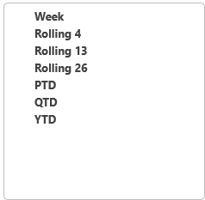
Time Selections
State1
User Interface
Geography Data Tree Bubble
Visible
User Interface
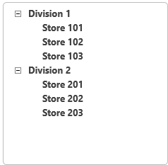
Product Data Tree Bubble
Visible
User Interface
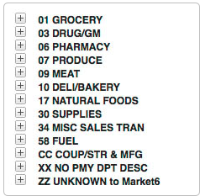
Save A New Bookmark
Visible
User Interface
Bookmarks Available
Visable
User Interface
Print Dialogue
Visible
User Interface
Email This Panel
Default
User Interface
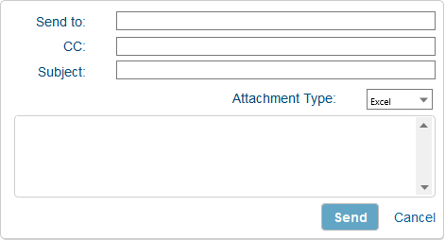
Sent
User Interface
Grid
Product
User Interface
Geography
User Interface
Vendor
User Interface
Activity Button
Save
User Interface
Edit
User Interface
ACTUAL SALES -- FORECAST SALES
QTD
User Interface
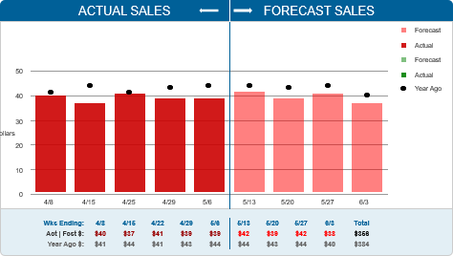
13 Week Spread
User Interface
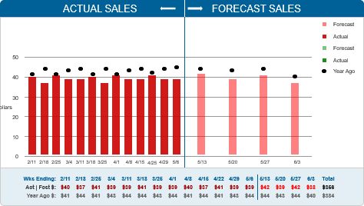
YTD
User Interface
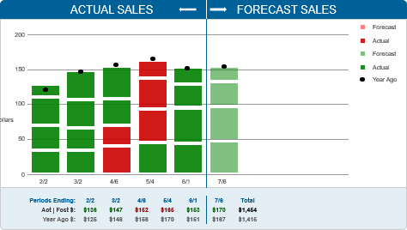
Hover Bubble 1
State1
User Interface
Hover Bubble 2
State1
User Interface
Hover Bubble 3
State1
User Interface
Hover Bubble 4
State1
User Interface
Hover Bubble 5
State1
User Interface
Hover Bubble 6
State1
User Interface
Hover Bubble 7
State1
User Interface
Hover Bubble 8
State1
User Interface
Hover Bubble 9
State1
User Interface
Hover Dot Bubble 1
State1
User Interface
Hover Dot Bubble 2
State1
User Interface
Hover Dot Bubble 3
State1
User Interface
Hover Dot Bubble 4
State1
User Interface
Hover Dot Bubble 5
State1
User Interface
Hover Dot Bubble 6
State1
User Interface
Hover Dot Bubble 7
State1
User Interface
Hover Dot Bubble 8
State1
User Interface
Hover Dot Bubble 9
State1
User Interface
Hover Dot Bubble 1
State1
User Interface
Hover Bar Bubble R1.1
State1
User Interface
Hover Bar Bubble R1.2
State1
User Interface
Hover Bar Bubble R1.3
State1
User Interface
Hover Bar Bubble R1.4
State1
User Interface
GROSS MARGIN to LAST YEAR
Active
User Interface
DOS to LAST YEAR
Active
User Interface
ACTUAL GM -- FORECAST GM
QTD
User Interface
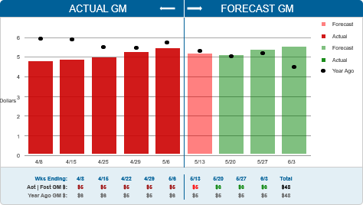
13 Week Spread
User Interface
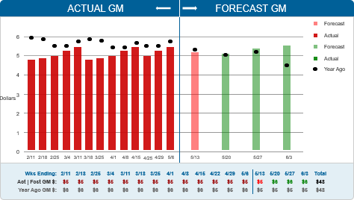
YTD
User Interface
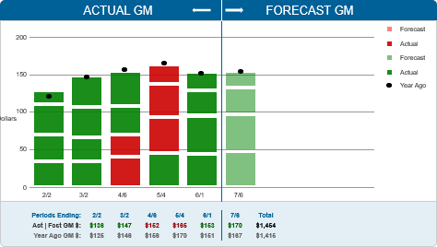
ACTUAL D.O.S.
QTD
User Interface
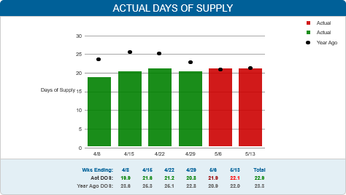
13 Week Spread
User Interface
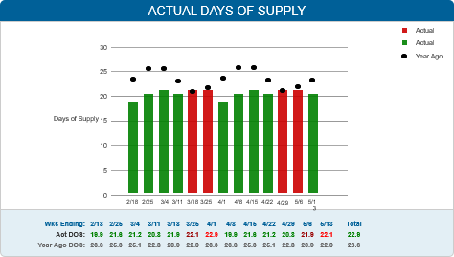
YTD
User Interface
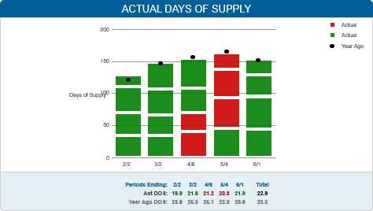

Masters
Master List
Footer
Header
Login Header
Alt Header
Secondary Menu (Ribbon)
Mouse Over Bubble
Footer
User Interface
Header
User Interface
Learning Center
Grey
User Interface
Blue
User Interface
Settings
Grey
User Interface
Blue
User Interface
Support
Grey
User Interface
Blue
User Interface
Log Out
Grey
User Interface
Blue
User Interface
Change Password Menu
Visible
User Interface
Login Header
User Interface
Alt Header
User Interface
Learning Center
Grey
User Interface
Blue
User Interface
Settings
Grey
User Interface
Blue
User Interface
Support
Grey
User Interface
Blue
User Interface
Log Out
Grey
User Interface
Blue
User Interface
Change Password Menu
Visible
User Interface
Secondary Menu (Ribbon)
User Interface
Scorecards Button
Inactive
User Interface
Mouse Over
User Interface
Selected
User Interface
Analysis
Inactive
User Interface
Mouse Over
User Interface
Selected
User Interface
Reailer's Tab
Inactive
User Interface
Moused Over
User Interface
Selected
User Interface
Dashboard Button
Inactive
User Interface
Moused Over
User Interface
Selected
User Interface
Reports Button
Inactive
User Interface
Moused Over
User Interface
Selected
User Interface
Applications
Inactive
User Interface
Mouse Over
User Interface
Selected
User Interface
Manage My Bookmarks
White
User Interface
Light Blue
User Interface
Scorecards Menu
Visible
User Interface
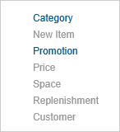
Reports Menu
Visible
User Interface
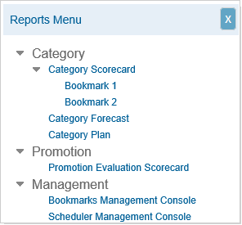
Mouse Over Bubble
User Interface

