Faith Warren

Project

Wireframes

Wireframes
Version 1.0
March 24, 2020

Client Signature

Date

Table of Contents

Introduction to Wireframes 3

Introduction to Wireframes
A wireframe, known as page architecture or a blueprint, is a highly simplified sketch to inventory page content and relationships to show the organization and priority of information as well as essential links and functionality. It is not a visual design.
Changes to the wireframe are necessary if doing so will make a substantive impact on the design and user experience. These reasons include:
- Content areas are missing.
- The relationship between two or more elements is incorrect.
- Unnecessary or useless content is present.
- Priority given to the elements is not sufficient to meet the strategic needs of the website.
- Functionality will not support typical user behavior.
- Content or functionality is out of scope for this project or otherwise cannot be implemented.

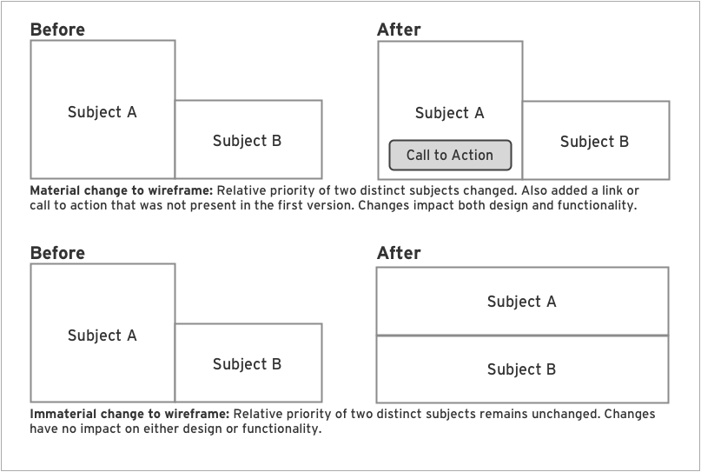

Pages
Site Map
User Interface
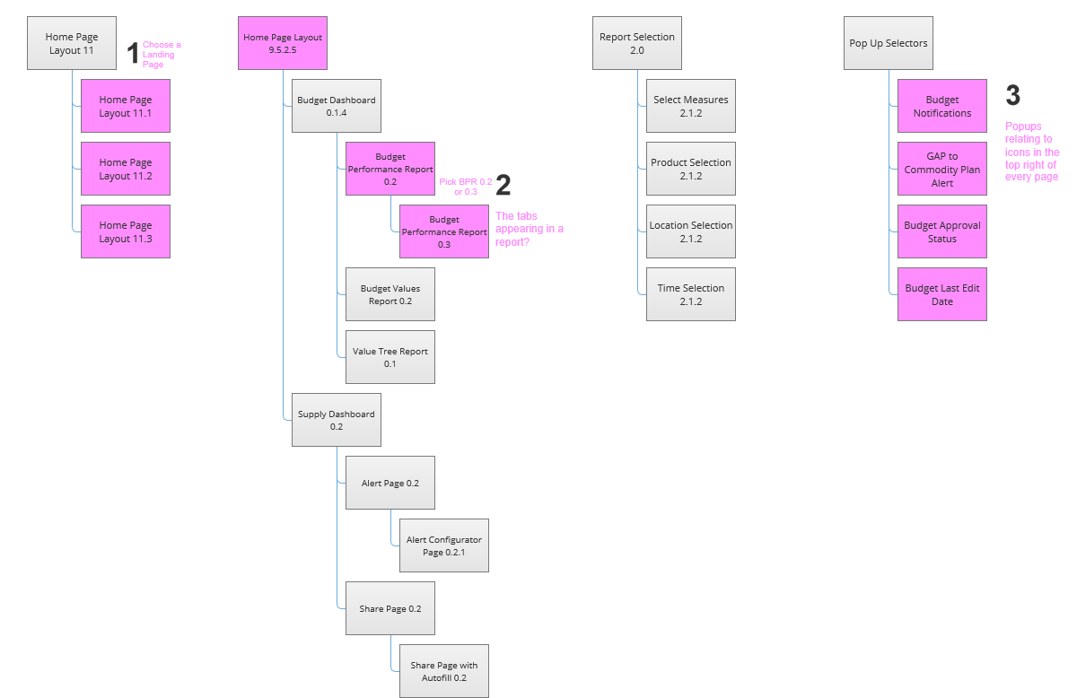
Home Page Layout 9.5.2.5
User Interface
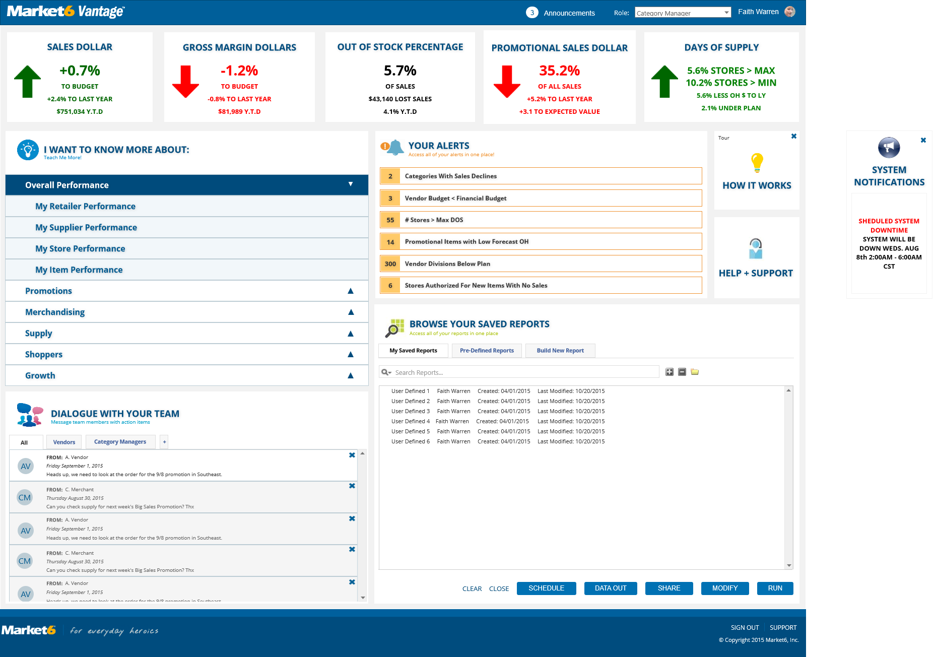
Budget Dashboard 0.1.4
User Interface
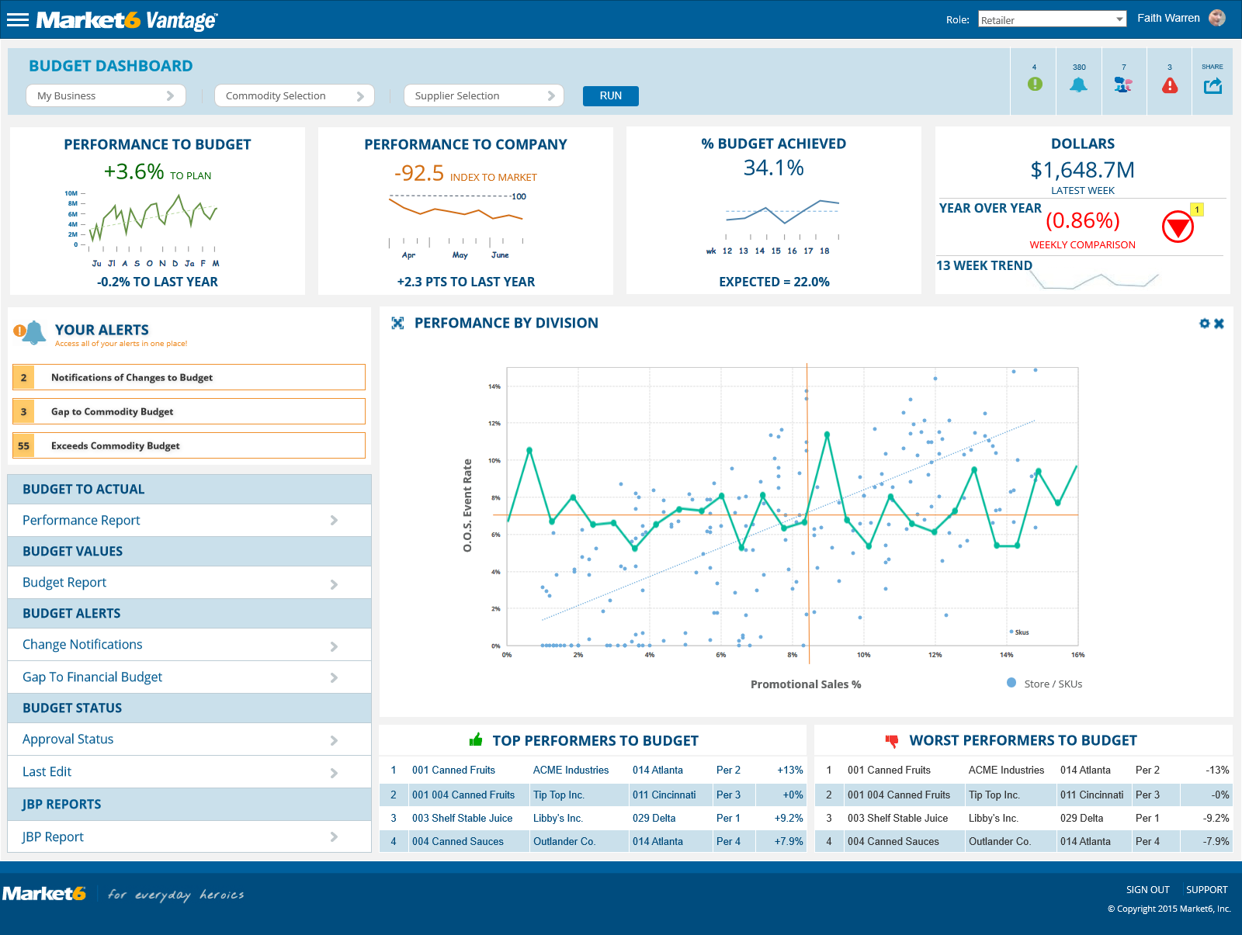
Widget Table
Footnote | Label | Interactions | Description
1 | Notification Scollable Area |  | 240px high by 460px w
Budget Performance Report 0.2
User Interface
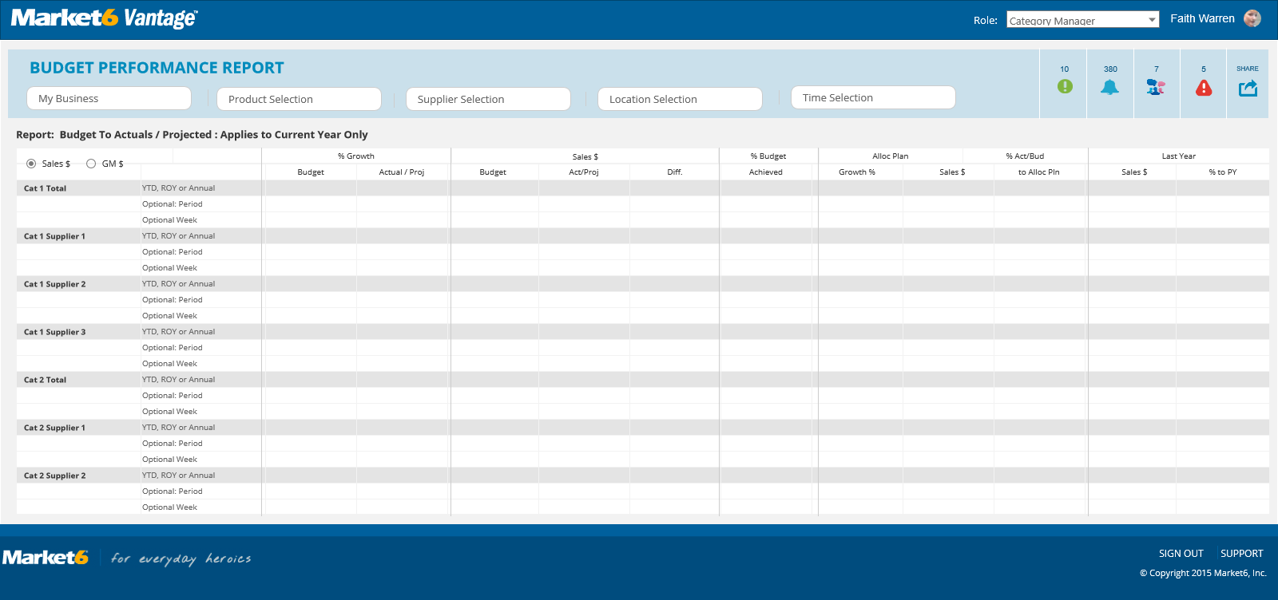
Budget Values Report 0.2
User Interface
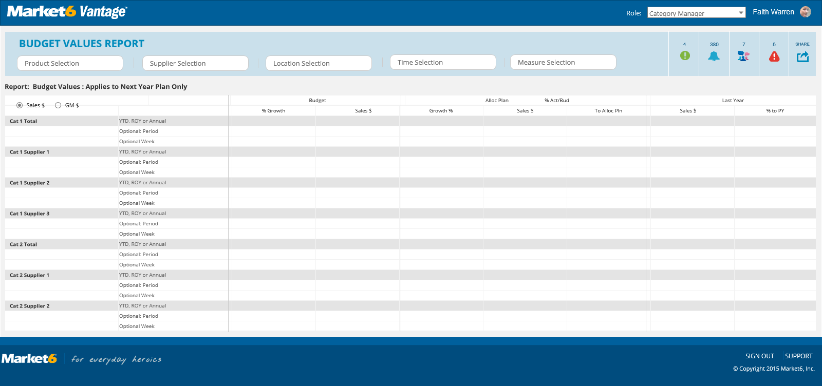
Value Tree Report 0.1
User Interface
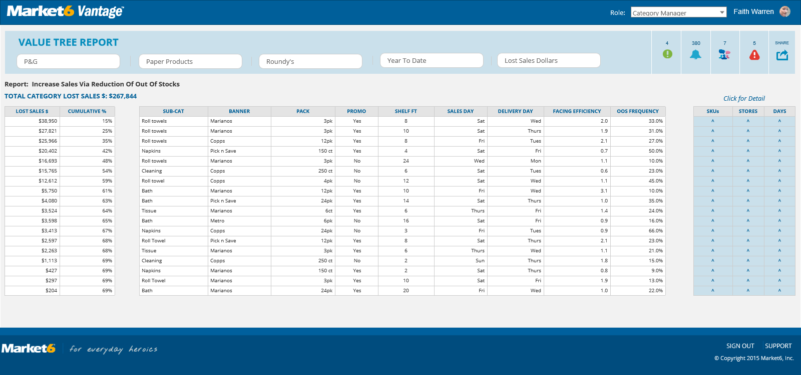
Supply Dashboard 0.2
User Interface
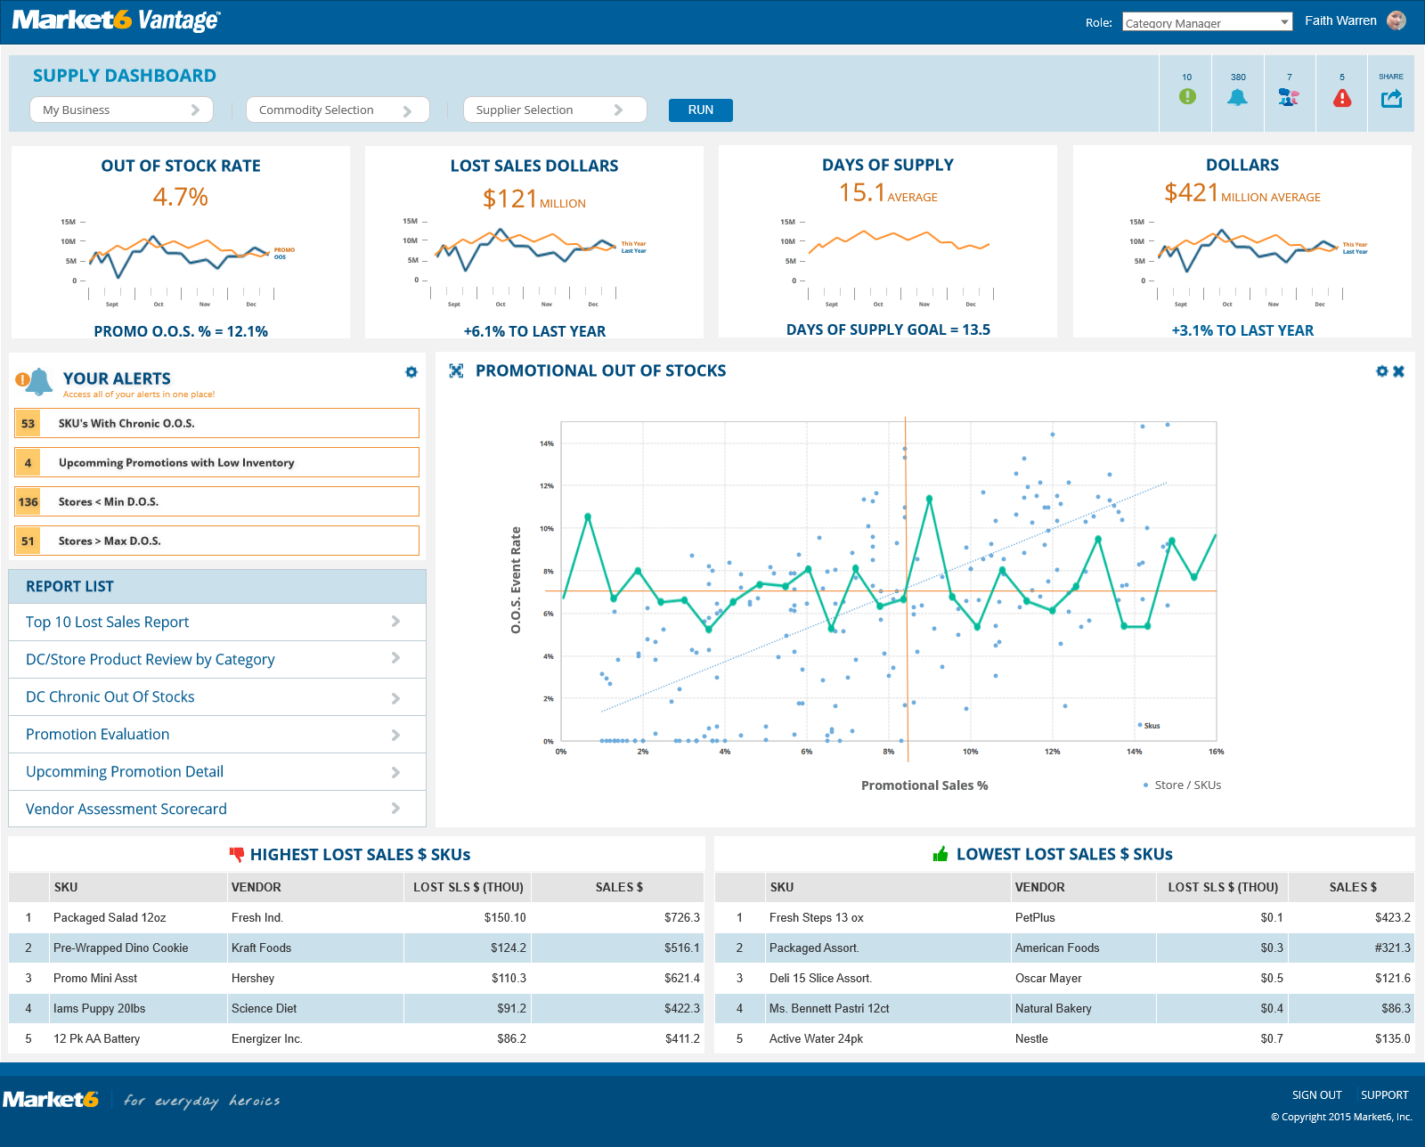
Alert Page 0.2
User Interface
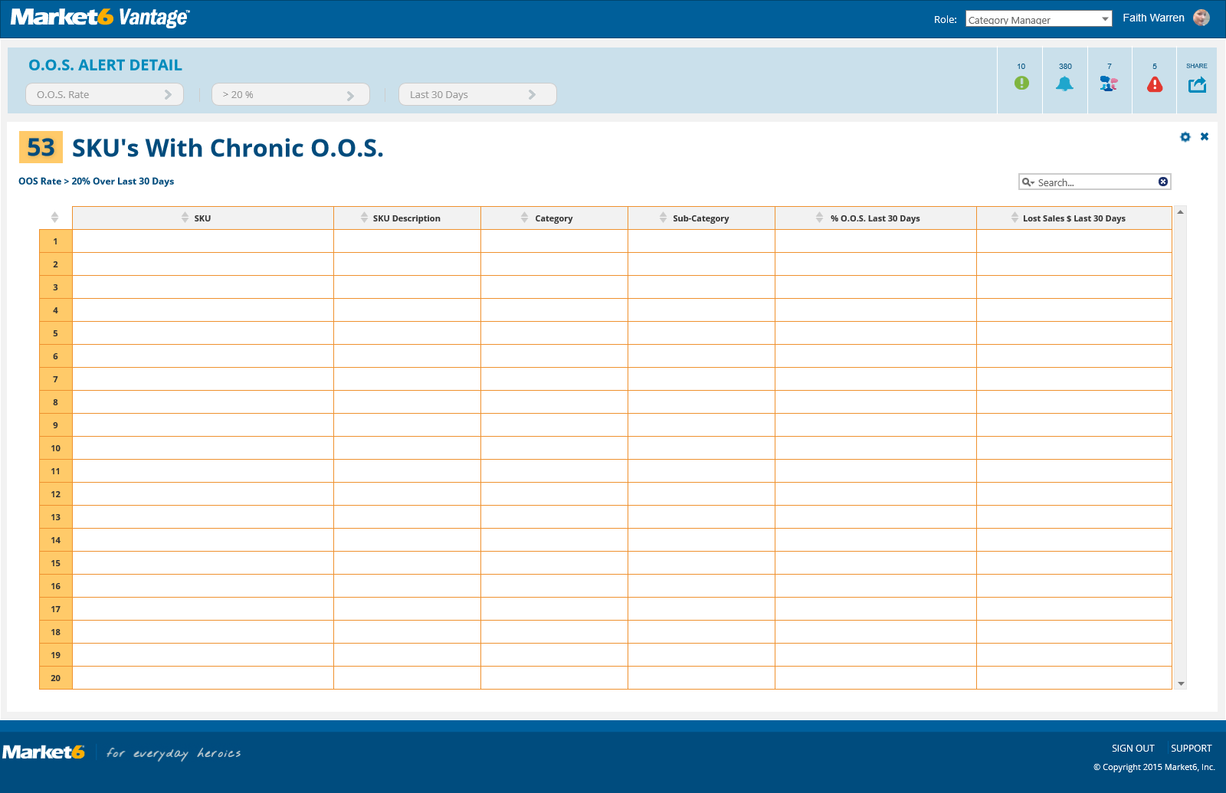
Alert Configurator Page 0.2.1
User Interface
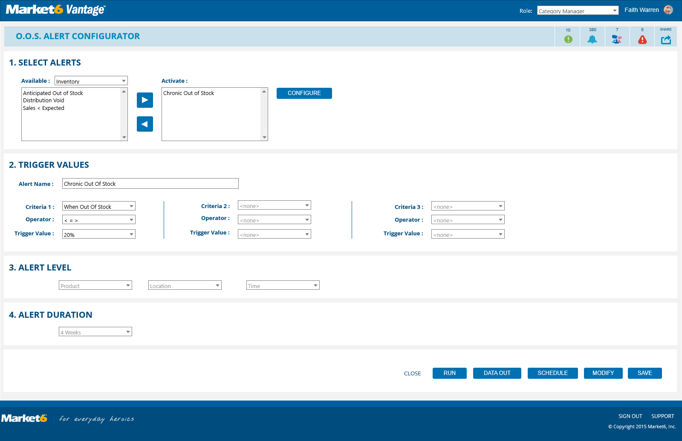
Share Page 0.2
User Interface
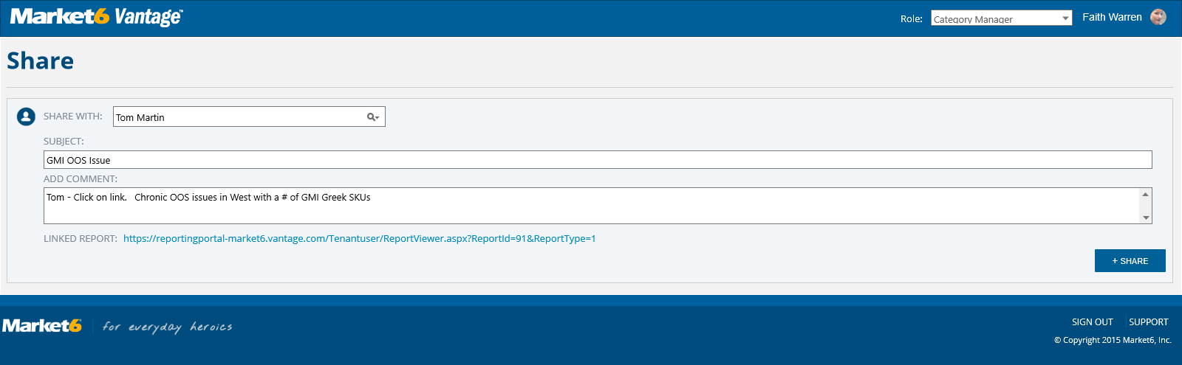
Share Page with Autofill 0.2
User Interface
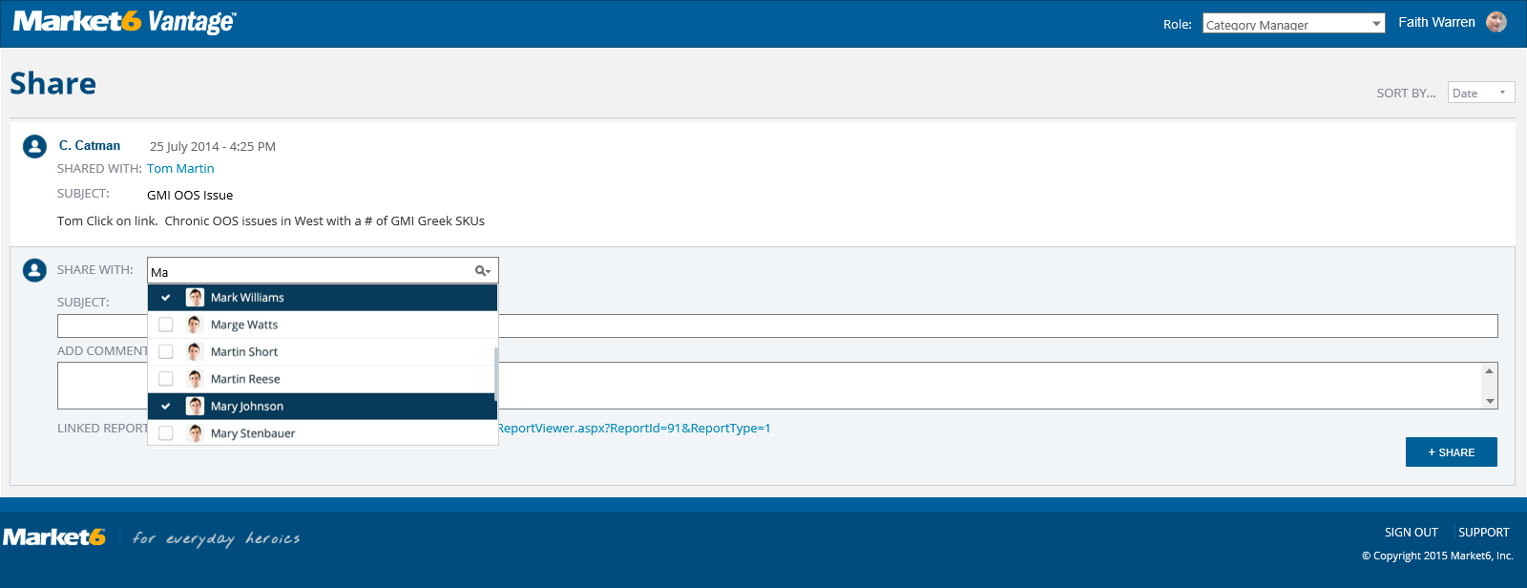
Pop Up Selectors
User Interface
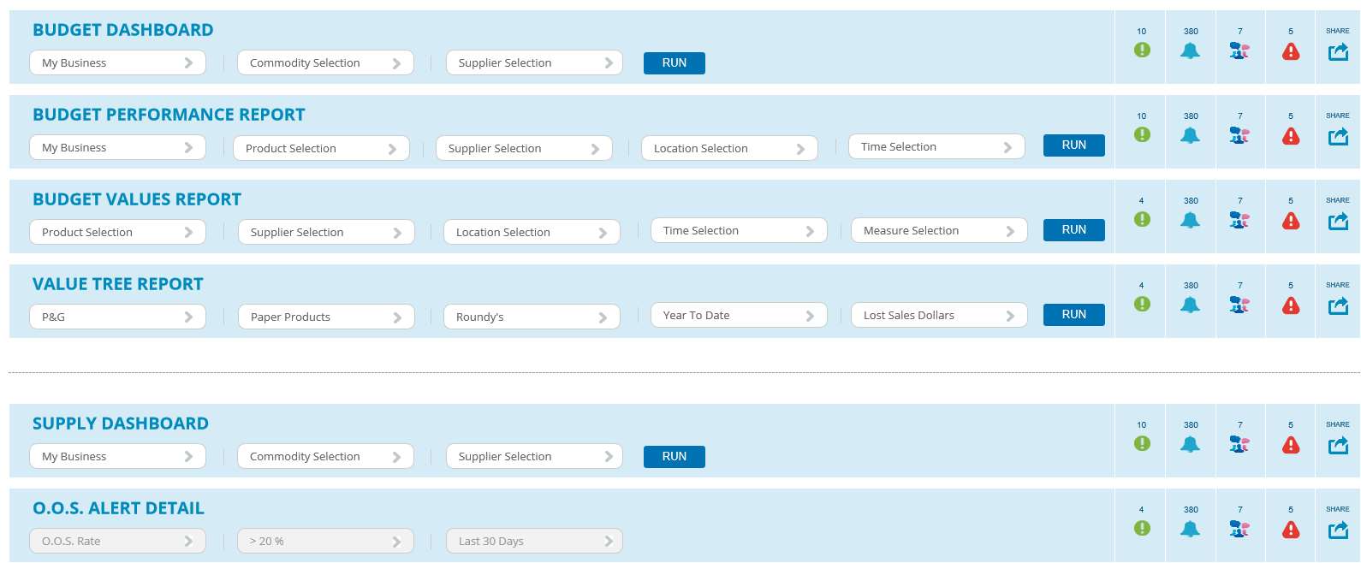
Report Selection 0.3
User Interface
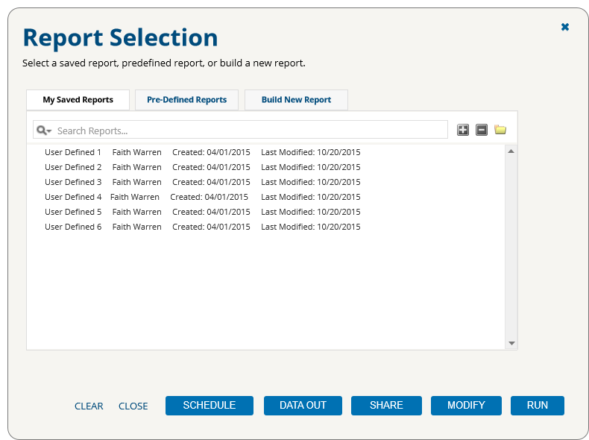
Product Selection 0.3
User Interface
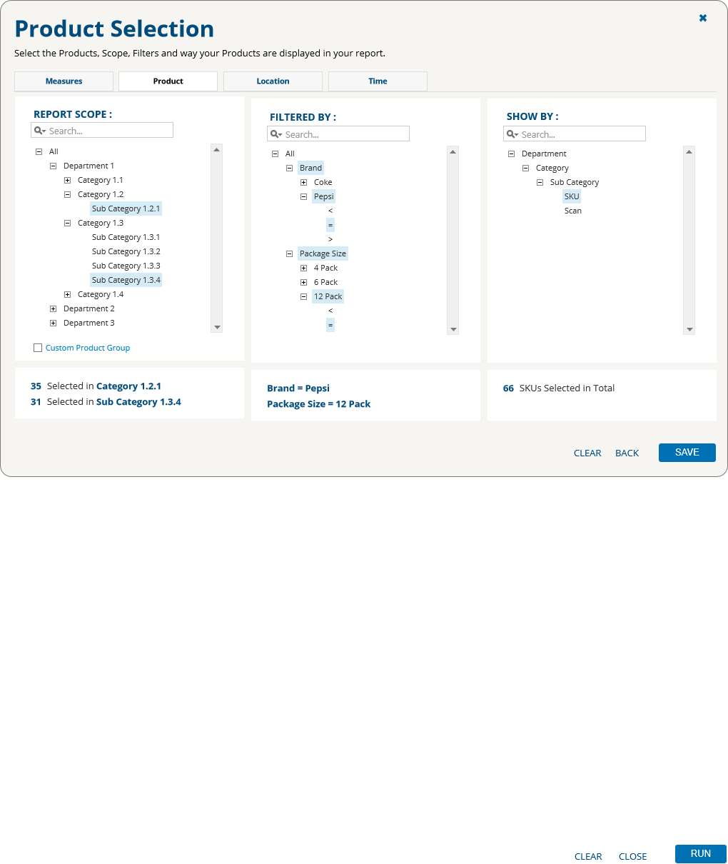
Location Selection 0.3
User Interface
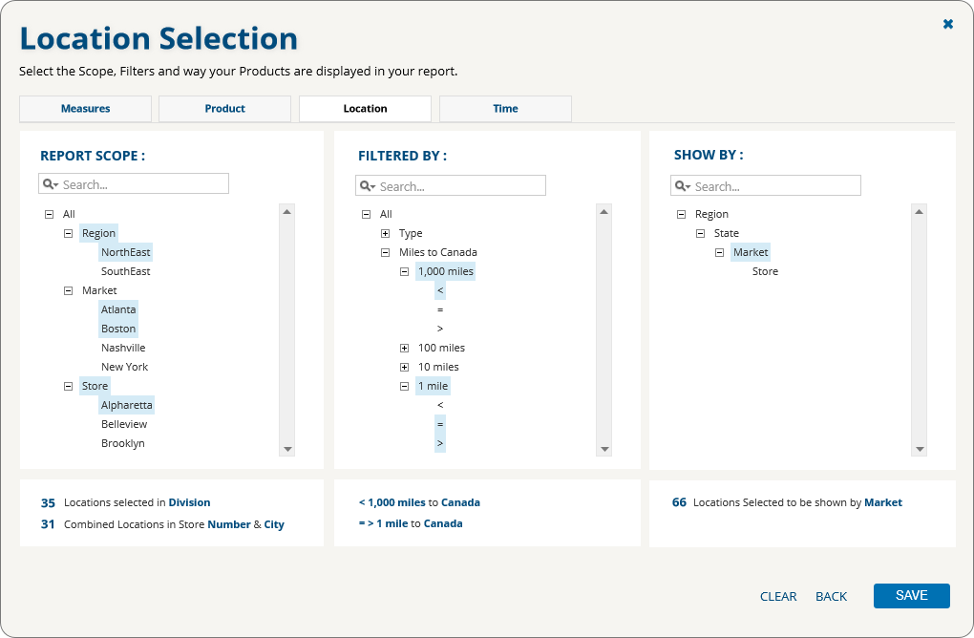
Time Selection 0.3
User Interface
