Table of Contents
[To update the table of contents, select the message below and press F9]

1. Pages 2
1.1. Page Tree 2
1.2. Home 3
1.2.1. User Interface 3
1.3. Variation 1 4
1.3.1. User Interface 4
1.4. Variation2 5
1.4.1. User Interface 5
1.5. Variation 2a 6
1.5.1. User Interface 6
1.6. Variation 2b 7
1.6.1. User Interface 7
1.7. Variation 3 8
1.7.1. User Interface 8
1.8. Variation 3a 9
1.8.1. User Interface 9
2. Masters 10
2.1. Master List 10
2.2. Header 11
2.2.1. User Interface 11
2.3. Footer 12
2.3.1. User Interface 12

- Pages
  - Page Tree
- Home
- Variation 1
- Variation2
- Variation 2a
- Variation 2b
- Variation 3
- Variation 3a
  - Home
    - User Interface
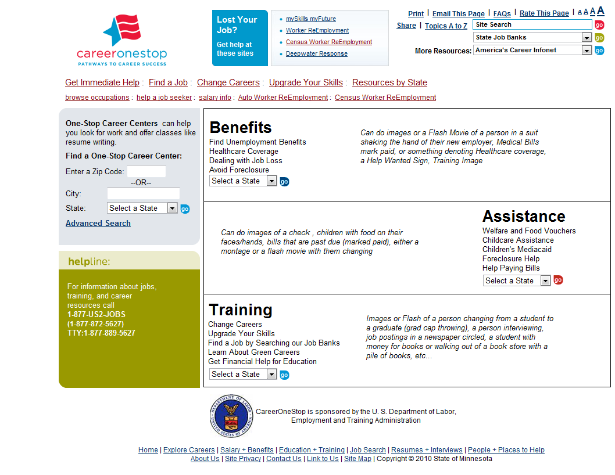
  - Variation 1
    - User Interface
  - Variation2
    - User Interface
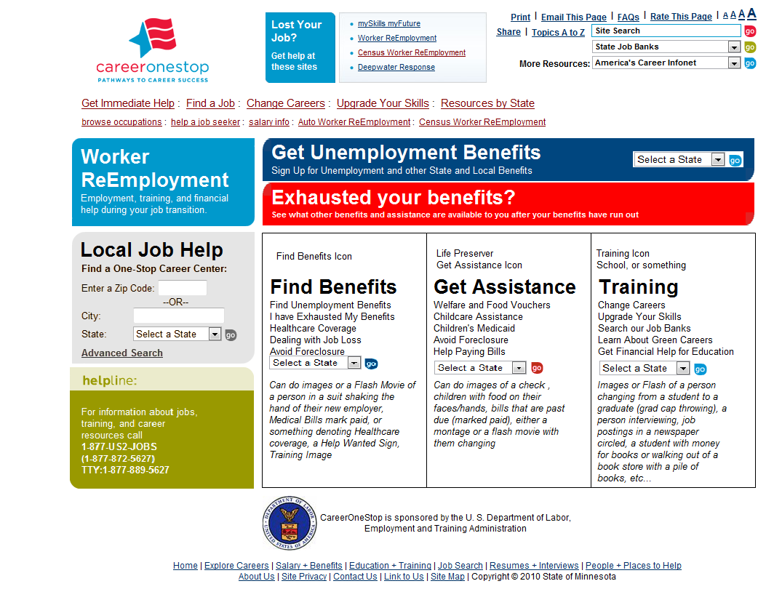
  - Variation 2a
    - User Interface
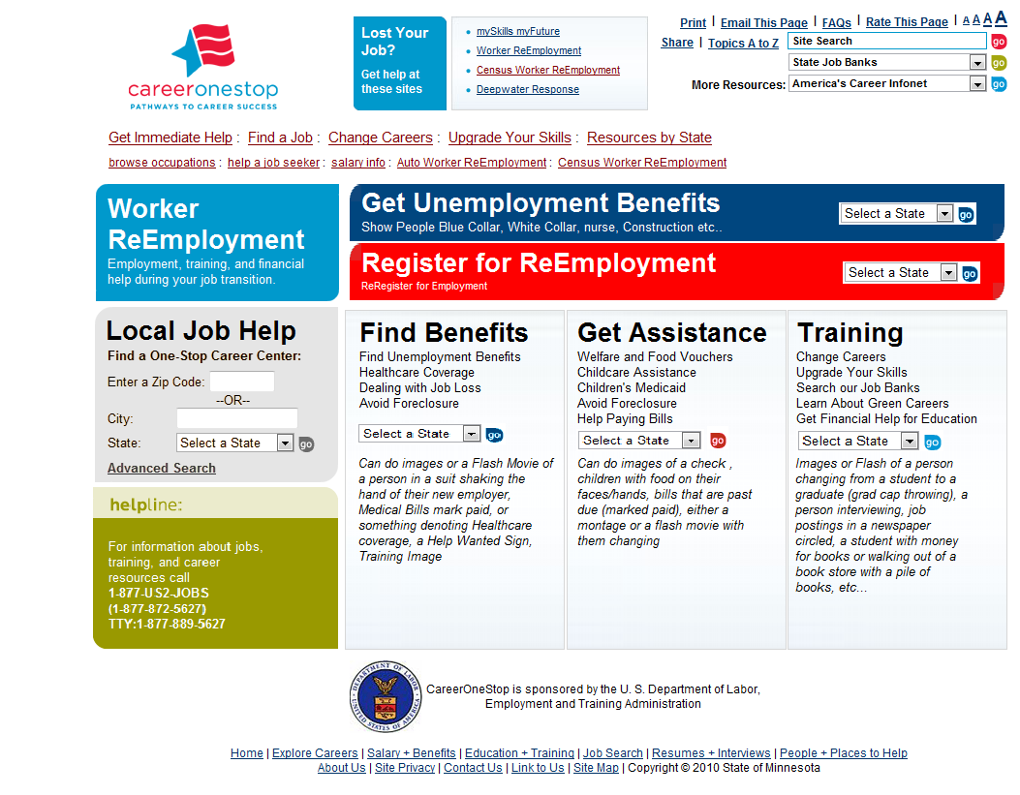
  - Variation 2b
Show People Graduating, taking a class, on the "Upgrade Your Career"
    - User Interface
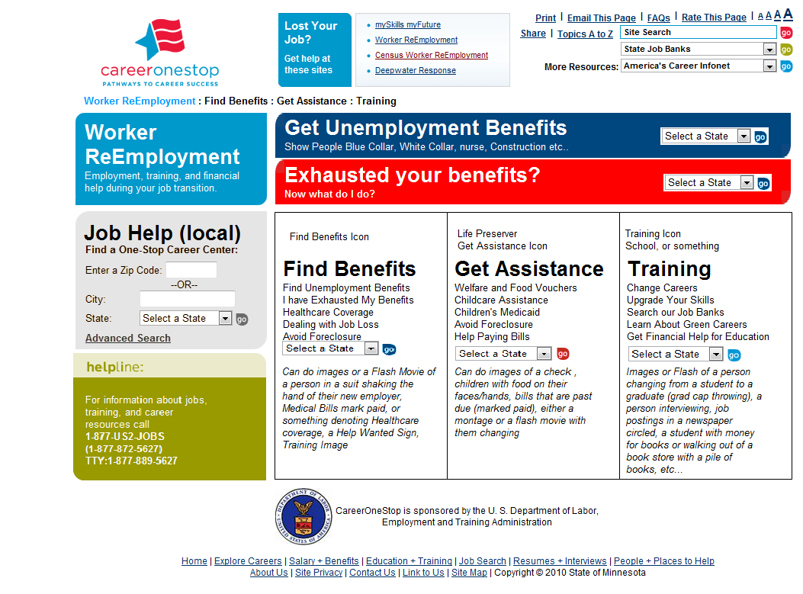
  - Variation 3
    - User Interface
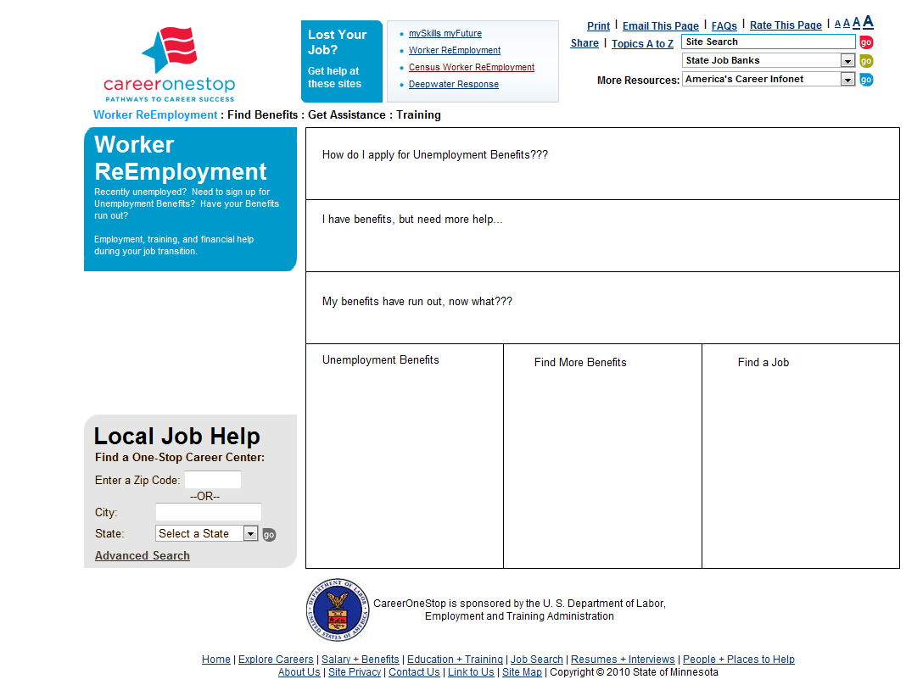
  - Variation 3a
    - User Interface
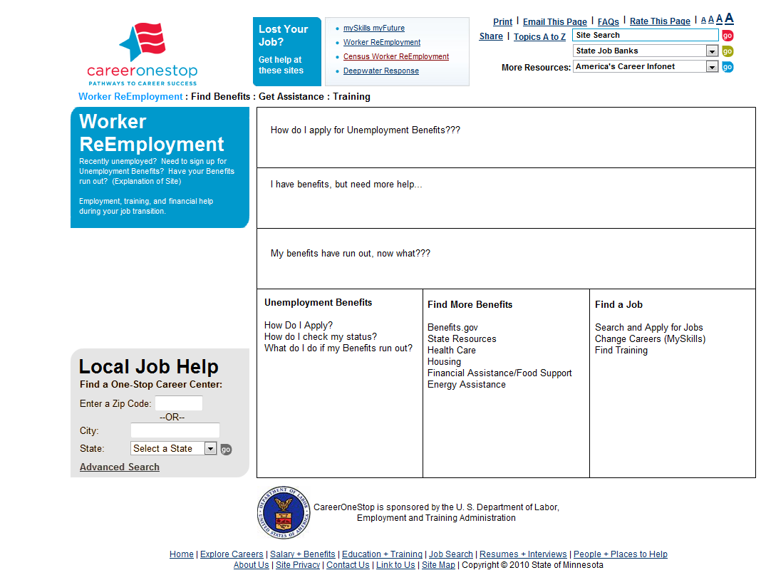

- Masters
  - Master List
- Header
- Footer
  - Header
    - User Interface
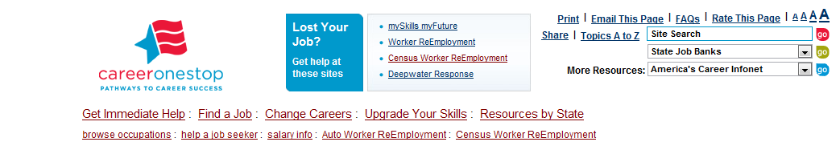
  - Footer
    - User Interface

